Machine Learning 101 for Financial Trading

FSE-DAT-3019-1.1 | Data Analytics and Computational Modelling
Sector: Financial Services | Proficiency Level 3
LEARNER GUIDE

Tertiary Infotech Academy Pte Ltd
UEN 201200696W
Version 2.4 | 22 October 2026

Table of Contents

Version History 1
Introduction to the Course 1
Low Code - You Own the Algorithm 1
Course Objectives 1
Alignment to the Skills Framework 1
Course Structure 1
How You Will Be Assessed 1
Before You Start: Platform Setup 1
Platform Guides: Sign-Up and Paper Trading Step by Step 1
Download the Course Materials: Learner Guide, Slides and Lab Manual 1
Download, Install and Start the Trading Simulator Software 1
Sign Up for Alpaca and Open the Paper-Trading Account 1
Sign Up for TradingView and Find the Tools You Will Use 1
Paper Trading on TradingView, Step by Step 1
Paper Trading on Alpaca, Step by Step - Manual and Automated 1
Topic 1: Foundations of Quant and Algorithmic Trading: From Thorp to AI Agents 1
1.1 Quant Success Stories: What Systematic Trading Has Achieved 1
1.2 The Evolution of Quant: From Thorp and Renaissance to High-Frequency Trading 1
1.3 The Paradigm Shift from Machine Learning to LLMs, and Its Impact on Quant 1
1.4 Agentic AI versus AI Agents in Trading, and Multi-Agent Trading Systems 1
1.5 Forms of Data within Financial Services and Big Data Applications in Trading 1
1.6 Developing Hypotheses for Quant and Algorithmic Trading Models 1
Reference: Quant Success Stories 1
Timeline: The Evolution of Quant and Algorithmic Trading 1
Comparison: Machine-Learning Quant versus LLM-Era Quant 1
Comparison: Agentic AI versus AI Agents in Trading 1
1.7 Lab 1: Pipeline Skeleton, Configuration and the Alpaca Paper Account 1
1.8 Lab 2: Data-Validation Stage: Cross-Check Pipeline Bars against TradingView 1
1.9 Lab 3: Ingestion Stage: Multi-Timeframe Bars, Headlines and Data Quality 1
1.10 Lab 4: Hypothesis Stage: from a Written Card to an Automated Statistical Test 1
1.11 Topic Summary 1
Topic 2: Technical Indicators, Trading Strategies and Metrics with TradingView and Alpaca 1
2.1 Technical Indicators: Trend, Momentum, Volatility and Volume 1
2.2 Classification of Algorithmic Trading and Quant Algorithms 1
2.3 Analytics Platforms and Tools: TradingView versus Alpaca, and Python 1
2.4 Coding Languages for Algorithms and Signals, and Order Placement 1
2.5 Performance and Risk Metric Definitions 1
Reference: Classification of Trading Algorithms 1
Comparison: TradingView versus Alpaca 1
Strategy Families: the Idea, When It Works, When It Will Not 1
Key Metrics Defined 1
Indicator by Indicator 1
How It Works: Moving-Average Crossover (Trend Following) 1
How It Works: Bollinger Band Mean Reversion 1
How It Works: RSI and MACD Momentum Oscillators 1
How It Works: Cross-Sectional Momentum 1
How It Works: Donchian Channel Breakout 1
How It Works: VWAP and TWAP Execution 1
How It Works: Market Making 1
2.6 Lab 5: Indicator Stage: Pine Script v6 Indicators and their Python Twins 1
2.7 Lab 6: Strategy Prototype: TradingView Strategy Tester, Paper Trading from the Chart and Pipeline Reconciliation 1
2.8 Lab 7: Signal Stage: a Library of Trend, Mean-Reversion, Momentum and Breakout Signals 1
2.9 Lab 8: Execution Stage: an Order Manager that Trades the Paper Account in Any Session 1
2.10 Lab 9: Evaluation Stage: Performance and Risk Metrics with a Benchmark Table 1
2.11 Topic Summary 1
Topic 3: Machine Learning Models, Statistical Modelling and A/B Testing for Trading Signals 1
3.1 Types of Statistical Analyses, Data Models, Algorithms and Computational Methods 1
3.2 Supervised Learning Models for Trading Signals 1
3.3 Unsupervised Learning: Clustering and PCA for Market Regimes 1
3.4 Statistical Modelling Techniques for Financial Time Series 1
3.5 A/B Testing Trading Strategies 1
3.6 Pairs Trading: Statistical Arbitrage as a Hedging Algorithm 1
Reference: Pairs Trading Step by Step 1
How It Works: Logistic Regression for Direction 1
How It Works: Decision Tree and Random Forest 1
How It Works: Gradient Boosting (XGBoost) 1
How It Works: K-Means Clustering for Market Regimes 1
How It Works: Principal Component Analysis (PCA) 1
How It Works: Walk-Forward Validation 1
How It Works: A/B Testing Two Strategy Variants 1
How It Works: Pairs Trading (Hedged Statistical Arbitrage) 1
3.7 Lab 10: Strategy-Search Stage: Grid Search, Out-of-Sample Ranking and Decay 1
3.8 Lab 11: ML-Signal Stage: a Walk-Forward Classifier from Probability to Position 1
3.9 Lab 12: Regime-Filter Stage: PCA and K-Means as a Gate on the Signals 1
3.10 Lab 13: A/B-Test Stage: a Statistical Decision before Capital Moves 1
3.11 Lab 14: Pairs Stage: a Hedged, Market-Neutral Statistical-Arbitrage Sleeve 1
3.12 Topic Summary 1
Topic 4: Building an End-to-End Algorithmic Trading Pipeline: Backtest, Forward Test and Performance Analysis 1
4.1 Architecture of an End-to-End Algorithmic Trading Pipeline 1
4.2 Backtesting with Realistic Trading Costs 1
4.3 Forward Testing with Automated Paper Trading 1
4.4 Potential Reasons for Unintended Outcomes and How to Diagnose Them 1
4.5 Performance Analysis, Insights and Reporting 1
Historical Data: Backtest, Tune, Then Forward Test 1
4.6 Lab 15: Backtest-Engine Stage: Cost Models, Execution Timing and Break-Even 1
4.7 Lab 16: Automation Stage: a Scheduled, Risk-Checked Forward Test and Live Paper Trading 1
4.8 Lab 17: Event-Driven Automation: TradingView Webhook to Signal, Risk and Execution 1
4.9 Lab 18: Diagnostics Stage: Automated Bias Checks before Go-Live 1
4.10 Lab 19: Monitoring and Reporting Stage: Automated Tearsheet and Backtest-vs-Forward Report 1
4.11 Lab 20: Capstone: One Command Runs the Pipeline End to End, with an Agentic Layer and Human Approval 1
4.12 Topic Summary 1
Assessment Preparation 1
Formula Sheet 1
Troubleshooting Cheat-Sheet 1
Glossary 1
References 1

Version History
Version No | Date Effected | Change Update | Approved by
2.4 | 22 October 2026 | Practical Performance question paper simplified: one answer box per task, in which the candidate answers every part of the task and pastes its screenshot - the hypothesis test result in Task 1 and a TradingView Strategy Tester backtest of the Bollinger Bands strategy on XLF in Task 2. | Dr Alfred Ang
2.3 | 22 October 2026 | Assessment papers: every Practical Performance sub-question now has its own answer box, with screenshot boxes naming the lab where the step was practised, and the Written Assessment's ruled lines are replaced by answer boxes, so candidates type or paste their answers into the paper and upload it to the LMS. Assessment Plan Annex A wording aligned with the Written Assessment paper. | Dr Alfred Ang
2.2 | 22 October 2026 | Screenshots added to Labs 7, 8 and 9: a Bollinger Band mean-reversion strategy in TradingView with the Paper Trading order panel (Lab 7), the simulator's paper order ticket and its passed pre-trade risk checks and fill (Lab 8), and Performance Analytics comparing a strategy with SPY buy-and-hold (Lab 9). Slide references in the Lesson Plan, Learner Guide and Facilitator Guide updated to the new slide numbers. | Dr Alfred Ang
2.1 | 21 October 2026 | Low-code delivery. Every lab now runs in the Trading Simulator without coding, and the Practical Performance is done by configuring and running a provided trading program, with the same scenario, tasks, ability coverage and marking. A Prompt Library provides one AI prompt per lab, with one-click links, for learners who want code generated for them. Getting Started screenshots added (simulator Pipeline Map and Integrations, Alpaca paper dashboard, TradingView chart). Version History added to every document. Topic 2 slides added on mean reversion (the simulator's rules, mean reversion versus trend following, the main risk and safeguards), on the RSI look-back period (RSI(2) versus RSI(14)) and on long and short positions. | Dr Alfred Ang
2.0 | 18 October 2026 | Major revision, focused entirely on quant and algorithmic stock trading. Courseware rebuilt and re-platformed to Alpaca (API-first broker, paper trading, 24/5 US stock trading) and TradingView (charting, Pine Script v6, Strategy Tester, Paper Trading) with Python. Four topics: quant success stories and the evolution of quant from Thorp and Renaissance through statistical arbitrage to high-frequency trading, the paradigm shift from machine learning to LLMs and its impact on quant, and AI agents versus agentic AI in trading; the classification of trading algorithms, indicators, strategies, a TradingView versus Alpaca comparison, order placement and metric definitions; machine learning models, statistical modelling, A/B testing and pairs trading as a hedging algorithm; and an end-to-end, automated algorithmic trading pipeline. 'How the algorithm works' slides explain each algorithm on real market data. Twenty hands-on labs build one pipeline stage by stage, each with an instruction PDF containing step-by-step AI prompts, and include live paper trading of a strategy. Assessment: Written Assessment (short-answer questions, K1-K9) and Practical Performance (four tasks, A1-A10) with a standalone SMART marking rubric. Facilitator Guide added. Fee restated in SGD exclusive of GST, optimum class size stated, provider name updated to Tertiary Infotech Academy Pte Ltd. | Dr Alfred Ang
1.1 | 22 December 2022 | Multiple choice questions removed; practical test retained as the sole assessment instrument. | Dr Alfred Ang
1.0 | 10 June 2022 | Initial release for pilot launch, aligned to Data Analytics and Computational Modelling (Proficiency Level 3). | Dr Alfred Ang
This document is at Version 2.4, effective 22 October 2026.

Introduction to the Course
Algorithms now place the majority of orders in the world's major equity markets. Banks use them to execute client orders at the best price, asset managers to rebalance portfolios, and proprietary desks to run systematic strategies. Over the last decade two further changes have reached every trading floor: machine learning, which lets a model learn patterns from data rather than follow hand-written rules, and agentic AI, in which language-model agents research, debate and act.
This course teaches the discipline that makes those tools safe to use. You will frame a trading idea as a testable hypothesis, chart it on TradingView, configure and test it in the Trading Simulator on Alpaca market data, search for and model better variants with machine learning, A/B test them, backtest them with realistic trading costs, and then forward-test the winner with an automated bot that places buy and sell orders on an Alpaca paper-trading account. Finally you will diagnose what went wrong, analyse the performance and report a recommendation.
This Learner Guide contains the full content of all four topics and step-by-step instructions for all twenty labs. Use it in class, in the assessment (both components are open book), and afterwards at your desk.
Lion City Capital and every scenario in these materials are fictitious and for training only. All trading in this course is paper (simulated) trading. Nothing in these materials is investment advice or a recommendation to trade any security.

Low Code - You Own the Algorithm
This is a low-code course. Every lab runs in the Trading Simulator: you set the hypothesis, choose and configure the algorithm, run the tests and judge the results, while the software does the programming. What matters is the big concepts: the hypothesis, how each algorithm makes its decision, how it is tested without bias and with costs, how risk is controlled, and how the results are judged.
Role | What it means
Your job: the hypothesis | What edge do you expect, why, and how will you know it is real?
Your job: the algorithm's logic | The rule or model, its inputs, and when it buys or sells.
Your job: testing and judgement | Out-of-sample, next-bar, net of costs; read the metrics.
Your job: risk and accountability | Limits, kill switch, approval - you answer for every trade.
The simulator's job: the code | It runs every stage - data, signals, backtests, paper orders and reports - from settings you choose.
The simulator's job: the drudgery | Data plumbing, charts, Pine Script export, reports - you review what it produces.

Course Objectives
- LO1: Develop hypotheses for implementing data analytics and computational modelling activities in algorithmic trading, and identify possible big data applications across the forms of data within financial services.
- LO2: Identify appropriate statistical algorithms and data models to test trading hypotheses, and use appropriate analytics platforms, analytical tools and statistical methods given specific analytics and reporting requirements.
- LO3: Conduct statistical modelling of market data with machine learning models to derive patterns and solutions, and perform A/B testing of trading strategies based on different hypotheses.
- LO4: Perform coding and configuration of an automated trading program based on selected models or algorithms, conduct tests on its actions and outcomes, diagnose unintended outcomes, and draw insights from the results to support decisions and report accordingly.

Alignment to the Skills Framework
This course is aligned to FSE-DAT-3019-1.1 Data Analytics and Computational Modelling at Proficiency Level 3 under the Skills Framework for Financial Services: "Identify and utilise appropriate statistical algorithms and data models to perform data analyses, test hypotheses and derive inferences, patterns or solutions from data". All 10 ability statements and all 9 knowledge statements are delivered and assessed.
Ref | Ability Statement | Delivered In
A1 | Develop hypotheses for implementing data analytics and computational modelling activities | Topic 1
A2 | Identify appropriate statistical algorithms and data models to test hypotheses and/or theories | Topics 2, 3
A3 | Use appropriate analytics platforms, analytical tools, statistical methods and analytical approaches given specific analytics and reporting requirements | Topics 1, 2
A4 | Conduct statistical modelling of data to derive patterns and solutions | Topic 3
A5 | Perform A/B testing based on different hypotheses | Topic 3
A6 | Identify possible big data applications | Topic 1
A7 | Perform coding and configuration of software agents or programs based on selected models or algorithms | Topic 4
A8 | Conduct tests on the actions taken and outcomes to assess effectiveness of the models | Topic 4
A9 | Diagnose unintended outcomes produced by statistical models | Topic 4
A10 | Draw relevant trends and insights from data analysis to support decisions and report accordingly | Topic 4

Ref | Knowledge Statement | Delivered In
K1 | Data analytics and modelling business use cases | Topics 1, 4
K2 | Types of statistical analyses, data models, algorithms and advanced computational methods | Topic 3
K3 | Range and application of various statistical methods and algorithms | Topic 2
K4 | Range and application of various types of data models | Topic 3
K5 | Usage of analytics platforms and tools | Topics 1, 2, 4
K6 | Statistical modelling techniques | Topic 3
K7 | Coding languages for programming of algorithms and signals | Topics 2, 4
K8 | Potential reasons for unintended outcomes | Topic 4
K9 | Forms of data within financial services | Topic 1

Course Structure
Course duration: 16 hours over 2 training days (14 hours classroom training + 2 hours assessment). Daily schedule: 0900 - 1830 (8 instructional hours per day, excluding two 15-minute tea breaks and a 1-hour lunch break).
Topic | Title | Day | Labs | TSC Ref
Topic 1 | Foundations of Quant and Algorithmic Trading: From Thorp to AI Agents | Day 1 | 1 - 4 | A1, A6, K1, K9
Topic 2 | Technical Indicators, Trading Strategies and Metrics with TradingView and Alpaca | Day 1 | 5 - 9 | A2, A3, K3, K5, K7
Topic 3 | Machine Learning Models, Statistical Modelling and A/B Testing for Trading Signals | Day 2 | 10 - 14 | A4, A5, K2, K4, K6
Topic 4 | Building an End-to-End Algorithmic Trading Pipeline: Backtest, Forward Test and Performance Analysis | Day 2 | 15 - 20 | A7, A8, A9, A10, K7, K8

How You Will Be Assessed
You must be assessed as Competent (C) in BOTH components to be awarded competency for this module. Each component is marked out of 100; you need at least 80 marks in each, and at least 60% of the marks for every knowledge and ability statement. Both components are open book: you may refer to this Learner Guide, the lab manuals and your own class notes.
Component | Duration | What it covers
Written Assessment  (Short Answer Questions) | 45 minutes | 9 open-ended questions, one for each knowledge statement (K1 - K9). There are no multiple choice questions.
Practical Performance | 75 minutes | 4 practical tasks (configure and run the provided trading program - no coding, on the program's built-in paper broker) on a new trading scenario, covering the 10 ability statements (A1 - A10). The tasks mirror the labs.

Before You Start: Platform Setup
Every lab runs in the Trading Simulator, a free app that runs on your own laptop - no coding is needed. It works in one of two modes. In ONLINE mode it uses your own Alpaca paper-trading account for market data and orders. In OFFLINE mode - used automatically when no API keys are set - it uses its bundled demo data and a built-in paper broker. Every lab works in both modes, so nothing is lost if the venue network blocks the API. Install it with the guide 'Download, Install and Start the Trading Simulator Software' below.

Platform Guides: Sign-Up and Paper Trading Step by Step
Follow these guides in order: download the course materials and install the trading simulator first, then sign up for Alpaca and TradingView before Lab 1 and Lab 2; the paper-trading guides are used in Lab 6 (TradingView) and Labs 8 and 16 (Alpaca). Menu labels on both platforms change from time to time - if a label differs, use the nearest equivalent.

Download the Course Materials: Learner Guide, Slides and Lab Manual
Get your own copy of the courseware before Day 1. Everything is free to download.
Step 1: Go to the course portal
Open lms-tms.tertiaryinfotech.com in your browser (the Tertiary Infotech Training Management System).
Step 2: Request a one-time password
Under Sign in to the TMS, enter the email you registered for the course with and click Send OTP. (Prefer a password? Click Login with password instead.)
Step 3: Key in the OTP
Open the email from the TMS, copy the one-time password and key it in. No OTP, or the class is missing after sign-in? Use Register with your Course Run ID (from your trainer or course administrator).
Step 4: Download the Learner Guide and slides
Open this course. Under Courseware, open the Learner Slides and the Learner Guide and download both PDFs (they open in Google Drive: File > Download).
Step 5: Download the lab manual
Open Activities / Lab. It holds the labs folder: every lab has its own folder with a LabNN_Instructions.pdf (the lab manual for that lab). Download the whole folder (right-click > Download).
Step 6: Or download everything from GitHub
Open https://github.com/tertiarycourses/TGS-2023018794-Machine-Learning-101-for-Financial-Trading, click Code > Download ZIP and unzip it. The lowcode/ folder holds the course: the Learner Guide (PDF, Word and Markdown), the slides, the Lesson Plan and all twenty lab manuals.
Step 7: Keep the materials together
Unzip into one folder on your laptop, for example Documents/ML101-Trading, so the Learner Guide, the lab manuals and the simulator sit side by side.
Each lab folder has its own LabNN_Instructions.pdf - the step-by-step lab manual.

Download, Install and Start the Trading Simulator Software
The labs run in the course's trading simulator - a user-friendly web app on your own laptop. Install it once before Lab 1. Choose Option A (uv) or Option B (Docker). It is a one-time software install - no coding; your trainer can help.
Step 1: Install the prerequisites
Install Git and Python 3.11 or later. Then install uv: on macOS or Linux run curl -LsSf https://astral.sh/uv/install.sh | sh ; on Windows (PowerShell) run powershell -ExecutionPolicy ByPass -c "irm https://astral.sh/uv/install.ps1 | iex". For Option B install Docker Desktop instead.
Step 2: Download the software from GitHub
Open https://github.com/alfredang/algorithmic-trader-bot, click Code > Download ZIP and unzip it into your course folder.
Step 3: Option A - install and start with uv
Run: uv sync (installs everything), then uv run trader seed (loads the demo data, about 15 seconds), then uv run trader serve --with-worker (web app, API and the automation scheduler in one process). Leave the terminal open.
Step 4: Option B - start with Docker Compose
Run: docker compose up -d --build and wait until all four containers are healthy (docker compose ps). Load the demo data with docker compose exec backend trader seed . Stop it later with docker compose down (your data is kept).
Step 5: Open the app
Open http://localhost:8000 in your browser (if port 8000 is busy: uv run trader serve --with-worker --port 8010). The onboarding wizard lets you choose the offline demo or connect your Alpaca paper account; Settings > Load demo data reloads the demo at any time.
Step 6: Connect Alpaca and the AI agents in the app
Keys are never typed into a file: open Integrations in the app to paste your Alpaca paper keys (next guide) and, optionally, to see the AI agent cards. Without AI logins the multi-agent desk runs its rule-based agents - every lab still works.
Step 7: Start Lab 1
In the app's sidebar open Course Labs > Lab 1 and follow the checklist alongside Lab01_Instructions.pdf. If the README of the software gives a different command or port, follow the README - it is the authoritative start-up guide.
Simulator: github.com/alfredang/algorithmic-trader-bot - the README has the full start-up steps and troubleshooting.

Sign Up for Alpaca and Open the Paper-Trading Account
Alpaca paper trading is free and needs no funding. You use it in every lab that places orders. Do this before Lab 1.
Step 1: Create the account
Go to alpaca.markets and choose Sign Up. Register with your email address and a strong password, then open the verification email and confirm your address.
Step 2: Log in to the dashboard
Log in at app.alpaca.markets and go to the Home page.
Step 3: Switch to the paper account
In the upper-left corner choose your 'Paper Trading' account. Paper trading needs no deposit and no brokerage approval; every order uses virtual money.
Step 4: Generate your paper API keys
On the paper account's Home page find the API section and generate a key. Copy the Key ID and the Secret Key immediately - the secret is shown only once. Generating a new key invalidates the old one.
Step 5: Store the keys in the simulator
In the Trading Simulator open Integrations > Alpaca, paste the Key ID and the Secret Key and press Save & test. The keys stay on your laptop and are only ever shown masked. Never put keys in a slide, a chat, an AI prompt or any file you share.
Step 6: Check the connection
On the same card press Test connection: it must report 'Paper account ACTIVE' with your equity. Paper keys only work on the paper endpoint (paper-api.alpaca.markets) - they cannot touch a live account.
Step 7: If you cannot open an account
Skip the keys. Every lab runs OFFLINE on the simulator's demo data and its built-in paper broker, so nothing in the course is blocked.
No funding needed. Paper keys only work on paper-api.alpaca.markets. No account? Every lab also runs offline.

Sign Up for TradingView and Find the Tools You Will Use
The free TradingView plan is enough for Labs 2, 5 and 6. Do this before Lab 2.
Step 1: Create the account
Go to tradingview.com and choose Sign up (top right). Register with email, Google or Apple, then confirm the activation email.
Step 2: Choose the free plan
Keep the free plan when asked. It shows adverts and limits the number of indicators per chart and the alert features; webhook alerts (Lab 17) need a paid plan.
Step 3: Open Supercharts
From Products choose Supercharts. Search a symbol such as NASDAQ:AAPL or SGX:D05 in the symbol box at the top left and choose the daily (1D) timeframe.
Step 4: Set the time zone
Click the time zone at the bottom right of the chart and choose (UTC+8) Singapore, so bar times match the course examples.
Step 5: Locate the four panels the labs use
Indicators (top toolbar), the Pine Editor and the Strategy Tester (tabs at the bottom), and Trade / the Trading Panel (top right) for paper trading.
The free plan covers Labs 2, 5 and 6. Webhook alerts in Lab 17 need a paid plan - the lab includes a local simulator.

Paper Trading on TradingView, Step by Step
TradingView's built-in Paper Trading account lets you place simulated orders from the chart. You use it in Lab 6 to put the moving-average strategy into action.
Step 1: Connect Paper Trading
On Supercharts click Trade (top right). Choose Paper Trading from the broker list and click Connect. The Trading Panel opens at the bottom of the chart.
Step 2: Set your starting capital and commission
In the Trading Panel open the account settings and set the starting balance and a commission that matches the course cost assumptions, so paper results are comparable with the Python backtest.
Step 3: Open the order ticket
Click Buy or Sell (or Trade) to open the order ticket. Choose the side, quantity and order type - Market, Limit or Stop - and the price for a limit or stop order.
Step 4: Add a stop loss and take profit
In the order ticket's risk settings tick Stop Loss and Take Profit and enter the levels (for example 2 x ATR below and above the entry). Then place the order.
Step 5: Watch the order and position
Use the Trading Panel tabs: Positions (open trades and unrealised P&L), Orders (working, filled, cancelled) and Account History. Orders and positions also appear as lines on the chart, which you can drag to modify.
Step 6: Put the strategy into action
With the Lab 6 Pine strategy on the chart, read its latest signal in the Strategy Tester's List of Trades and place the matching paper order. Record the fill price and compare it with the strategy's simulated fill.
Step 7: Close and reset
Close a position from the Positions tab (or the x on its chart line). To start again, reset the paper account from the Trading Panel's account settings - this clears its orders and history.
Paper fills use TradingView's prices but cannot show your own market impact - compare them with the backtest's assumed costs.

Paper Trading on Alpaca, Step by Step - Manual and Automated
First place one order by hand to see the order lifecycle, then let the simulator place orders automatically (Labs 8 and 16).
Step 1: Place a manual paper order
In the Alpaca dashboard select the Paper Trading account (upper left), search the symbol (for example SPY) and open its page. Set the side, quantity, order type and time in force, then press Buy.
Step 2: Follow the order lifecycle
Open the Orders view and watch the status move from new / accepted to filled (or cancelled). Open Positions to see the holding, cost basis and unrealised P&L.
Step 3: Know the trading hours from Singapore
The US regular session runs 21:30-04:00 Singapore time (22:30-05:00 in the northern winter). Outside it, Alpaca's 24/5 trading accepts only LIMIT orders with extended hours enabled (time in force DAY or GTC), at lower liquidity; a market order placed while the market is closed waits for the next session.
Step 4: Let the simulator place the orders
In the simulator open Paper Trading > Order ticket (Lab 8): choose the symbol, side, quantity and order type and press Send. With Alpaca connected it becomes a real paper order on your Alpaca account.
Step 5: Run the strategy automatically
Paper Trading > + New bot (Lab 16): pick a strategy and symbol, set the schedule and press Start. Each cycle fetches bars, computes the signal, runs the risk checks and places or skips the paper order.
Step 6: Check the results in the dashboard
Refresh the Alpaca dashboard: the bot's orders appear under Orders and its holdings under Positions, matching the simulator's Orders tab and the bot's trade log.
Step 7: Stop it safely
Press the bot's Kill switch (or the global kill switch in the simulator's top bar): the next cycle halts before any order is sent. Cancel working orders and close positions if you wish.
From Singapore the US regular session is 21:30-04:00 (22:30-05:00 in northern winter); class-time orders use Alpaca's 24/5 extended-hours limit orders.

Topic 1: Foundations of Quant and Algorithmic Trading: From Thorp to AI Agents
Day | Abilities | Knowledge | Labs | Slides
Day 1 | A1, A6 | K1, K9 | 1 - 4 | 35 - 76

Learning Outcome
Develop hypotheses for implementing data analytics and computational modelling activities in algorithmic trading, and identify possible big data applications across the forms of data within financial services.

1.1 Quant Success Stories: What Systematic Trading Has Achieved
Maps to: K1 | Slides 36-38
- Ed Thorp - from blackjack to markets: his fund (Convertible Hedge Associates, 1969; Princeton Newport Partners from 1974) is often called the first market-neutral hedge fund and earned about 20% a year after fees for two decades by hedging warrants and convertibles with probability models.
- Renaissance Technologies - mathematician Jim Simons founded Monemetrics in 1978 (renamed 1982). Its Medallion fund (1988) trades purely on mathematical models of market data and averaged about 66% a year before fees (about 39% after fees) from 1988 to 2018.
- D.E. Shaw - founded in 1988 by computer-science professor David Shaw, a former member of Morgan Stanley's quantitative trading group; it builds mathematical models and software to exploit market anomalies and manages about US$60-65 billion.
- Man AHL - founded in 1987 as a systematic trend-following futures manager whose founders typed historical prices in by hand; it grew into a multi-strategy quant business trading momentum models across 800+ markets.
- Two Sigma - founded in 2001, it applies artificial intelligence, machine learning and distributed computing to trading, and manages about US$70 billion.
- Quant market makers - Jane Street reported about US$20.5 billion of net trading revenue in 2024 and nearly a quarter of primary US-listed ETF activity; Citadel Securities is estimated to handle about a quarter of all US equities trading.
- The common thread: a testable hypothesis, clean data, rigorous out-of-sample testing, realistic costs and strict risk control - exactly the pipeline this course builds.

1.2 The Evolution of Quant: From Thorp and Renaissance to High-Frequency Trading
Maps to: K1, K9 | Slides 39-46
- Algorithmic trading is the use of a computer program that follows a defined set of instructions to generate and execute orders automatically, based on price, timing, volume or a mathematical model.
- Foundations (1950s-1970s): Markowitz's 'Portfolio Selection' (1952) measures risk as variance; Thorp's 'Beat the Market' (1967) applies probability to hedging; the Black-Scholes option formula is published as the CBOE opens in April 1973.
- Factors and program trading (1970s-1980s): Barr Rosenberg's Barra builds multi-factor risk models of style, industry and size; computers trade baskets of stocks against new index futures. Black Monday (19 October 1987) shows portfolio-insurance program selling can deepen a crash.
- Statistical arbitrage (1980s-1990s): Gerry Bamberger and Nunzio Tartaglia's group at Morgan Stanley trades pairs of stocks that move together, by rule rather than intuition. Alumni and imitators - D.E. Shaw (1988) and Renaissance's Medallion (1988) - industrialise many small, market-neutral edges.
- Lessons from failure: Long-Term Capital Management, a highly leveraged relative-value fund, lost US$4.6 billion in 1998 and was recapitalised under Federal Reserve supervision; in the 'quant quake' of August 2007 crowded quant equity market-neutral funds lost heavily in days as positions unwound.
- From quant to high-frequency trading (1996-2010s): electronic order books such as Island ECN (1996), decimalisation (2001) and Regulation NMS (2005, in force 2007) reward speed. HFT firms co-locate servers at exchanges; Spread Networks' US$300 million straight fibre cut about 3 ms off New York-Chicago, and microwave links soon beat it.
- The speed race meets regulation: the 6 May 2010 Flash Crash and Knight Capital's loss of more than US$460 million in 45 minutes (2012) lead to kill switches and testing rules - MiFID II (2018), the SEC Market Access Rule - and IEX's 350-microsecond 'speed bump' exchange (2016). In Singapore, SGX RegCo's Regulatory Guide on Algorithmic Trading (2020) sets the expectations.
- Democratisation and AI (2018-present): API-first brokers such as Alpaca (2018) open algorithmic stock trading to individuals; machine learning and alternative data widen the signal set; LLMs and multi-agent systems now read text and propose trades.

1.3 The Paradigm Shift from Machine Learning to LLMs, and Its Impact on Quant
Maps to: K1, K9 | Slides 47-51
- Classical machine-learning quant works on structured data - prices, volumes, fundamentals - with features engineered by the quant (lagged returns, RSI, factor scores) and models such as regression, random forests and gradient boosting fitted to labelled history.
- The LLM paradigm adds unstructured text - news, filings, earnings-call transcripts, research - read directly by a pretrained language model. Lopez-Lira and Tang (2023) found that ChatGPT's good / bad scores for news headlines predict next-day stock returns, most strongly for small stocks and negative news.
- Finance-specific LLMs: BloombergGPT (March 2023) is a 50-billion-parameter model trained with 363 billion tokens of Bloomberg financial data plus general text, aimed at sentiment, entity recognition and news classification.
- Automated alpha research: systems such as Alpha-GPT turn a quant's idea in plain language into formulaic alpha factors, and AlphaAgent targets alpha decay by steering away from crowded, homogeneous factors. Coding agents now draft strategy code and backtests that the quant reviews.
- New risks: an LLM may already 'know' what happened in its training period, so in-sample backtests can carry look-ahead bias and a 'distraction' effect from what the model knows about the company (Glasserman and Lin, 2023). Test only on data after the model's knowledge cutoff and anonymise company names.
- Faster crowding: Lopez-Lira and Tang report that the returns to LLM news strategies decline as LLM adoption rises - prices become more efficient, so an LLM signal decays like any other alpha.
- The paradigm shift: AI now writes the code. Coding assistants and agents produce the Python, Pine Script and pipelines, so the quant's value moves from writing every line to the big concepts - the hypothesis, how the algorithm decides, unbiased testing with costs, risk control and judging the results. This course is taught that way: AI codes, you own the algorithm.
- What does not change: the hypothesis, out-of-sample testing, costs, risk limits and human accountability - the quant specifies, tests and supervises the models and agents, and answers for every trade.

1.4 Agentic AI versus AI Agents in Trading, and Multi-Agent Trading Systems
Maps to: K1 | Slides 52-58
- Agentic AI is the capability of AI to plan and act: it calls tools (market-data and broker APIs), uses skills and memory, and follows instructions and guardrails to complete multi-step work when it is asked - for example, an LLM that fetches a stock's bars and news, checks its memory of past trades and proposes an order within its instructions.
- An AI agent is a special class of agentic AI that stands by 24/7 and works all the time: it is always on, woken by schedules, events and messages rather than by a prompt, and keeps long-term memory across days. Examples: OpenClaw (an open-source, self-hosted agent), Hermes Agent (Nous Research, February 2026) and OpenAI Dots (always-on agents in ChatGPT, September 2026). In trading, an AI agent is a round-the-clock monitor that watches prices and news overnight and proposes paper trades within limits.
- Multi-agent systems are agentic AI with several specialised agents - analysts, researchers, a trader and a risk manager - that coordinate, debate and decide; run continuously, the same desk becomes an always-on AI agent.
- TradingAgents (Xiao et al., 2024) simulates a stock-trading firm: fundamental, sentiment, news and technical analyst agents, bullish and bearish researchers who debate, a trader agent and a risk-management team.
- Other stock-trading agent systems: FinMem (2023, an LLM trading agent with layered memory making Buy / Sell / Hold decisions), FinAgent (2024, multimodal - prices, news and chart images), StockAgent (2024, LLM investors in a simulated stock market), QuantAgent (2025, indicator, pattern, trend and risk agents for high-frequency trading), the open-source AI Hedge Fund and Agentic Trading Lab, which paper-trades through the Alpaca API.
- Agentic systems introduce new failure modes: hallucinated figures, prompt injection from news text, over-trading and unclear accountability. Controls: hard risk limits coded outside the LLM, paper trading first, a full decision log and a human who approves every live order.
- Regulatory context in Singapore: MAS's FEAT principles (2018); the MAS Technology Risk Management Guidelines; and the MAS Guidelines on Artificial Intelligence Risk Management, issued on 7 October 2026 and effective from 7 October 2027, which require AI inventories, materiality assessment and lifecycle controls.

1.5 Forms of Data within Financial Services and Big Data Applications in Trading
Maps to: K9, A6 | Slides 59-63
- Market data: OHLCV bars (open, high, low, close, volume) at timeframes from one minute to one month; quotes (best bid and ask); trades (every print); and order-book depth. Alpaca's Market Data API serves bars, quotes, trades and news.
- Reference and corporate-action data: symbols, exchanges, trading calendars, splits and dividends. Using unadjusted prices across a split creates a false crash in a backtest.
- Fundamental and macroeconomic data: financial statements, ratios (P/E, P/B, ROE), earnings; interest rates, inflation and central-bank decisions - the inputs to factor models.
- Alternative data: news and social-media sentiment, earnings-call transcripts, web traffic, satellite imagery and card spending - increasingly turned into trading signals by NLP and LLMs.
- The four Vs of big data in trading: volume (tick data runs to billions of rows), velocity (streaming quotes), variety (prices, text, images) and veracity (bad ticks, survivorship, restatements).
- Big data applications in trading: tick-level execution analytics and smart order routing, cross-asset regime detection, news-driven event trading, sentiment signals, intraday risk monitoring, and surveillance of order and trade data for market abuse.

1.6 Developing Hypotheses for Quant and Algorithmic Trading Models
Maps to: A1, K1 | Slides 64-66
- Every trading model starts with a hypothesis: a precise, testable statement about market behaviour - not 'buy good stocks' but 'when SPY closes below its lower Bollinger Band, its average 5-day forward return exceeds its unconditional 5-day return'.
- A good trading hypothesis states the universe, the signal, the holding period, the expected effect and the benchmark, and is written down BEFORE looking at the results - otherwise it is curve-fitting.
- Express it as a null hypothesis (H0: no difference) and an alternative (H1: the signal earns more than the benchmark), with the test and the significance level chosen in advance.
- Economic rationale matters: trend following rests on under-reaction and herding; mean reversion on over-reaction and liquidity provision; momentum on slow diffusion of information; pairs trading on a stable economic link between two stocks. A pattern with no rationale is more likely to be noise.
- The quant model-building steps: frame the hypothesis, collect data, define the target and features, split by time, train, validate, test out of sample, then paper trade before risking capital.
- Business use cases for data analytics and modelling in trading: signal generation, execution cost reduction, portfolio construction, risk forecasting and trade surveillance - each with its own success metric.

Reference: Quant Success Stories
Firm / person | Year | Story
Ed Thorp - Princeton Newport | 1969 | First market-neutral quant fund: about 20% a year after fees for two decades by hedging warrants and convertibles
Renaissance - Medallion | 1988 | Purely model-driven; about 66% a year before fees, 39% after (1988-2018); closed to outsiders, employee-owned
D.E. Shaw | 1988 | Founded by a computer-science professor from Morgan Stanley's quant group; models and software; about US$60-65bn
Man AHL | 1987 | Systematic trend following from hand-typed price histories to momentum models across 800+ markets
Two Sigma | 2001 | AI, machine learning and distributed computing applied to trading; about US$70bn under management
Jane Street | 2024 | Quant market maker: about US$20.5bn net trading revenue; nearly a quarter of primary US ETF activity
Citadel Securities | Today | Quant market maker estimated to handle about a quarter of all US equities trading

Common thread | Meaning
Hypothesis first | Each started from a testable idea about prices, not from a tool
Data and testing | Clean data and out-of-sample tests before capital
Many small edges | Diversified, market-neutral bets rather than one big call
Costs and risk | Execution cost, leverage and risk limits decide survival - see LTCM 1998

Timeline: The Evolution of Quant and Algorithmic Trading
Algorithm: A finite, step-by-step set of instructions that a computer follows to solve a problem or complete a task.
Algorithmic trading: Using computer programs that follow predefined rules on price, timing, volume or models to generate and execute orders automatically, with limited or no human intervention.
- 1950s-70s: portfolio theory, arbitrage and option pricing
- 1970s-80s: factor risk models and program trading
- 1980s-90s: statistical arbitrage and pairs trading
- 1988 on: fully systematic signal mining (Renaissance, D.E. Shaw)
- 2000s: electronic market making and HFT
- 2010s: speed race - co-location, microwave, microseconds
- 2020s: ML on alternative data, then LLM and agentic quant
Year | Milestone | Significance
1952 | Modern portfolio theory | Markowitz's 'Portfolio Selection' measures risk as variance: diversification becomes maths
1967 | Thorp's 'Beat the Market' | Ed Thorp applies probability to hedging warrants - an early quant trading playbook
1969 | First market-neutral quant fund | Thorp's fund (Princeton Newport from 1974) earns about 20% a year after fees for two decades
1973 | Black-Scholes and the CBOE | Option-pricing formula published as the CBOE opens (Apr 1973); CBOE adopts it by 1975
Mid-1970s | Factor risk models | Barr Rosenberg's Barra models portfolio risk from style, industry and size factors
1978 | Renaissance is founded | Mathematician Jim Simons founds Monemetrics; renamed Renaissance Technologies in 1982
1980s | Statistical arbitrage | Bamberger and Tartaglia's Morgan Stanley group trades pairs of co-moving stocks by rule
1987 | Black Monday | Dow falls 22.6% on 19 Oct; portfolio-insurance program selling deepens the crash
1988 | Medallion and D.E. Shaw | Renaissance launches Medallion; ex-Morgan Stanley quant David Shaw founds D.E. Shaw
1996 | Island ECN | Fast electronic order book (trading from 1997) becomes a hub for early HFT firms
1998 | LTCM collapses | Leveraged relative-value fund loses US$4.6bn; Fed-supervised US$3.65bn recapitalisation
2001 | Decimalisation | US stocks quote in cents, not 1/16ths; spreads narrow and electronic market making grows
2005 | Regulation NMS | SEC rule (in force 2007) links venues; fragmentation rewards speed and smart order routing
2007 | The quant quake | Week of 6 Aug: crowded quant market-neutral funds suffer sudden losses as positions unwind
2010 | Flash Crash | 6 May: the Dow drops nearly 1,000 points in minutes after a large algorithmic sell order
2010 | The speed race | US$300m straight fibre New York-Chicago cuts about 3 ms; microwave links soon beat it
2012 | Knight Capital | A faulty deployment sends millions of orders in 45 minutes; Knight loses over US$460m
2016 | IEX speed bump | SEC approves IEX as an exchange with a 350-microsecond delay against latency arbitrage
2018 | MiFID II | EU requires algorithm testing, kill switches and records; HFT formally defined
2018 | API-first brokers | Alpaca's commission-free trading API opens algorithmic stock trading to individuals
2020 | SGX RegCo algo guide | Sets expectations for governance, risk controls and testing of algorithms by SGX members
2023 | LLM trading signals | ChatGPT headline sentiment predicts next-day stock returns (Lopez-Lira and Tang)
2024 | Multi-agent LLM trading | TradingAgents (Dec 2024): analyst, debate, trader and risk agents trade stocks
2026 | MAS AI Risk Management | Guidelines issued 7 Oct 2026, effective 7 Oct 2027: AI inventories and lifecycle controls

Paradigm shift | Period | What changed
From intuition to probability | 1950s-1970s | Markowitz, Thorp and Black-Scholes make risk, hedging and option value mathematical
From stocks to factors | 1970s-1980s | Barra factor models and program trading treat portfolios as baskets of risk exposures
From factors to statistical arbitrage | 1980s-2000s | Morgan Stanley's pairs group, D.E. Shaw and Renaissance harvest many small market-neutral edges
From floors to electronic speed | 1996-2010s | ECNs, decimalisation and Reg NMS enable HFT: co-location, microwave links, microseconds
From statistics to machine learning | 2000s-2010s | Models learn non-linear patterns from prices, order books and alternative data
From writing code to directing AI | 2023-present | AI writes and runs the code; quants own the big concepts - hypothesis, algorithm logic, testing, risk

Benefits of algorithmic trading | Risks of algorithmic trading
Speed: reacts and executes in milliseconds | Technical failure: bugs and outages (Knight Capital, 2012)
Discipline: rules remove fear, greed and fatigue | Overfitting: great backtests that fail on live data
Backtesting: test ideas on historical data first | Black swans and regime change the model has never seen
Lower costs: split large orders to reduce market impact | Feedback loops between algorithms (2010 Flash Crash)
Scale: monitors many markets and assets around the clock | Set-up, data and compliance costs; no guaranteed profit

Comparison: Machine-Learning Quant versus LLM-Era Quant
Era | Years | In trading
Symbolic AI | 1956-1980s | Hand-written rules: expert systems and rule-based program trading; brittle when markets change
Machine learning | 1990s-2000s | Models learn from data: regression, tree and boosting signals; statistical arbitrage at scale
Deep learning | 2012-2017 | Many-layer networks on GPUs find non-linear patterns in prices, order books and alternative data
Generative AI | 2017-2023 | Transformers and LLMs turn news, filings and earnings calls into trading signals
Agentic AI | 2024-present | LLM agents research, code, backtest and paper-trade strategies under hard risk limits

Year | AI milestone | Trading counterpart
1950 | Turing Test | Turing asks if machines can think; in 1952 Markowitz turns portfolio choice into maths
1956 | 'AI' is named | AI becomes a field; Ed Thorp soon applies computers and probability to blackjack, then markets
1980s | Expert systems | Hand-written if-then rules - the same logic as the rule-based program trading of the 1980s
1986 | Backpropagation | Multi-layer neural networks become trainable - the ancestor of today's price-prediction nets
1988 | Models trade markets | Renaissance's Medallion fund launches, trading purely on mathematical models of market data
1997 | Deep Blue | IBM beats Kasparov at chess; computer-driven quant firms such as D.E. Shaw are already trading
2012 | Deep learning | GPU-trained deep networks win ImageNet; deep learning becomes a new tool for market data
2016 | AlphaGo | Deep reinforcement learning wins at Go; RL is researched for order execution and portfolios
2017 | Transformer | The architecture behind every LLM - later used to read news and filings for trading signals
2023 | LLMs meet markets | BloombergGPT (50bn parameters); ChatGPT headline sentiment predicts next-day stock returns
2024 | Multi-agent trading | TradingAgents models a trading firm: analyst, bull/bear debate, trader and risk agents
2025 | Agentic quant research | LLM agents mine formulaic alphas and write backtests (e.g. Alpha-GPT, AlphaAgent)
2026 | Always-on AI agents | OpenClaw, Hermes Agent and OpenAI Dots stand by 24/7: agentic AI that keeps working
2026 | Governed AI | MAS AI Risk Management Guidelines (7 Oct 2026) set lifecycle controls for AI in finance

Dimension | Machine-learning quant | LLM-era quant
Main data | Structured: prices, volumes, fundamentals | Adds unstructured text: news, filings, earnings calls, research
Features | Hand-engineered by the quant (lags, RSI, factors) | Text read directly; LLM scores sentiment and events
Model building | Fit regressions, trees, boosting on labelled data | Prompt or fine-tune pretrained LLMs; agents propose alphas
Who writes the code | The quant, line by line | AI writes it; the quant directs and reviews
Research workflow | The quant writes every line of code | Coding agents draft code and backtests; the quant reviews
Alpha decay | Signals fade as more funds trade them | LLM signals fade too as LLM adoption rises
New risks | Overfitting; look-ahead in features | LLM training-data look-ahead and 'distraction'; homogeneous factors
Human role | Model builder | Supervisor: hypothesis, testing, risk sign-off

Impact on quant | Evidence
Text becomes a signal | ChatGPT headline scores predict next-day returns, strongest for small stocks and bad news (Lopez-Lira and Tang)
Finance-specific LLMs | BloombergGPT (2023): 50bn parameters trained with 363bn tokens of Bloomberg financial data
Automated alpha mining | Alpha-GPT turns ideas into formulaic alphas; AlphaAgent targets alpha decay and crowding
Backtests need new controls | LLMs may 'know' in-sample history: test after the knowledge cutoff and anonymise firms (Glasserman and Lin)
Faster crowding | Strategy returns decline as LLM adoption rises - prices become more efficient (Lopez-Lira and Tang)
Agents still need limits | Agents propose trades; hard-coded risk checks and humans approve them

Comparison: Agentic AI versus AI Agents in Trading
Agentic AI: The capability of AI to plan and act: it calls tools, uses skills and memory, and follows instructions to complete multi-step work when it is asked.
Trading example: On request, an LLM fetches a stock's bars and news through tools, checks its memory of past trades and proposes an order within its instructions
AI agent: A special class of agentic AI that stands by 24/7 and works all the time: always on, woken by schedules, events and messages, with its own long-term memory. Examples: OpenClaw, Hermes Agent, OpenAI Dots.
Trading example: A round-the-clock trading agent that watches prices and news overnight and proposes paper trades within risk limits
Dimension | AI Agents | Agentic AI
What it is | A special class of agentic AI that is always on | Capability to plan and act with tools, skills, memory
Runtime | Persistent: stands by 24/7 on a server or PC | Runs when invoked: a chat, workflow or pipeline
Trigger | Schedules, events, messages - unprompted | A user prompt or a pipeline step
Memory | Long-term memory across days and tasks | Session or task memory; can use long-term memory
Building blocks | Agentic AI + always-on runtime and scheduler | LLM + tools + skills + memory + instructions
Examples | OpenClaw, Hermes Agent, OpenAI Dots | Claude Code, ChatGPT with tools, TradingAgents
Trading example | 24/7 market and news monitor proposing trades | On-demand multi-agent analysis before a trade
Main risks | Acting unsupervised overnight; runaway loops | Hallucination; prompt injection; tool misuse

Framework | What it does in stock trading
TradingAgents (Xiao et al., 2024)  https://arxiv.org/abs/2412.20138 | Simulated stock-trading firm: fundamental, sentiment, news and technical analysts, bull/bear debate, trader, risk team
FinMem (Yu et al., 2023)  https://arxiv.org/abs/2311.13743 | LLM trading agent with profiling and layered memory making Buy / Sell / Hold decisions on individual stocks
FinAgent (Zhang et al., 2024)  https://arxiv.org/abs/2402.18485 | Multimodal agent reading prices, news and chart images, with dual-level reflection; tested on stocks and crypto
StockAgent (2024)  https://arxiv.org/abs/2407.18957 | LLM investor agents trade a simulated stock market under macro, policy and event shocks; avoids test-set leakage
QuantAgent (2025)  https://arxiv.org/abs/2509.09995 | Price-driven multi-agent system for high-frequency trading: Indicator, Pattern, Trend and Risk agents
AI Hedge Fund (open source)  https://github.com/virattt/ai-hedge-fund | Investor-persona agents (e.g. Warren Buffett), a risk manager and a portfolio manager decide trades for chosen tickers
Agentic Trading Lab (Open-Finance-Lab)  https://github.com/Open-Finance-Lab/AgenticTrading | Agent-run stock portfolios with backtests and paper trading through the Alpaca API

Agent role | Responsibility
Orchestrator / Planner | Breaks the goal into tasks, routes work to agents and assembles the result
Fundamental Analyst | Reads filings, earnings and balance sheets to judge intrinsic value
Technical Analyst | Reads price, volume and indicators such as MACD and RSI
Sentiment Analyst | Gauges mood from social media, analyst ratings and options flow
News Analyst | Tracks news wires, press releases and macro events
Bull / Bear Researchers | Argue for and against the trade so weak ideas are challenged
Trader | Combines the reports into a buy, sell or hold call with timing and size
Risk Manager | Checks volatility, liquidity, exposure and drawdown limits
Portfolio Manager | Approves or rejects the proposal and fits it into the whole portfolio
Execution Agent | Places approved orders through a broker API at the best price
Backtest / Evaluation Agent | Tests signals on historical data and feeds back improvements
Audit / Compliance Agent | Logs every decision and checks it against rules and limits

Risk | What goes wrong | Control
Hallucination | An LLM states a wrong earnings figure or invents a signal with confidence | Ground answers in tool or RAG data, log the reasoning, review unusual calls
Prompt injection | Malicious text in news, web pages or files hijacks the agent's instructions | Input and output guardrails, least-privilege API keys, no secrets in prompts
Overtrading and runaway loops | Agents trade too often or amplify each other, compounding losses | Order and position caps, daily-loss circuit breaker, kill switch
Model and backtest risk | Overfitting, look-ahead bias and regime change: strong backtests, weak live results | Walk-forward tests, paper trade first, monitor drift and costs
Accountability | Unclear who answers for an autonomous agent's trade or a vendor's AI | The firm stays accountable: human sign-off, audit trails, clear owners
Regulation (MAS) | FEAT principles (2018) and MAS AI Risk Management Guidelines (issued Oct 2026) | Board oversight, AI inventory, materiality assessment and lifecycle controls

1.7 Lab 1: Pipeline Skeleton, Configuration and the Alpaca Paper Account
Maps to: K5 | Duration: 20 min | Slide 67

Scenario
Lion City Capital (fictitious), a Singapore-based systematic trading desk, is building an automated algorithmic trading pipeline for US equities and ETFs on an Alpaca paper-trading account. Every later stage - data, signals, execution, automation - reads one configuration file, so the desk starts by creating that file, keeping the API keys outside the code, and proving that the paper account, the market clock and the data path answer.

Objective
Get the simulator running, decide between the offline demo and an Alpaca paper account, and check every integration's status.

Lab Steps - In the Trading Simulator
No coding is needed. Make sure the Trading Simulator is running (installed once - see the guide 'Download, Install and Start the Trading Simulator Software') and open http://localhost:8000. In the sidebar open Course Labs > Lab 01: the app shows the same steps with a Go button that opens each page pre-filled. Every step works offline on the bundled demo data and the built-in paper broker.
Step 1. Load the demo data
Open Settings and press 'Load / refresh demo data'. This caches 12 symbols of daily bars 2018-2025, SPY hourly bars, sample headlines, two custom strategies and sample backtests.
Open: http://localhost:8000/#/settings (Settings > Demo data)
Check: Settings shows about 29,000 bars and at least 8 backtests.
Step 2. Check the integrations
Open Integrations. Without keys, Alpaca shows 'not configured' and the app uses the simulator broker and the offline data. To connect Alpaca paper: alpaca.markets > Paper Trading > API Keys > Generate, then paste the Key ID and Secret into the Alpaca card and press Save & test.
Open: http://localhost:8000/#/integrations (Integrations)
Check: Alpaca test says 'Paper account ACTIVE' (online) - or you understand the app runs fully offline.
Step 3. Check the AI agent login
On the Integrations page read the OpenAI Codex and Claude cards. They are optional: without them the multi-agent desk runs its rule-based agents and every lab still works.
Open: http://localhost:8000/#/integrations (Integrations > AI providers)
Check: You can say which brain the desk will use: codex, claude, openai or the rule-based fallback.
Step 4. Read the market clock
Look at the US session badge in the top bar. Singapore is 12-13 hours ahead of New York, so a 09:00-18:30 SGT class sits in the US overnight and pre-market sessions.
Open: http://localhost:8000/#/trading (Paper Trading > clock)
Check: You can explain why orders placed during class become extended-hours LIMIT orders.
Step 5. Tour the Pipeline Map
Open the Pipeline Map and hover each of the 14 stages. Click 'Data ingestion' to see its recent activity.
Open: http://localhost:8000/#/pipeline (Pipeline Map)
Check: Data ingestion and Backtesting are green; you can name the stage that enforces the kill switch.
Expected in the app: A working app with demo data loaded, a verified Alpaca paper account or the simulator, and a known AI-agent brain.
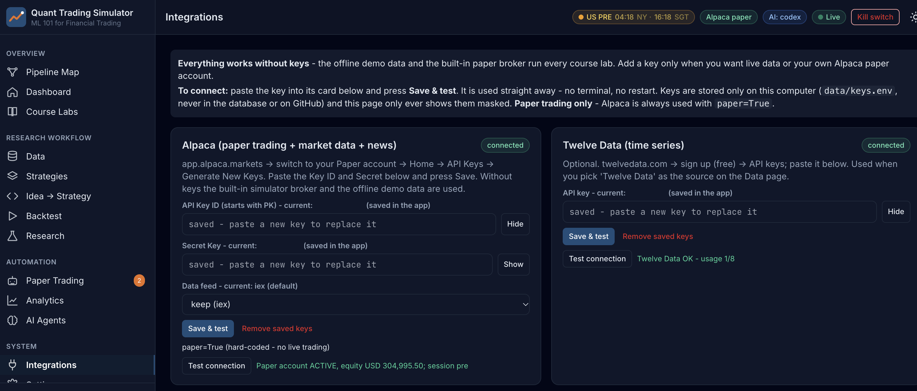
Figure: Lab 01 in the Trading Simulator.

Optional: Let AI Write the Code
This lab needs no coding. To see, run or customise the code behind it, click a link: the AI opens with the prompt filled in and writes the code for you. All prompts are also in labs_lowcode/Prompt_Library.html and .pdf.
Market sessions and your first data - run it in Google Colab
I am a beginner and do not write code. Write ONE complete Python script that runs as-is in a Google Colab notebook. Start with a !pip install line for any library Colab lacks, use pandas, numpy, matplotlib, scipy, scikit-learn, statsmodels and yfinance only, get daily prices from yfinance (auto_adjust=True unless I say otherwise), put a one-line comment above each section, print results as clear tables and charts, and after the code explain in 5 short bullet points how to read the output. Paper trading and education only. Task: show the current US market session (pre-market, regular, after-hours, overnight or closed) in New York time and the matching Singapore time using zoneinfo; then download SPY daily bars for 2018-01-01 to 2025-12-31 and print the first and last 5 rows and the number of bars.
Open in Claude | Open in ChatGPT | Open Google Colab

Debrief
A trading pipeline is only as safe as its configuration and its connection to the broker. One validated config file, paper-only enforcement, keys held in the environment and a pre-flight check that a scheduler can read from the exit code show how AI and algorithmic trading programs are connected to execution platforms in a controlled way (K5).

1.8 Lab 2: Data-Validation Stage: Cross-Check Pipeline Bars against TradingView
Maps to: A3, K5, K9 | Duration: 20 min | Slide 69

Scenario
Lion City Capital's traders watch DBS Group (SGX:D05) and Apple (NASDAQ:AAPL) on TradingView, while the pipeline trains and trades on data from an API. Before any model is built, the desk must prove that the pipeline's bars agree with what traders see on the chart - and understand why adjusted research prices differ from the unadjusted prices on the screen and on an order ticket.

Objective
Prove the app's prices are right: compare its bars with TradingView's Data Window and explain adjusted vs unadjusted prices.

Lab Steps - In the Trading Simulator
No coding is needed. Make sure the Trading Simulator is running (installed once - see the guide 'Download, Install and Start the Trading Simulator Software') and open http://localhost:8000. In the sidebar open Course Labs > Lab 02: the app shows the same steps with a Go button that opens each page pre-filled. Every step works offline on the bundled demo data and the built-in paper broker.
Step 1. Read TradingView's Data Window
In TradingView open NASDAQ:AAPL, daily timeframe, hover the bar of 2025-12-31 and read open/high/low/close in the Data Window (default settings: dividends NOT adjusted).
Open: http://localhost:8000/#/data?tab=reference&ref=AAPL (Data > Validate vs TradingView (AAPL))
Check: You have four numbers from TradingView.
Step 2. Compare with RAW and ADJUSTED bars
Type your TradingView values into the 'Your TradingView reading' row. The app shows the difference against RAW (split-adjusted only) and ADJUSTED (split + dividend) bars.
Open: http://localhost:8000/#/data?tab=reference&ref=AAPL (Data > Validate vs TradingView)
Check: Verdict 'PASS - TradingView matches RAW' (to within 0.1%).
Step 3. Repeat for SGX:D05 (DBS)
Select SGX:D05. DBS pays large dividends, so the adjustment factor is far from 1.
Open: http://localhost:8000/#/data?tab=reference&ref=D05.SI (Data > Validate vs TradingView (D05))
Check: You can explain why the ADJUSTED close is lower than the RAW close and why a model trained on adjusted prices must never be fed raw live prices.
Step 4. Inspect the chart
Open the AAPL chart and compare its shape with TradingView.
Open: http://localhost:8000/#/data?tab=chart&symbol=AAPL (Data > Chart AAPL)
Check: The candles match TradingView's daily chart (allowing for the adjustment).
Expected in the app: A PASS / FAIL validation for SGX:D05 and NASDAQ:AAPL on 2025-12-31, with the dividend-adjustment factor explained.
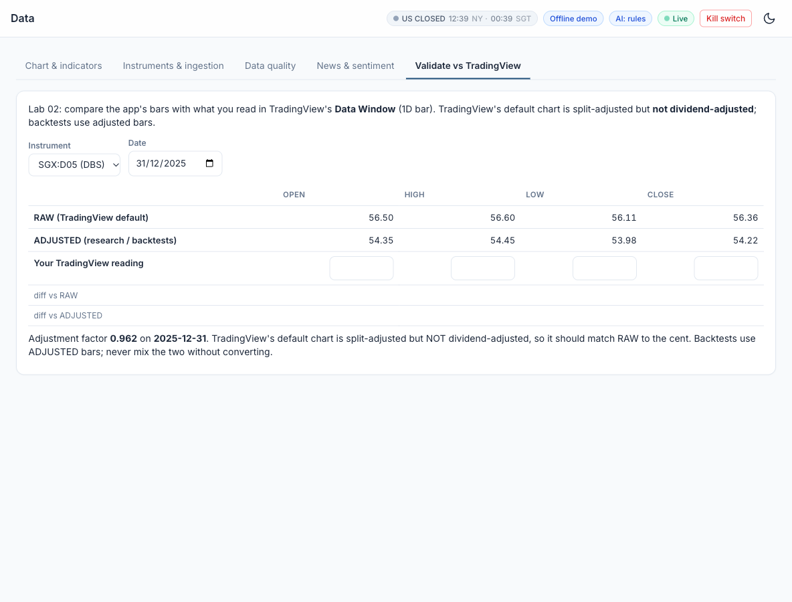
Figure: Lab 02 in the Trading Simulator.

Optional: Let AI Write the Code
This lab needs no coding. To see, run or customise the code behind it, click a link: the AI opens with the prompt filled in and writes the code for you. All prompts are also in labs_lowcode/Prompt_Library.html and .pdf.
Validate prices: adjusted versus unadjusted - run it in Google Colab
I am a beginner and do not write code. Write ONE complete Python script that runs as-is in a Google Colab notebook. Start with a !pip install line for any library Colab lacks, use pandas, numpy, matplotlib, scipy, scikit-learn, statsmodels and yfinance only, get daily prices from yfinance (auto_adjust=True unless I say otherwise), put a one-line comment above each section, print results as clear tables and charts, and after the code explain in 5 short bullet points how to read the output. Paper trading and education only. Task: download AAPL and D05.SI (DBS) daily bars for December 2025 twice - unadjusted (auto_adjust=False) and adjusted (auto_adjust=True). For 2025-12-31 print open, high, low and close from both, the ratio adjusted/unadjusted close (the dividend adjustment factor), and explain why TradingView's default chart matches the unadjusted prices.
Open in Claude | Open in ChatGPT | Open Google Colab

Debrief
Charting platforms are analytics tools (A3) and the API is the pipeline's data path (K5); a validation stage proves they agree before anything is automated. Knowing that adjusted and unadjusted prices are different forms of the same data (K9) prevents a classic error: training on adjusted history and then trading on raw quotes without converting.

1.9 Lab 3: Ingestion Stage: Multi-Timeframe Bars, Headlines and Data Quality
Maps to: A6, K9 | Duration: 20 min | Slide 71

Scenario
The pipeline's research and trading stages must all read the same clean data. The desk's data engineer automates ingestion: bars for the whole universe at four timeframes, a data-quality report that blocks bad files, a cache every later stage reads, and a first unstructured source - news headlines - that will later feed a sentiment agent.

Objective
Ingest bars from Alpaca / Twelve Data / yfinance (or the demo files), run the data-quality checks and score news sentiment.

Lab Steps - In the Trading Simulator
No coding is needed. Make sure the Trading Simulator is running (installed once - see the guide 'Download, Install and Start the Trading Simulator Software') and open http://localhost:8000. In the sidebar open Course Labs > Lab 03: the app shows the same steps with a Go button that opens each page pre-filled. Every step works offline on the bundled demo data and the built-in paper broker.
Step 1. Fetch data
Data > Instruments & ingestion: fetch AAPL with source 'auto' (Alpaca if keys, else the demo file). Online, try 'yfinance' or 'Twelve Data' too (Twelve Data needs TWELVEDATA_API_KEY).
Open: http://localhost:8000/#/data?tab=instruments&symbol=AAPL (Data > Fetch AAPL)
Check: A toast reports the number of bars, the source and the quality status.
Step 2. Read the data-quality report
Open Data quality for SPY. Look at missing values, duplicate timestamps, gaps over 4 days and big moves (possible unadjusted splits).
Open: http://localhost:8000/#/data?tab=quality&symbol=SPY (Data > Quality SPY)
Check: Status OK or CHECK; the big-move dates include March 2020.
Step 3. Switch timeframes
On the chart, switch SPY between 1Day, 1Week, 1Month and 1Hour.
Open: http://localhost:8000/#/data?tab=chart&symbol=SPY&timeframe=1Week (Data > Chart SPY weekly)
Check: Weekly and monthly bars are resampled from daily bars; hourly bars are US/Eastern.
Step 4. Headlines and sentiment
Data > News & sentiment for NVDA: press 'Fetch & score headlines'. Online with NEWSAPI_KEY it calls NewsAPI.org; otherwise Alpaca News or the synthetic sample headlines. Try the sentiment box with your own sentence.
Open: http://localhost:8000/#/data?tab=news&symbol=NVDA (Data > News NVDA)
Check: Each headline has a VADER score between -1 and +1; the daily sentiment chart appears.
Expected in the app: A cached universe, a data-quality report and scored headlines with daily sentiment.
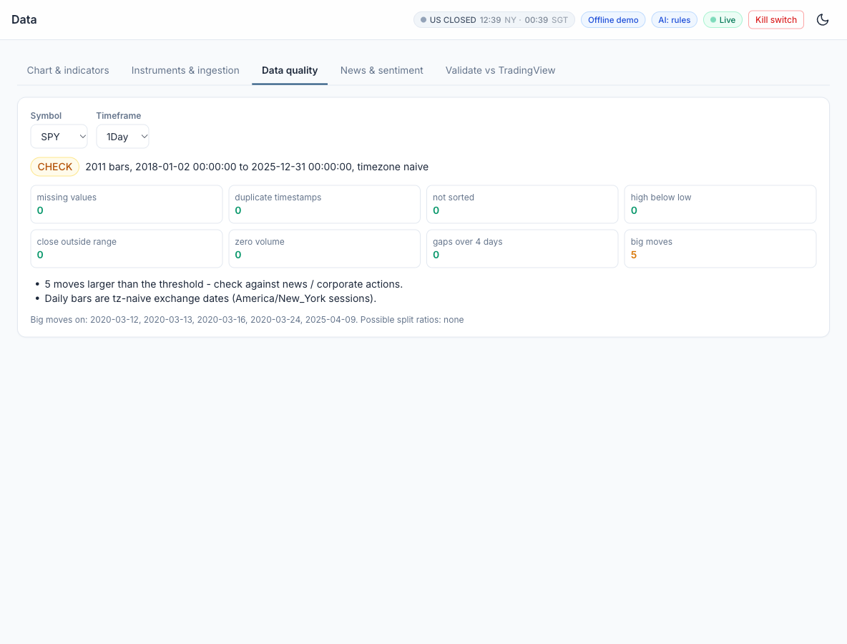
Figure: Lab 03 in the Trading Simulator.

Optional: Let AI Write the Code
This lab needs no coding. To see, run or customise the code behind it, click a link: the AI opens with the prompt filled in and writes the code for you. All prompts are also in labs_lowcode/Prompt_Library.html and .pdf.
Multi-timeframe data, a data-quality report and headline sentiment - run it in Google Colab
I am a beginner and do not write code. Write ONE complete Python script that runs as-is in a Google Colab notebook. Start with a !pip install line for any library Colab lacks, use pandas, numpy, matplotlib, scipy, scikit-learn, statsmodels and yfinance only, get daily prices from yfinance (auto_adjust=True unless I say otherwise), put a one-line comment above each section, print results as clear tables and charts, and after the code explain in 5 short bullet points how to read the output. Paper trading and education only. Task: download SPY daily bars for 2018-2025 and hourly bars for the last 60 days; resample the daily bars to weekly and monthly; print a data-quality report (missing values, duplicate timestamps, gaps longer than 4 calendar days, daily moves above 15% that may be unadjusted splits). Then get recent NVDA news headlines with yfinance (Ticker('NVDA').news), score each headline with VADER sentiment (vaderSentiment) and print the average sentiment per day.
Open in Claude | Open in ChatGPT | Open Google Colab

Debrief
Ingestion is the first automated stage: it fixes one version of the truth for every later stage and blocks bad data before a model can learn from it. Bars, quotes, trades, news and alternative data are different forms of financial data (K9) with different volume, velocity and variety - which is what turns a trading data set into a big-data application (A6).

1.10 Lab 4: Hypothesis Stage: from a Written Card to an Automated Statistical Test
Maps to: A1, A6, K1 | Duration: 15 min | Slide 74

Scenario
A portfolio manager believes SPY tends to bounce after several losing days. The desk's rule is that no idea enters the signal and backtest stages until it is written as a hypothesis card - before anyone looks at results - and passes an automated statistical test with a decision rule that includes trading costs.

Objective
Write H0 and H1 before looking at results and test them with a Welch t-test and a bootstrap CI.

Lab Steps - In the Trading Simulator
No coding is needed. Make sure the Trading Simulator is running (installed once - see the guide 'Download, Install and Start the Trading Simulator Software') and open http://localhost:8000. In the sidebar open Course Labs > Lab 04: the app shows the same steps with a Go button that opens each page pre-filled. Every step works offline on the bundled demo data and the built-in paper broker.
Step 1. Write the hypothesis card
Research > Hypothesis test. Keep signal 'losing streak' n = 3, horizon 1 day, alpha 0.05, min edge 3 bps. Read the H1 and H0 text.
Open: http://localhost:8000/#/research/hypothesis (Research > Hypothesis (SPY, losing streak 3))
Check: H0 and H1 are written before you press Run.
Step 2. Run the test
Press 'Run the test'.
Open: http://localhost:8000/#/research/hypothesis
Check: You can read the signal-day mean, the other-day mean, Welch t and p, and the 95% bootstrap CI.
Step 3. Robustness and multiple testing
Read the robustness grid (other streak lengths and QQQ) and the Bonferroni alpha.
Open: http://localhost:8000/#/research/hypothesis
Check: You can explain why trying many variants inflates false positives.
Expected in the app: A decision (SUPPORTED / NOT SUPPORTED) with p-value, edge in bps and a robustness grid.
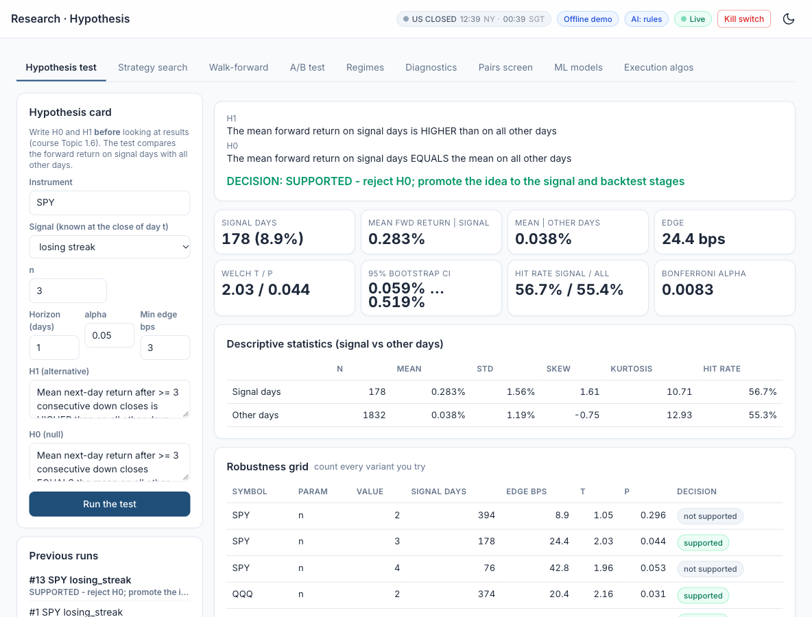
Figure: Lab 04 in the Trading Simulator.

Optional: Let AI Write the Code
This lab needs no coding. To see, run or customise the code behind it, click a link: the AI opens with the prompt filled in and writes the code for you. All prompts are also in labs_lowcode/Prompt_Library.html and .pdf.
Test a trading hypothesis - run it in Google Colab
I am a beginner and do not write code. Write ONE complete Python script that runs as-is in a Google Colab notebook. Start with a !pip install line for any library Colab lacks, use pandas, numpy, matplotlib, scipy, scikit-learn, statsmodels and yfinance only, get daily prices from yfinance (auto_adjust=True unless I say otherwise), put a one-line comment above each section, print results as clear tables and charts, and after the code explain in 5 short bullet points how to read the output. Paper trading and education only. Task: test the hypothesis 'after 3 consecutive down days, SPY's next-day return is higher than on other days' on 2018-2025. Write H0 and H1 first, then compare next-day returns after a 3-day losing streak with all other days using a Welch t-test and a bootstrap 95% confidence interval of the difference, and state whether the edge is above 3 basis points at alpha 0.05.
Open in Claude | Open in ChatGPT | Open Google Colab

Debrief
Writing the hypothesis before testing, with a null, a cost-aware decision rule and a count of the variants tried, is the foundation of data-driven trading (A1). AI and machine-learning methods (K1) only add value when they test well-posed questions, and larger data sets (A6) are how a promising effect in one ETF is confirmed or rejected.

1.11 Topic Summary
- A1 - Develop hypotheses for implementing data analytics and computational modelling activities
- A6 - Identify possible big data applications
- K1 - Data analytics and modelling business use cases
- K9 - Forms of data within financial services
Assessed by: Practical Performance Task 1 | Written Assessment Q1, Q9

Topic 2: Technical Indicators, Trading Strategies and Metrics with TradingView and Alpaca
Day | Abilities | Knowledge | Labs | Slides
Day 1 | A2, A3 | K3, K5, K7 | 5 - 9 | 77 - 142

Learning Outcome
Identify appropriate statistical algorithms and data models to test trading hypotheses, and use appropriate analytics platforms, analytical tools and statistical methods given specific analytics and reporting requirements.

2.1 Technical Indicators: Trend, Momentum, Volatility and Volume
Maps to: K3 | Slides 78-89
- Simple Moving Average (SMA): the average close over n bars. Exponential Moving Average (EMA): a weighted average with smoothing factor 2/(n+1), reacting faster to recent prices. Both are trend indicators.
- Relative Strength Index (RSI): 100 - 100/(1 + RS), where RS is the ratio of average gains to average losses over 14 bars (Wilder smoothing). Readings above 70 are conventionally 'overbought', below 30 'oversold'.
- The number in brackets is the look-back period. RSI(2) uses the last 2 bars and swings to extremes after a 1-2 day move (SPY RSI(2) was below 10 on 9.6% of days in 2018-2025); RSI(14) moves slowly (below 30 on 1.7% of days). On 10 October 2025 SPY fell 2.7%: RSI(2) dropped to 5.8 while RSI(14) read a neutral 42.5. SMA(50), EMA(20), Bollinger(20, 2) and ATR(14) follow the same convention.
- MACD: the 12-period EMA minus the 26-period EMA, with a 9-period EMA 'signal line'. A MACD cross above its signal line is a momentum buy signal.
- Bollinger Bands: a 20-period SMA plus and minus 2 standard deviations. The bands widen in volatile markets and narrow in quiet ones; closes outside the bands feed both mean-reversion and breakout strategies.
- Average True Range (ATR): the average of the true range (the largest of high-low, |high-previous close| and |low-previous close|). Used to size positions and to set volatility-based stops.
- Volume indicators: Volume-Weighted Average Price (VWAP), the benchmark price for execution quality, and On-Balance Volume (OBV), which accumulates volume on up days and subtracts it on down days.
- Every indicator is a statistical transformation of past prices; none predicts the future on its own. Indicators lag, and many are highly correlated with each other - adding more rarely adds information.

2.2 Classification of Algorithmic Trading and Quant Algorithms
Maps to: K3, A2 | Slides 90, 96-118
- By purpose, trading algorithms fall into seven families: execution, market making, arbitrage, directional (alpha), statistical arbitrage and pairs (hedged), factor and portfolio construction, and hedging and risk control.
- Execution algorithms work a large order at low cost and market impact: TWAP slices evenly over time; VWAP follows the day's volume curve; percentage-of-volume (POV) trades a fixed share of live volume; implementation shortfall minimises cost versus the arrival price; iceberg orders show only part of the size; smart order routing chooses the venue.
- The SEC's 2010 Concept Release on Equity Market Structure groups high-frequency strategies into four types: passive market making (resting bids and offers that provide liquidity), arbitrage (pricing inefficiencies between related products, such as an ETF and its basket), structural (exploiting structural vulnerabilities, such as stale quotes), and directional (short-term positions anticipating an intraday move).
- Directional (alpha) strategies: trend following (moving-average crossover), momentum (hold recent winners), breakout (new n-day high), mean reversion (Bollinger Bands, RSI(2)) and event or news-driven trading.
- Long and short positions: a long buys first and profits when the price rises (the most it can lose is the amount paid); a short borrows shares and sells them first, buys them back later and profits when the price falls (losses are unlimited, and it needs a margin account - Alpaca requires at least $2,000 of equity). Selling shares you own only closes a long.
- Mean reversion buys when the price is stretched below its normal range (a close below the lower Bollinger Band, RSI(14) below 30, RSI(2) below 10, or a losing streak) and exits at the average. Compared with trend following it has a high win rate but rare large losses when a dip becomes a crash, so it needs a stop-loss or time limit, a trend filter (price above its 200-day SMA) and stable markets.
- Statistical arbitrage and pairs trading are hedged: long one asset and short a related one, so most market moves cancel and the profit comes from the spread reverting (Topic 3.6).
- By holding period: high-frequency (microseconds to seconds), intraday (minutes to hours), swing (days to weeks) and position (weeks to months). By model: rule-based, statistical, machine learning, reinforcement learning, and LLM / agentic.
- Matching the algorithm to the hypothesis - and to the right statistical test - is the A2 skill: a difference in means needs a t-test or bootstrap, a direction forecast needs a classifier, a regime question needs clustering, and a spread needs a cointegration test.

2.3 Analytics Platforms and Tools: TradingView versus Alpaca, and Python
Maps to: K5, A3 | Slides 119-121, 123
- TradingView is a charting and strategy-design platform: global markets including SGX, built-in indicators, the Pine Script language, the Strategy Tester for backtests, alerts and webhooks (webhooks need a paid plan), and a built-in Paper Trading account opened from the chart's Trading Panel with your own starting capital and commission.
- Alpaca is an API-first US broker: commission-free US stocks and ETFs, plus options and crypto; a free paper-trading account that mirrors the live API; the Trading API (account, orders, positions, clock) and the Market Data API (bars, quotes, trades, news; the free plan uses the IEX feed); and the official alpaca-py Python SDK.
- The key difference: TradingView is where a strategy is designed, visualised and first tested; Alpaca is where a program places and manages orders automatically. TradingView has no machine learning and a simplified backtester; Alpaca has no charting or strategy tester - in this course the Trading Simulator provides them, so no coding is needed.
- Trading hours for automation from Singapore: Alpaca offers 24/5 trading of US stocks (8 pm ET Sunday to 8 pm ET Friday) - outside the regular session only limit orders with extended hours enabled are accepted, at lower liquidity.
- They work together: a TradingView alert can send a webhook to your server, which places the order on Alpaca; and an Alpaca account can be connected in TradingView's trading panel to trade from the chart.
- Python - pandas, NumPy, scikit-learn, XGBoost, SciPy, matplotlib and alpaca-py - joins them: data handling, machine learning, statistical tests, cost-aware backtests and the automation loop.
- API keys are credentials: paste them only into a protected settings store such as the simulator's Integrations page - never into code, chats or files you share - and use separate paper and live keys.

2.4 Coding Languages for Algorithms and Signals, and Order Placement
Maps to: K7 | Slides 91-92, 122
- Pine Script v6 (TradingView's language): every script starts with //@version=6 and declares indicator() or strategy(). Built-in functions such as ta.ema, ta.rsi, ta.crossover and strategy.entry express a signal in a few lines.
- Python: the dominant language for quantitative research - readable, with mature data and machine learning libraries. A signal is typically a pandas Series of +1 / 0 / -1 aligned to the bar index.
- Other languages: C++ and Java for low-latency execution systems, R for statistics, SQL for data stores, and MQL for MetaTrader. LLMs can now draft code in all of them, but the developer remains accountable for testing it.
- Order types on Alpaca: market (fill now at the best price), limit (fill only at the limit price or better), stop (becomes a market order when the stop is hit), stop-limit, and trailing stop.
- Time in force: day, gtc (good till cancelled), opg (market on open), cls (market on close), ioc (immediate or cancel) and fok (fill or kill). Order classes: simple, bracket (entry with take-profit and stop-loss), OCO and OTO.
- The order lifecycle: new, accepted, partially filled, filled, cancelled, expired or rejected. A program must read the order status rather than assume a fill.
- Paper trading simulates fills against real market quotes but cannot model your own market impact or queue position - a limitation to remember when comparing paper and live results.

2.5 Performance and Risk Metric Definitions
Maps to: K3, A3 | Slides 93-95
- Return metrics: total return; compound annual growth rate CAGR = (ending value / starting value)^(1/years) - 1; and the benchmark-relative excess return.
- Risk metrics: annualised volatility = standard deviation of daily returns x sqrt(252); maximum drawdown = the largest peak-to-trough fall in the equity curve.
- Risk-adjusted metrics: Sharpe ratio = (mean return - risk-free rate) / standard deviation, annualised by sqrt(252); Sortino ratio uses only downside deviation; Calmar ratio = CAGR / |maximum drawdown|.
- Trade metrics: number of trades, win rate (% of profitable trades), profit factor (gross profit / gross loss), average win and loss, expectancy = win rate x average win - loss rate x average loss.
- Activity metrics: exposure (% of time in the market) and turnover (traded value / average capital). High turnover multiplies the drag of trading costs.
- Market-relative metrics: beta (sensitivity to the benchmark) and alpha (return not explained by beta), estimated by regressing strategy returns on benchmark returns.
- No single metric is enough: report return, risk and cost together, and always against a buy-and-hold benchmark for the same period.

Reference: Classification of Trading Algorithms
Family | Purpose | Examples
Execution algorithms | Work a large order at low cost and market impact | VWAP, TWAP, POV, implementation shortfall, iceberg, smart order routing
Market making | Quote bids and offers, earn the spread, manage inventory | Passive market making with resting limit orders
Arbitrage | Capture mispricing between related products or markets | ETF versus its basket, index futures versus stocks
Directional / alpha | Take a view on the direction of price | Trend following, momentum, breakout, mean reversion, news
Statistical arbitrage and pairs | Hedged: long one asset, short a related one; trade the spread | Pairs trading, cointegration, market-neutral baskets
Factor and portfolio | Build and rebalance portfolios from return drivers and risk | Value, momentum, size factors; mean-variance optimisation
Hedging and risk | Offset unwanted exposure and enforce limits | Delta hedging, beta hedging, pairs hedge, kill switch

SEC HFT strategy type (2010) | Description
Passive market making | Submits non-marketable resting bids and offers that provide liquidity at specified prices
Arbitrage | Captures pricing inefficiencies between related products or markets, e.g. an ETF and its basket
Structural | Exploits structural vulnerabilities in the market or its participants, e.g. stale quotes via faster data
Directional | Takes a short-term position anticipating an intraday price move in a particular direction

Holding period | Horizon | Typical algorithms
High-frequency | Microseconds to seconds | Market making, ETF and latency arbitrage
Intraday | Minutes to hours | VWAP / TWAP execution, intraday momentum
Swing | Days to weeks | Mean reversion, pairs trading
Position | Weeks to months | Trend following, factor portfolios

Model type | Description
Rule-based | Fixed if-then rules on indicators, e.g. a moving-average crossover
Statistical | Econometric tests and models: cointegration, regression, t-tests
Machine learning | Models learn from labelled data: logistic regression, random forest, XGBoost
Reinforcement learning | Learns a policy from rewards, e.g. order-execution research
LLM and agentic | Language models read text and agents plan, code and act under limits

Strategy | Idea | Example rule
Trend following | Rides sustained moves in the direction of the trend; cuts losers quickly | Buy when the 50-day moving average crosses above the 200-day
Mean reversion | Bets that prices stretched far from their average will snap back | Buy when price closes below the lower Bollinger Band (20-day, 2 std dev)
Momentum and breakout | Buys recent winners or prices breaking out of a range, expecting them to keep going | Buy on a close above the 20-day high (Donchian channel breakout)
Statistical / pairs arbitrage | Trades the spread between two related assets when it drifts from its normal level | Short the rich leg, buy the cheap leg when the spread z-score exceeds 2
Execution algorithms | Split a large order to minimise cost and market impact: VWAP, TWAP, POV, implementation shortfall | POV: trade 10% of market volume until the order is filled
Market making | Continuously quotes buy and sell prices, earning the spread while managing inventory | Quote bid and ask around mid-price; skew quotes as inventory builds
Index rebalancing / event-driven | Trades predictable flows around index changes, earnings and corporate events | Position ahead of announced index inclusions on the rebalance date
Sentiment / NLP | Turns news, filings and social media text into trading signals using NLP or LLMs | Go long when the average FinBERT headline sentiment is strongly positive

Comparison: TradingView versus Alpaca
 | TradingView | Alpaca
What it is | Charting and strategy-design platform | API-first US broker for automated trading
Markets | Global charts incl. SGX, US, FX, crypto | US stocks and ETFs, options, crypto
Strategy design | Pine Script v6 indicators and strategies | Through the API - in this course the Trading Simulator does it for you
Backtesting | Strategy Tester (simplified costs and fills) | None built in - the Trading Simulator runs the cost-aware backtest
Paper trading | Built-in Paper Trading account from the chart | Paper account mirroring the live API
Automation | Alerts; webhooks on paid plans | Trading API: orders, positions, clock; 24/5 trading
Data | Charts and Data Window | Market Data API: bars, quotes, trades, news (IEX free)
Machine learning | Not supported | Through code - in this course the Trading Simulator has built-in logistic regression, random forest and XGBoost
Best used for | Designing, visualising and first-testing a rule | Executing and forward-testing it automatically

Strategy Families: the Idea, When It Works, When It Will Not
Family | The idea | When it works | When it will not work
Trend Following  (Lab 7: EMA 20/50 on SPY) | Prices that have started to move tend to keep moving. Buy when a fast average is above a slow one (or price is above its 200-day average); exit when the trend turns. | Long, persistent moves - bull or bear markets, macro trends lasting months. A few big winners pay for many small losses. | Sideways, choppy markets: price crosses the averages again and again (whipsaws), every crossing costs money, and signals arrive late at turns.
Mean Reversion  (Lab 7: Bollinger 20 / k = 2.0 and 1.5 on KO) | Like a rubber band, short-term over-reactions snap back. Buy when price is stretched below its normal range (lower Bollinger Band, RSI(2) below 10) and sell when it returns to the average. | Range-bound, liquid markets and stable large stocks, where extremes tend to snap back within days. | A real trend or a news shock: 'cheap' keeps getting cheaper. A high win rate hides rare large losses - as in March 2020.
Momentum  (Lab 7: 126-day time-series momentum on QQQ) | Winners keep winning for months. Buy what has risen over the last 6-12 months (time-series) or what has risen most among its peers (cross-sectional). | Persistent market or sector themes, spread across many assets and rebalanced regularly. | Sharp reversals - 'momentum crashes' such as the 2009 rebound, when last year's losers rally hardest - and choppy markets that churn the portfolio.
Breakout  (Lab 7: Donchian 20 / 10 on QQQ) | A close above the recent range (for example the 20-day high, the Donchian channel) signals the start of a new move: buy the breakout, exit on a shorter low. | Volatility expanding after a quiet period and a new trend starting - indices and commodities in strong regimes. | False breakouts in a range: price pokes above the high and falls back. A low win rate, so exits must be disciplined and costs kept low.

Key Metrics Defined

Sharpe Ratio
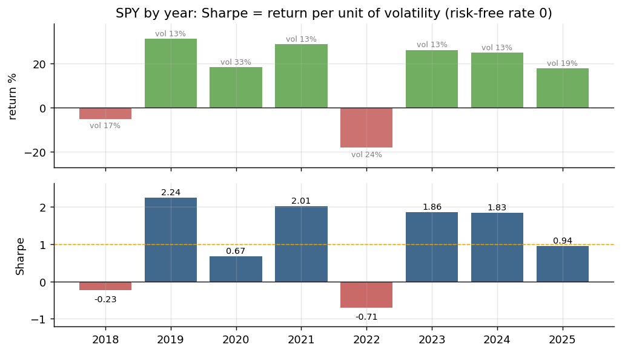
Figure: Metric: Sharpe Ratio - SPY 2018-2025.
Definition | Return earned per unit of risk taken: the average excess return divided by its volatility, annualised.
Formula | Sharpe = (mean daily return - daily risk-free rate) / std of daily returns x sqrt(252).
How to read it | Below 0.5 weak, about 1 good, above 2 rare for a daily strategy - check for errors. Always compare with buy-and-hold over the same period.
Insight | Volatility counts as risk whether it is up or down, and a short or costless backtest inflates it - 2020 returned 18% but at 33% volatility, a Sharpe of only 0.67.

Maximum Drawdown
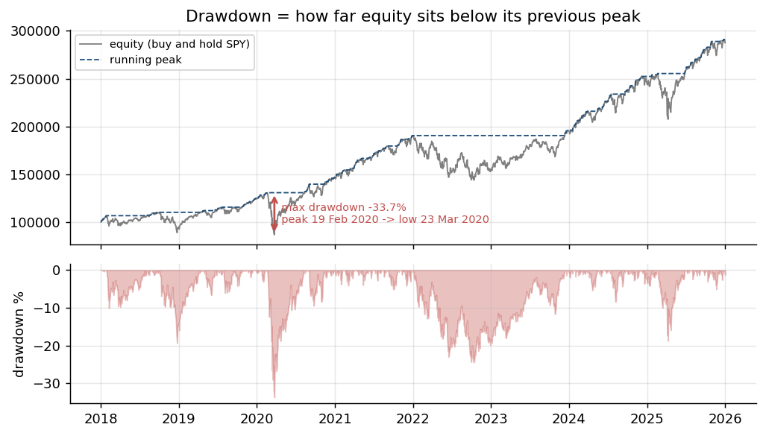
Figure: Metric: Maximum Drawdown - SPY 2018-2025.
Definition | The largest fall of the equity curve from a previous peak to a later low - the worst loss an investor would have lived through before a new high.
Formula | Drawdown(t) = equity(t) / running peak(t) - 1. Max drawdown = the most negative drawdown over the period.
How to read it | A -20% drawdown needs +25% to recover; -50% needs +100%. Compare with buy-and-hold and with the loss the investor can tolerate.
Insight | One path-dependent number: it does not say how long recovery took, and a short backtest may simply miss a bad period. SPY 2018-2025: -33.7% in five weeks of 2020.

Indicator by Indicator

Moving Averages (SMA and EMA)
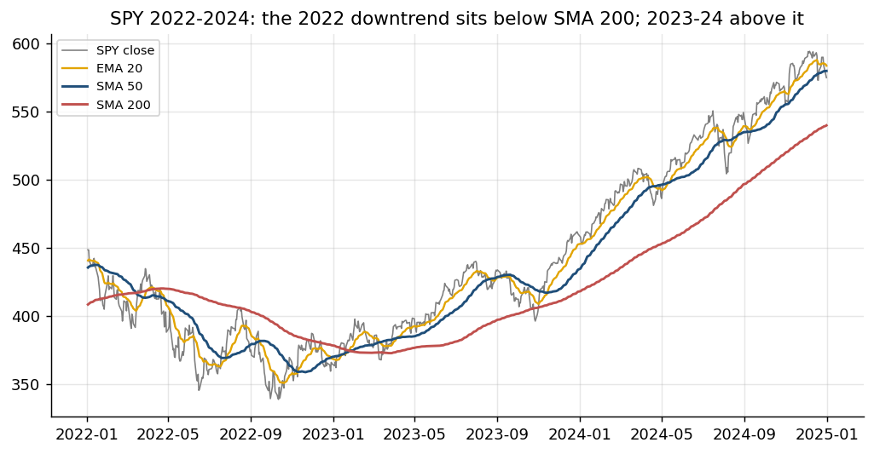
Figure: Indicator: Moving Averages (SMA and EMA) - on real market data.
Definition | The average closing price over the last n bars - a smoothed line that shows the trend. The EMA weights recent bars more, so it turns sooner.
Formula | SMA(n) = (C1 + C2 + ... + Cn) / n. EMA(t) = a x C(t) + (1 - a) x EMA(t-1), with a = 2 / (n + 1).
How to read it | Price above a rising average = uptrend. The 50 / 200-day pair is the classic trend filter; EMA 20 tracks the short-term trend.
Insight | Every average lags: the longer n, the smoother - and the later each signal. In sideways markets price whipsaws across it.

MACD (Moving Average Convergence Divergence)
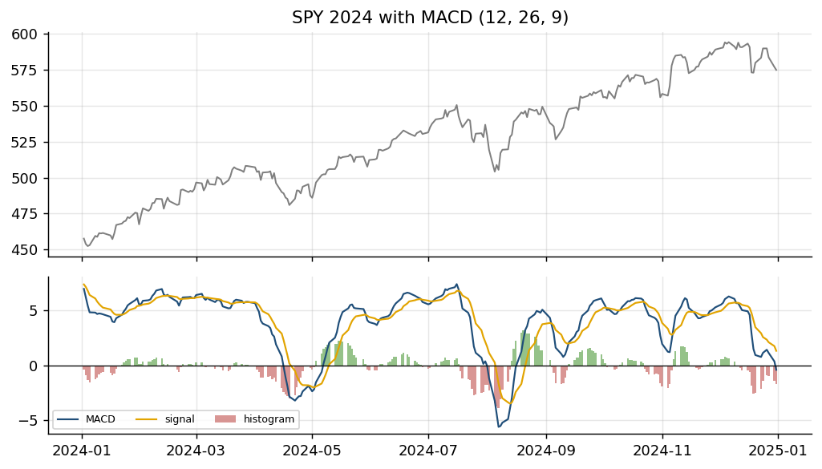
Figure: Indicator: MACD (Moving Average Convergence Divergence) - on real market data.
Definition | A momentum-of-trend gauge: the gap between a fast and a slow EMA, with a signal line and a histogram that show whether momentum is growing.
Formula | MACD = EMA12(C) - EMA26(C). Signal = EMA9(MACD). Histogram = MACD - Signal.
How to read it | MACD crossing above its signal line = momentum turning up; MACD above zero = the 12-day trend is above the 26-day trend.
Insight | A shrinking histogram warns that a move is losing strength before price turns - but it is built from EMAs, so it lags and whipsaws in ranges.

RSI (Relative Strength Index)
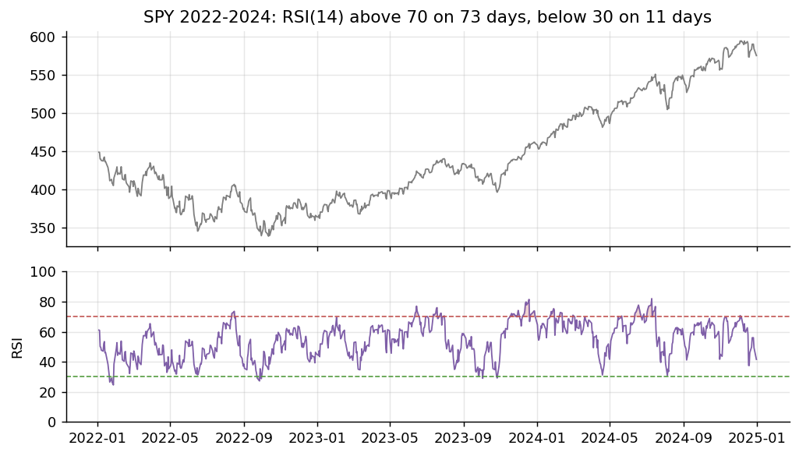
Figure: Indicator: RSI (Relative Strength Index) - on real market data.
Definition | An oscillator from 0 to 100 that compares the size of recent gains with recent losses - how stretched the latest move is.
Formula | RS = average gain / average loss over n bars (Wilder smoothing, n = 14). RSI = 100 - 100 / (1 + RS).
How to read it | Above 70 = overbought, below 30 = oversold. Short look-backs such as RSI(2) are used for mean-reversion entries.
Insight | In a strong trend RSI can stay above 70 for weeks: overbought is not a sell signal by itself. Test the thresholds - they are conventions.

Donchian Channel
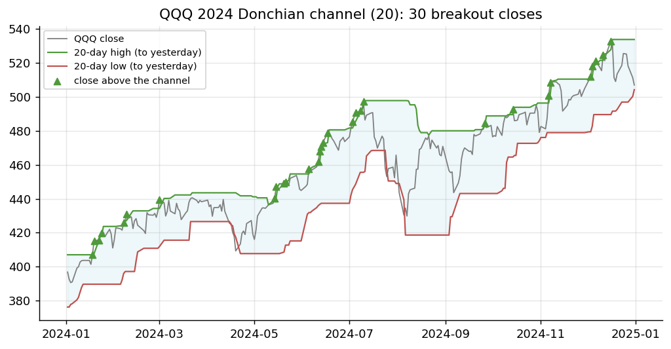
Figure: Indicator: Donchian Channel - on real market data.
Definition | A channel drawn through the highest high and the lowest low of the last n bars - the levels a breakout must clear.
Formula | Upper(n) = max(High, last n bars). Lower(n) = min(Low, last n bars). Classic n = 20 (the Turtle traders used 20 and 55).
How to read it | A close above the prior upper band = upside breakout; exit on a break of a shorter (e.g. 10-day) low.
Insight | Breakout systems win rarely but big. Compare today's close with the channel up to YESTERDAY - including today's high is look-ahead.

Bollinger Bands
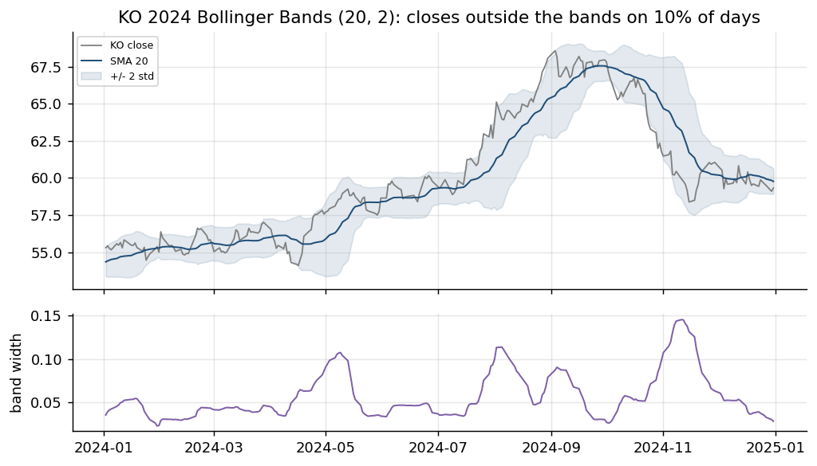
Figure: Indicator: Bollinger Bands - on real market data.
Definition | A moving average with bands set a number of standard deviations above and below it, so the bands widen and narrow with volatility.
Formula | Middle = SMA20(C). Upper / Lower = Middle +/- 2 x StDev20(C). %B = (C - Lower) / (Upper - Lower).
How to read it | Mean reversion: buy a close below the lower band, exit at the middle. A 'squeeze' (narrow bands) often comes before a big move.
Insight | Returns are not normal: closes fall outside the bands far more often than the 5% a normal curve implies. In a trend, 'oversold' keeps falling.

ATR (Average True Range)
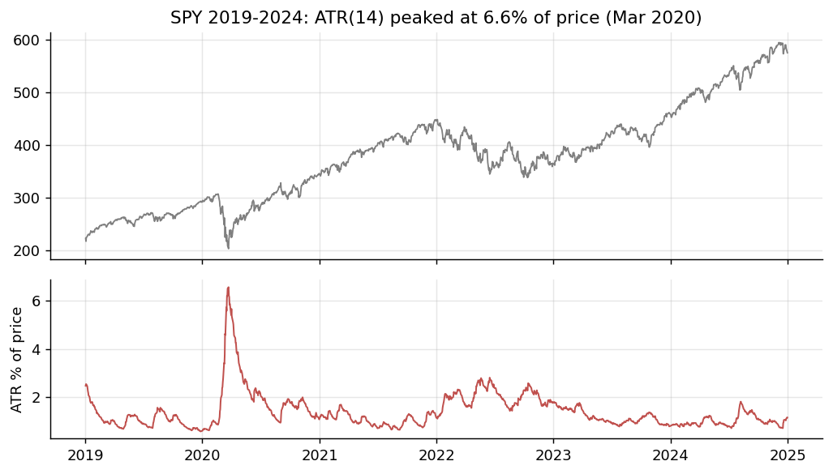
Figure: Indicator: ATR (Average True Range) - on real market data.
Definition | The average size of a day's price range, including overnight gaps - a volatility ruler in price units.
Formula | TR = max(H - L, |H - previous C|, |L - previous C|). ATR = average of TR over n bars (Wilder smoothing, n = 14).
How to read it | Set stops at 2-3 x ATR and size positions as risk budget / (k x ATR), so every trade carries similar risk.
Insight | ATR says how far, not which way. Compare instruments with ATR as a % of price, since ATR rises with the price level.

VWAP (Volume-Weighted Average Price)
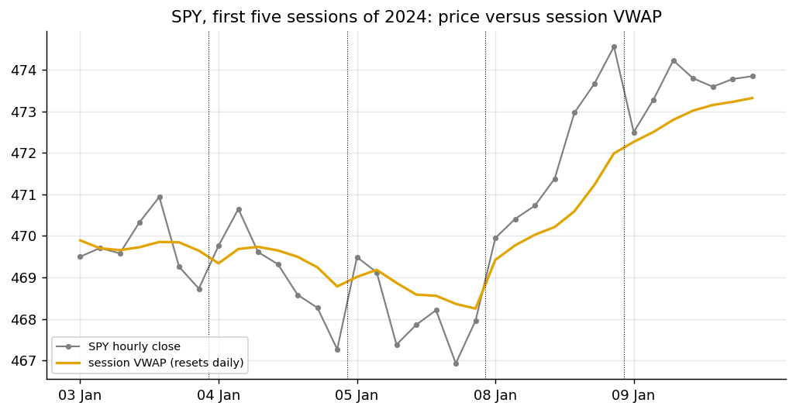
Figure: Indicator: VWAP (Volume-Weighted Average Price) - on real market data.
Definition | The average price paid during the session, weighted by the volume traded at each price. It resets at every session open.
Formula | Typical price P = (H + L + C) / 3. VWAP = sum(P x Volume) / sum(Volume), summed from the session open.
How to read it | The execution benchmark: buying below VWAP is a good fill. Intraday traders read price above VWAP as buyers in control.
Insight | Institutions judge execution algorithms against VWAP. It needs intraday data - on daily bars it is only an approximation.

OBV (On-Balance Volume)
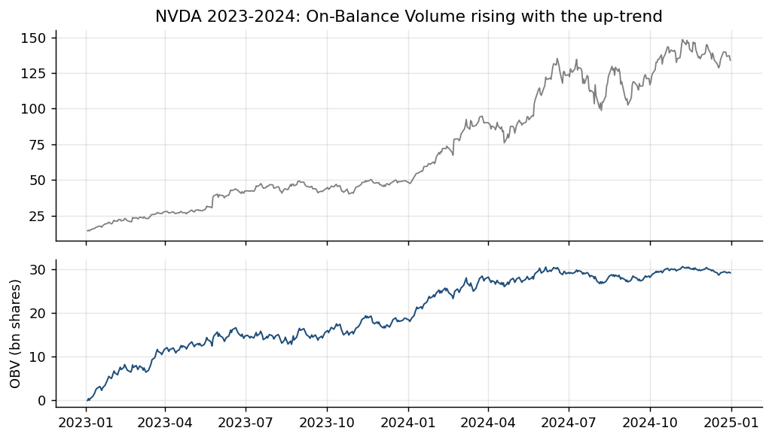
Figure: Indicator: OBV (On-Balance Volume) - on real market data.
Definition | A running total of volume that adds a day's volume when the close rises and subtracts it when the close falls.
Formula | OBV(t) = OBV(t-1) + Volume(t) if C(t) > C(t-1); - Volume(t) if C(t) < C(t-1); unchanged if equal.
How to read it | A rising OBV confirms an up-trend; OBV making new highs before price is read as accumulation. Read the slope, not the level.
Insight | Volume shows the conviction behind a move. An OBV that falls while price rises (divergence) is a warning, not a signal on its own.

How It Works: Moving-Average Crossover (Trend Following)
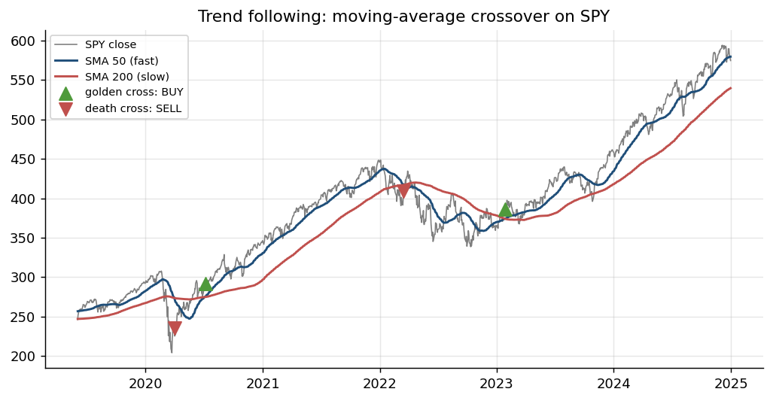
Figure: Algorithm: Moving-Average Crossover (Trend Following) - illustrated on real market data.
How it works | Two moving averages of the close: a fast one reacts quickly, a slow one shows the trend.
Rule | Fast crosses ABOVE slow (golden cross): buy. Fast crosses BELOW (death cross): sell or go flat.
Works best when | Markets trend for months - it rides the move and cuts losers when the trend turns.
Watch out for | Whipsaws in sideways markets; signals lag; trade on the next bar, not the crossing bar.

How It Works: Bollinger Band Mean Reversion
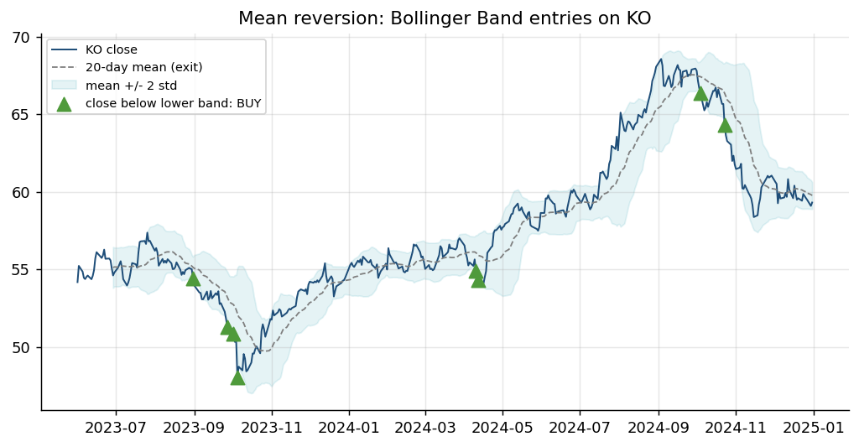
Figure: Algorithm: Bollinger Band Mean Reversion - illustrated on real market data.
How it works | Bands = 20-day mean +/- 2 standard deviations. A close outside the band is 'stretched'.
Rule | Close below the lower band: buy. Exit when the price returns to the middle band (the mean).
Works best when | Range-bound markets where over-reactions snap back, e.g. a defensive stock such as KO.
Watch out for | Strong trends keep 'stretching' - add a stop-loss or a trend filter; many small wins, rare big losses.

How It Works: RSI and MACD Momentum Oscillators
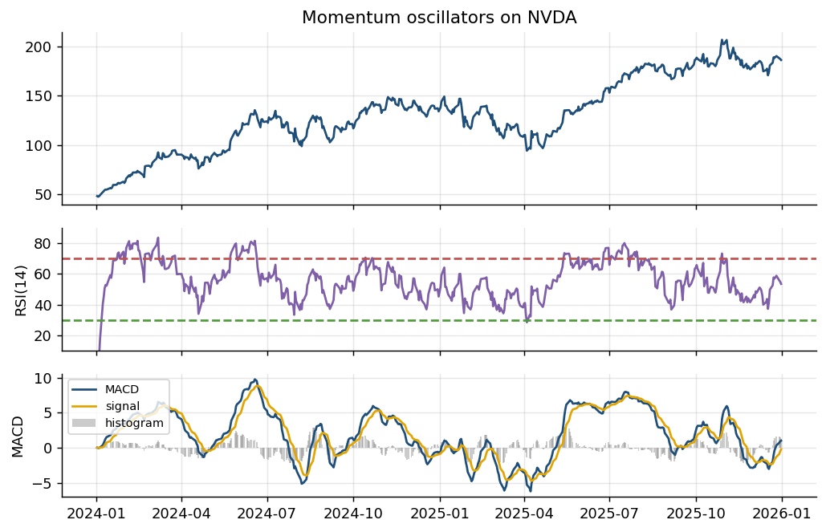
Figure: Algorithm: RSI and MACD Momentum Oscillators - illustrated on real market data.
How it works | RSI = 100 - 100/(1+RS), RS = average gain / average loss over 14 bars. MACD = EMA12 - EMA26.
Rule | RSI < 30 oversold / > 70 overbought. MACD crossing above its 9-EMA signal line = momentum buy.
Works best when | As filters or confirmation for a trend or mean-reversion rule, not as stand-alone predictors.
Watch out for | Oscillators can stay overbought in strong trends; RSI and MACD are highly correlated with price.

How It Works: Cross-Sectional Momentum
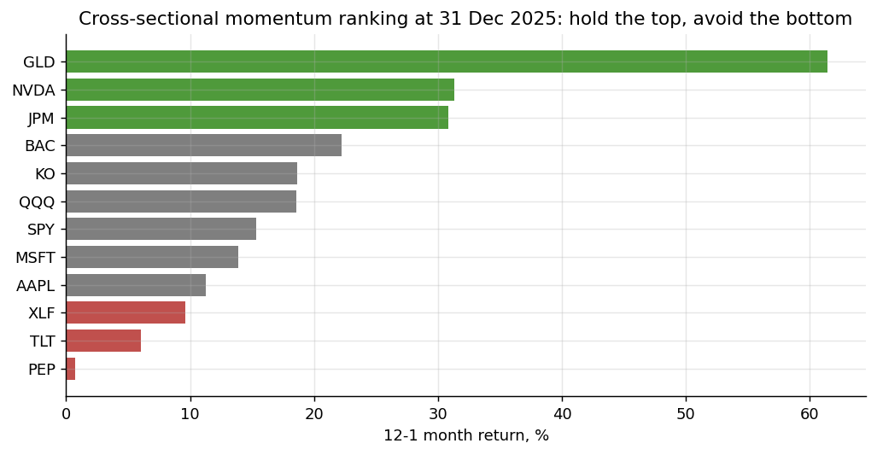
Figure: Algorithm: Cross-Sectional Momentum - illustrated on real market data.
How it works | Rank a universe by past return (e.g. 12 months, skipping the last month) each month.
Rule | Hold the top-ranked assets, avoid or short the bottom-ranked; rebalance monthly.
Works best when | Information spreads slowly and winners keep winning for several months.
Watch out for | Sharp 'momentum crashes' when markets reverse; turnover costs at every rebalance.

How It Works: Donchian Channel Breakout
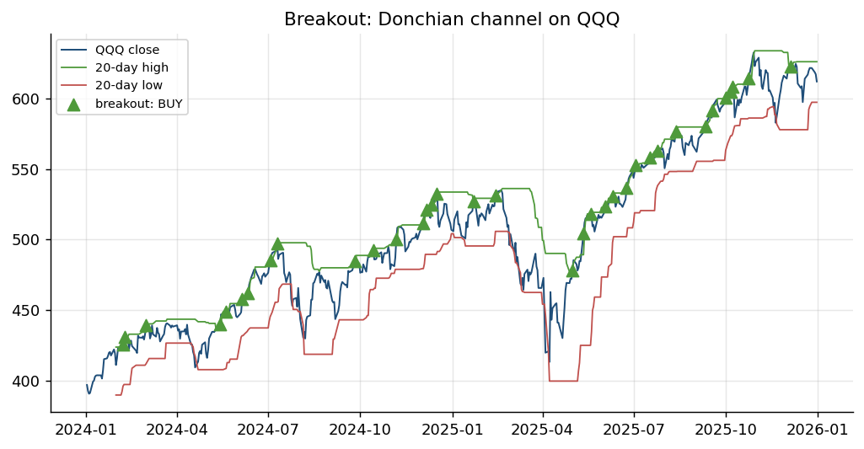
Figure: Algorithm: Donchian Channel Breakout - illustrated on real market data.
How it works | Track the highest high and lowest low of the last n bars (n = 20 here).
Rule | Close above the 20-day high: buy the breakout. Exit below the 20-day low (or a trailing stop).
Works best when | New trends start with a break of a range - the rule used by the 1980s 'Turtle Traders'.
Watch out for | False breakouts in choppy markets; the channel must use PREVIOUS bars only (no look-ahead).

How It Works: VWAP and TWAP Execution
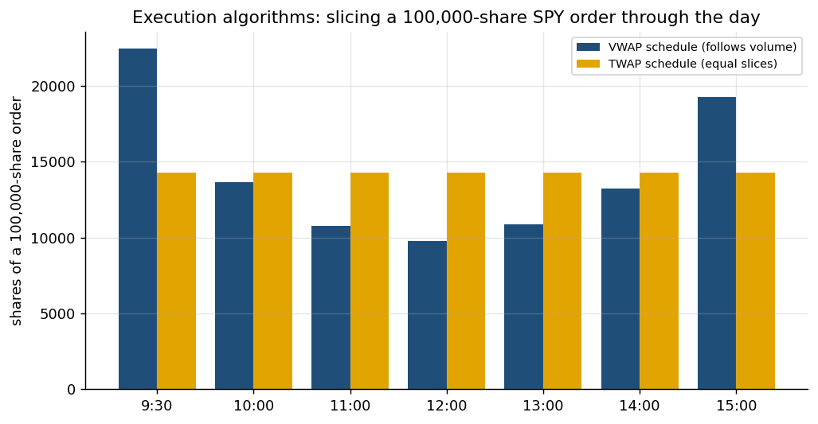
Figure: Algorithm: VWAP and TWAP Execution - illustrated on real market data.
How it works | Split a large parent order into child orders through the day to reduce market impact.
Rule | TWAP: equal slices per time interval. VWAP: slices proportional to the typical volume curve.
Works best when | Working client or fund orders too large to trade at once; benchmarked to the day's VWAP.
Watch out for | VWAP relies on a volume forecast; both are predictable to other traders - add randomisation.

How It Works: Market Making
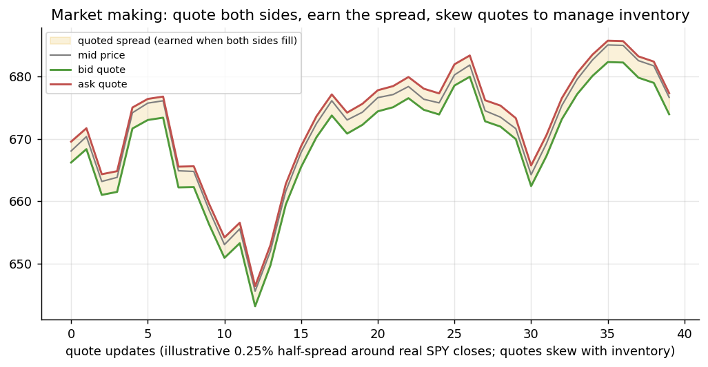
Figure: Algorithm: Market Making - illustrated on real market data.
How it works | Quote a bid below and an ask above the mid price at the same time.
Rule | Earn the spread when both sides fill; skew quotes down when long, up when short, to cut inventory.
Works best when | Liquid markets with steady two-way flow - the business of quant market makers.
Watch out for | Adverse selection by better-informed traders; inventory risk in fast moves; needs low latency.

2.6 Lab 5: Indicator Stage: Pine Script v6 Indicators and their Python Twins
Maps to: A3, K3, K7 | Duration: 25 min | Slide 124

Scenario
Lion City Capital's traders read trend (EMA 20/50), volatility (Bollinger Bands) and momentum (RSI) on TradingView, while the pipeline's signals are computed in Python. If the two disagree, a trader and the automated strategy will act on different numbers, so the desk builds Pine Script indicators and exact Python twins and cross-checks them value by value.

Objective
Plot SMA/EMA, Bollinger Bands, RSI and MACD and export a Pine Script v6 strategy for TradingView.

Lab Steps - In the Trading Simulator
No coding is needed. Make sure the Trading Simulator is running (installed once - see the guide 'Download, Install and Start the Trading Simulator Software') and open http://localhost:8000. In the sidebar open Course Labs > Lab 05: the app shows the same steps with a Go button that opens each page pre-filled. Every step works offline on the bundled demo data and the built-in paper broker.
Step 1. Overlay trend indicators
Data > Chart for SPY: toggle sma:50, sma:200, ema:20 and bollinger.
Open: http://localhost:8000/#/data?tab=chart&symbol=SPY&overlays=sma:50,sma:200,bollinger (Data > Chart SPY with SMA 50/200 and Bollinger)
Check: Lines draw over the candles (TradingView Lightweight Charts).
Step 2. Oscillators
Switch the lower pane between RSI(14) and MACD.
Open: http://localhost:8000/#/data?tab=chart&symbol=SPY&osc=macd (Data > Chart SPY MACD)
Check: RSI has 30/70 guide lines; the MACD histogram changes colour above and below 0.
Step 3. Export Pine Script v6
Strategy Library > EMA crossover > Pine Script v6 > Copy. In TradingView open the Pine Editor, paste, 'Add to chart'.
Open: http://localhost:8000/#/strategies?key=ema_cross (Strategies > EMA crossover)
Check: TradingView shows the two EMAs; their last values match the app's chart.
Expected in the app: A chart with overlays and an oscillator pane, and a Pine Script pasted into TradingView whose values match.
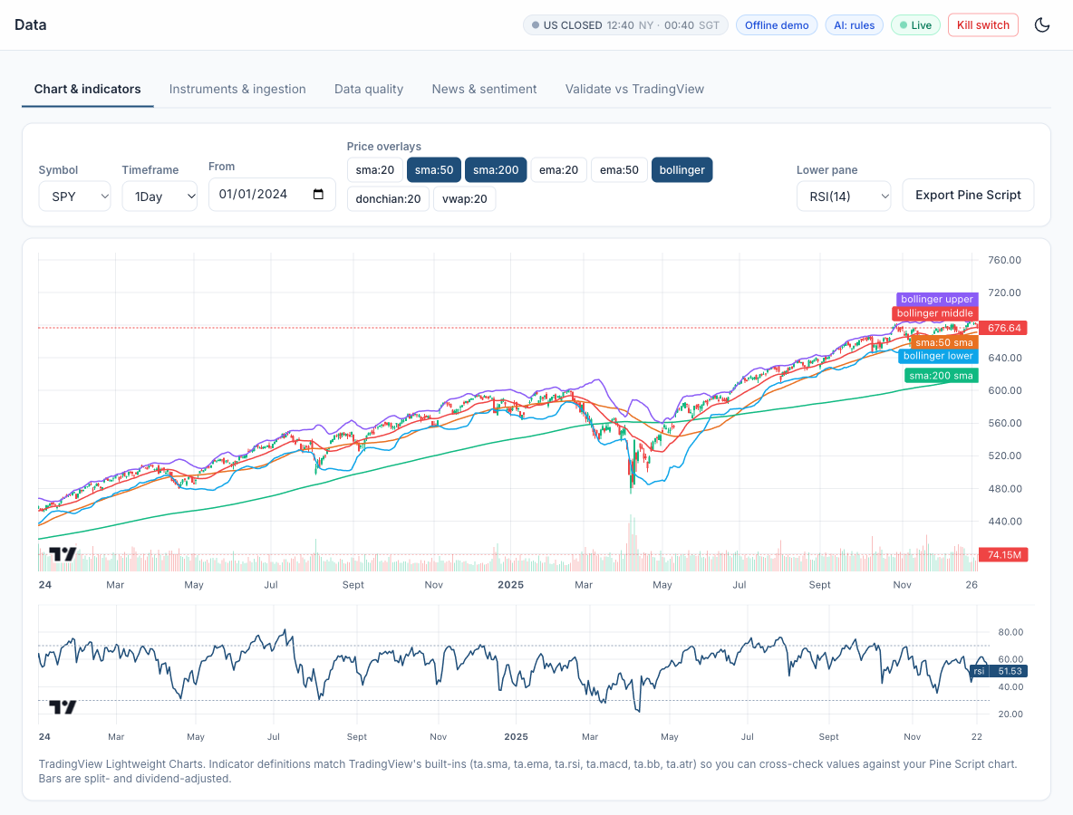
Figure: Lab 05 in the Trading Simulator.

Optional: Let AI Write the Code
This lab needs no coding. To see, run or customise the code behind it, click a link: the AI opens with the prompt filled in and writes the code for you. All prompts are also in labs_lowcode/Prompt_Library.html and .pdf.
Indicators and their Pine Script twin - run it in Google Colab
I am a beginner and do not write code. Write ONE complete Python script that runs as-is in a Google Colab notebook. Start with a !pip install line for any library Colab lacks, use pandas, numpy, matplotlib, scipy, scikit-learn, statsmodels and yfinance only, get daily prices from yfinance (auto_adjust=True unless I say otherwise), put a one-line comment above each section, print results as clear tables and charts, and after the code explain in 5 short bullet points how to read the output. Paper trading and education only. Task: for SPY 2018-2025 compute SMA(50), SMA(200), EMA(20), Bollinger Bands (20, 2), RSI(14) and MACD (12, 26, 9) with pandas only, print the latest values, and plot the price with the overlays and RSI and MACD in panes below. Then write the same indicators as a TradingView Pine Script v6 indicator I can paste into the Pine Editor.
Open in Claude | Open in ChatGPT | Open Google Colab

Debrief
Technical indicators (K3) turn prices into trend, volatility and momentum readings; defining them once in Pine Script and once in Python, and proving they match (A3), keeps traders and the automated pipeline on the same numbers. Faster settings fire more signals, which means more trades and more cost (K7).

2.7 Lab 6: Strategy Prototype: TradingView Strategy Tester, Paper Trading from the Chart and Pipeline Reconciliation
Maps to: A2, A3, K3, K7 | Duration: 30 min | Slide 127

Scenario
A portfolio manager prototypes a golden-cross rule for the desk's SPY sleeve in TradingView. Before it can enter the automated pipeline, the Strategy Tester result (with commission and slippage) must be reproduced by an independent pipeline backtest, and the trader must be able to put the idea into action on a paper account straight from the chart.

Objective
Run the same MA-crossover in TradingView's Strategy Tester and in the app, reconcile the results, and try TradingView Paper Trading.

Lab Steps - In the Trading Simulator
No coding is needed. Make sure the Trading Simulator is running (installed once - see the guide 'Download, Install and Start the Trading Simulator Software') and open http://localhost:8000. In the sidebar open Course Labs > Lab 06: the app shows the same steps with a Go button that opens each page pre-filled. Every step works offline on the bundled demo data and the built-in paper broker.
Step 1. Backtest the SMA 50/200 crossover in the app
Run the preset backtest: SMA crossover 50/200 on SPY, Alpaca-style costs, next-bar-open fills.
Open: http://localhost:8000/#/backtest?strategy=sma_cross&symbols=SPY&fast=50&slow=200&costs=alpaca_retail (Backtest SPY SMA 50/200, Alpaca costs)
Check: About 5 round trips 2018-2025; note the net CAGR and Sharpe.
Step 2. Run it in TradingView
Export the SMA crossover Pine Script and add it to an AMEX:SPY daily chart. Open the Strategy Tester.
Open: http://localhost:8000/#/strategies?key=sma_cross (Strategies > SMA crossover > Pine)
Check: The Strategy Tester list of trades has the same entry dates (TradingView also fills on the next bar's open).
Step 3. Reconcile and paper trade on TradingView
Explain any differences (adjusted vs raw data, commission per order, slippage ticks). Optionally connect TradingView Paper Trading and place one order from the chart.
Open: http://localhost:8000/#/backtest?strategy=sma_cross&symbols=SPY&fast=50&slow=200&costs=alpaca_retail
Check: You can list at least two reasons the two backtests differ.
Expected in the app: Trade counts and net profit that agree within the expected differences (fills, costs, data).
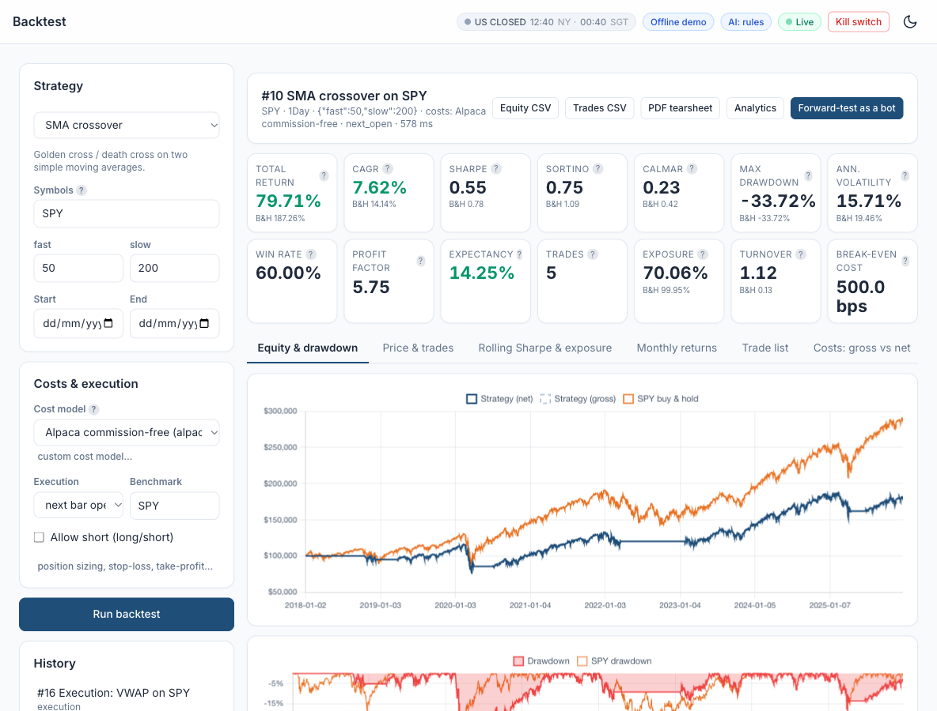
Figure: Lab 06 in the Trading Simulator.

Optional: Let AI Write the Code
This lab needs no coding. To see, run or customise the code behind it, click a link: the AI opens with the prompt filled in and writes the code for you. All prompts are also in labs_lowcode/Prompt_Library.html and .pdf.
A crossover backtest to compare with TradingView's Strategy Tester - run it in Google Colab
I am a beginner and do not write code. Write ONE complete Python script that runs as-is in a Google Colab notebook. Start with a !pip install line for any library Colab lacks, use pandas, numpy, matplotlib, scipy, scikit-learn, statsmodels and yfinance only, get daily prices from yfinance (auto_adjust=True unless I say otherwise), put a one-line comment above each section, print results as clear tables and charts, and after the code explain in 5 short bullet points how to read the output. Paper trading and education only. Task: backtest an SMA 50/200 crossover on SPY 2018-2025 (long when SMA50 > SMA200), trade at the next day's open with a 0.05% cost per trade. Print the list of trades (entry and exit dates and prices), the number of trades, net profit and maximum drawdown. Then write the same strategy in TradingView Pine Script v6 using strategy() so I can compare it in the Strategy Tester.
Open in Claude | Open in ChatGPT | Open Google Colab

Debrief
Choosing a rule and its parameters is a modelling decision (A2); the Strategy Tester and TradingView Paper Trading are analytics and execution platforms (A3) that report standard metrics (K3). An independent reconciliation is the gate between a chart prototype and the automated pipeline, and costs typed into strategy() (K7) barely touch a slow rule but compound for a fast one.

2.8 Lab 7: Signal Stage: a Library of Trend, Mean-Reversion, Momentum and Breakout Signals
Maps to: A2, K3, K7 | Duration: 25 min | Slide 131

Scenario
Lion City Capital wants every strategy - from a TradingView prototype to an ML model - to produce the same thing: a target position per symbol, decided at the close and traded on the next bar. The quant team builds one signal library that the evaluation, search, execution, automation and diagnostic stages all call.

Objective
Pick and customise one strategy from each family and compare them after costs.

Lab Steps - In the Trading Simulator
No coding is needed. Make sure the Trading Simulator is running (installed once - see the guide 'Download, Install and Start the Trading Simulator Software') and open http://localhost:8000. In the sidebar open Course Labs > Lab 07: the app shows the same steps with a Go button that opens each page pre-filled. Every step works offline on the bundled demo data and the built-in paper broker.
Step 1. Trend: EMA 20/50 on SPY
Run the preset.
Open: http://localhost:8000/#/backtest?strategy=ema_cross&symbols=SPY&fast=20&slow=50&costs=alpaca_retail (Backtest SPY EMA 20/50, Alpaca costs)
Check: Note Sharpe and max drawdown vs buy-and-hold.
Step 2. Mean reversion: Bollinger on KO
Run Bollinger Band mean reversion on KO (window 20, k 2.0), then change k to 1.5 and run it again. Set Benchmark to KO so the buy-and-hold figures under each metric are KO's, not SPY's.
Open: http://localhost:8000/#/backtest?strategy=bollinger_reversion&symbols=KO&window=20&k=2 (Backtest KO Bollinger 20/2)
Check: Win rate is high, but losses are larger than wins - 'many small wins, rare big losses'.
Step 3. Momentum and breakout
On the Backtest page choose Time-series momentum, look-back 126, symbol QQQ, Benchmark QQQ, and run it. Then run the Donchian breakout on QQQ (entry 20, exit 10).
Open: http://localhost:8000/#/backtest?strategy=donchian_breakout&symbols=QQQ&entry=20&exit=10 (Backtest QQQ Donchian 20/10)
Check: Open the 'Price & trades' tab: buy arrows follow 20-day highs.
Step 4. Read each strategy's explanation
Strategy Library: open each card and read How it works / Rule / Works best when / Watch out for.
Open: http://localhost:8000/#/strategies
Check: You can say which family suits a trending market and which a range-bound one.
Expected in the app: Four backtests with tuned parameters and an explanation of when each family works.
Record your results in Lab07_Results.xlsx in this lab folder: the settings are filled in - type the metrics into the yellow cells. Its Definitions sheet explains every column.
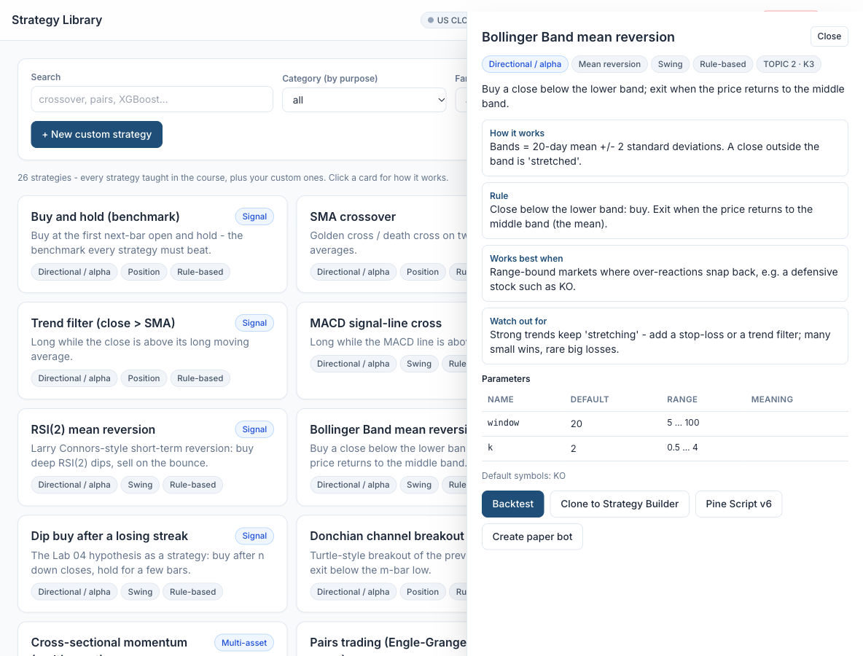
Figure: Lab 07 in the Trading Simulator.

Optional: Let AI Write the Code
This lab needs no coding. To see, run or customise the code behind it, click a link: the AI opens with the prompt filled in and writes the code for you. All prompts are also in labs_lowcode/Prompt_Library.html and .pdf.
A library of four strategy families - run it in Google Colab
I am a beginner and do not write code. Write ONE complete Python script that runs as-is in a Google Colab notebook. Start with a !pip install line for any library Colab lacks, use pandas, numpy, matplotlib, scipy, scikit-learn, statsmodels and yfinance only, get daily prices from yfinance (auto_adjust=True unless I say otherwise), put a one-line comment above each section, print results as clear tables and charts, and after the code explain in 5 short bullet points how to read the output. Paper trading and education only. Task: backtest four strategies on 2018-2025 daily data, trade at the next day's open with a 0.05% cost per trade: an EMA 20/50 crossover on SPY; Bollinger mean reversion on KO (buy below the lower band, exit at the middle band) with k = 2.0 and k = 1.5; 126-day time-series momentum on QQQ; and a Donchian 20/10 breakout on QQQ. Print CAGR, Sharpe ratio, maximum drawdown and number of trades in one table and explain when each family tends to work.
Open in Claude | Open in ChatGPT | Open Google Colab

Debrief
A single signal contract - target positions decided at the close, held from the next bar - is what lets one library feed backtests, live execution and diagnostics (A2). Indicators (K3) become signals through simple, testable rules, and the number of entries each rule produces is the first estimate of its trading cost (K7).

2.9 Lab 8: Execution Stage: an Order Manager that Trades the Paper Account in Any Session
Maps to: A3, K5 | Duration: 30 min | Slide 134

Scenario
The pipeline now produces target positions. The desk needs an order manager that turns 'target' versus 'actual' into paper orders safely: the right order type for the current US session (the Singapore class runs while New York is in its overnight and pre-market sessions), prices off the live quote, no duplicate orders if a job runs twice, and a printed order lifecycle the trader can match in the Alpaca dashboard.

Objective
Place market, limit, stop and bracket paper orders, including an extended-hours limit order, and follow each order's lifecycle.

Lab Steps - In the Trading Simulator
No coding is needed. Make sure the Trading Simulator is running (installed once - see the guide 'Download, Install and Start the Trading Simulator Software') and open http://localhost:8000. In the sidebar open Course Labs > Lab 08: the app shows the same steps with a Go button that opens each page pre-filled. Every step works offline on the bundled demo data and the built-in paper broker.
Step 1. Market order in the regular session
Open Paper Trading > Order ticket, fill in the fields below and press Send paper order. A market order buys straight away at the current price; it is accepted in the regular session.
- Account: Default paper account - the simulator's built-in paper broker (not TradingView). Keep it for every step: Session (sim) works only on this account, while the Alpaca paper account always uses the real clock.
- Symbol: SPY
- Side: buy
- Qty: 10
- Type: market
- Time in force: day
- Limit price, Stop price: leave blank
- extended hours: leave unticked
- Bracket take-profit, Bracket stop-loss: leave blank
- Session (sim): regular - pretends New York is in its regular session (21:30-04:00 Singapore time, 22:30-05:00 in winter); 'real clock' uses the actual time
Open: http://localhost:8000/#/trading?tab=ticket (Paper Trading > Order ticket)
Check: The Result panel shows ACCEPTED - all checks passed, 'BUY 10 SPY MARKET DAY -> filled', and each risk check (kill_switch, duplicate, session, allow_list, long_only, daily_loss, max_order_qty, max_order_value, max_position_pct) marked ok.
Step 2. Extended-hours limit order (Singapore class hours)
Keep the Step 1 ticket and change only the fields below, then press Send paper order. Session (sim) = overnight pretends New York is in its overnight session - where it is during Singapore class hours. Only LIMIT orders are accepted then, so 'auto' builds one for you: time in force DAY, extended hours on, and a limit price 0.25% (25 bps) above the ask for a buy, which caps the price you pay. Then send a market order in the same session to see it blocked.
- Type: auto (session-aware)
- Session (sim): overnight
- Limit price: leave blank - auto sets it from the quote
- extended hours: leave unticked - auto switches it on
- Everything else: as in Step 1
- Second send: Type = market, Session (sim) still overnight
Open: http://localhost:8000/#/trading?tab=ticket
Check: First send: ACCEPTED, 'BUY 10 SPY LIMIT DAY extended_hours limit <price> -> filled'; the Orders tab shows 'limit day ext-hrs', session overnight. Second send (market): BLOCKED - the session check reads 'overnight session accepts only LIMIT orders with extended_hours=True'.
Step 3. Bracket order
A bracket order is an entry plus two automatic exits: a take-profit (a sell limit above the price, to lock in a gain) and a stop-loss (a sell stop below it, to cap a loss). Brackets are accepted in the regular session only, and both exit prices must be filled in. Fill in the fields below and press Send paper order, then open the Orders tab and click each status badge to see that order's lifecycle.
- Qty: 5
- Type: market
- Session (sim): regular
- Bracket take-profit: about 3% above the current SPY price - e.g. SPY at 770 -> 793.10 (read the price in the Fill column of your Step 1 order)
- Bracket stop-loss: about 2% below it - e.g. SPY at 770 -> 754.60
- Limit price, Stop price: leave blank
- extended hours: leave unticked
- Everything else: as in Step 1
Open: http://localhost:8000/#/trading?tab=ticket
Check: Orders tab: the parent 'buy 5 SPY market day bracket' is filled, and two sell legs appear with status new - 'limit gtc bracket (leg)' at the take-profit and 'stop gtc bracket (leg)' at the stop-loss. They were held until the parent filled; when one leg fills, the other is cancelled (one-cancels-other).
Step 4. Queue while closed and cancel
Session (sim) = closed pretends the US market is shut (weekends and US holidays). 'auto' turns the order into a GTC (good-till-cancelled) limit order that queues for the next session instead of filling. First clear the two bracket fields - the ticket keeps them from Step 3. Press Send paper order, then open the Orders tab and cancel the queued order.
- Qty: 10
- Type: auto (session-aware)
- Session (sim): closed
- Bracket take-profit, Bracket stop-loss: clear both (blank)
- Limit price: leave blank - auto sets it
- Time in force: leave as day - auto changes it to gtc
- Everything else: as in Step 1
- Then: Orders tab > the new 'limit gtc' row (status accepted) > press the red cancel at the right-hand end
Open: http://localhost:8000/#/trading?tab=ticket
Check: Result: ACCEPTED, 'BUY 10 SPY LIMIT GTC limit <price> -> accepted', and the session check reads 'market closed - GTC limit order will queue for the next session'. After cancel the status is canceled; click the badge to see new -> accepted -> canceled. Tip: while the real US market is open (21:30-04:00 Singapore time) the simulator's background market can fill a queued order within a minute - cancel straight away, or send it again if it already filled.
Expected in the app: A blotter with filled, working, queued and cancelled orders and the risk checks for each.
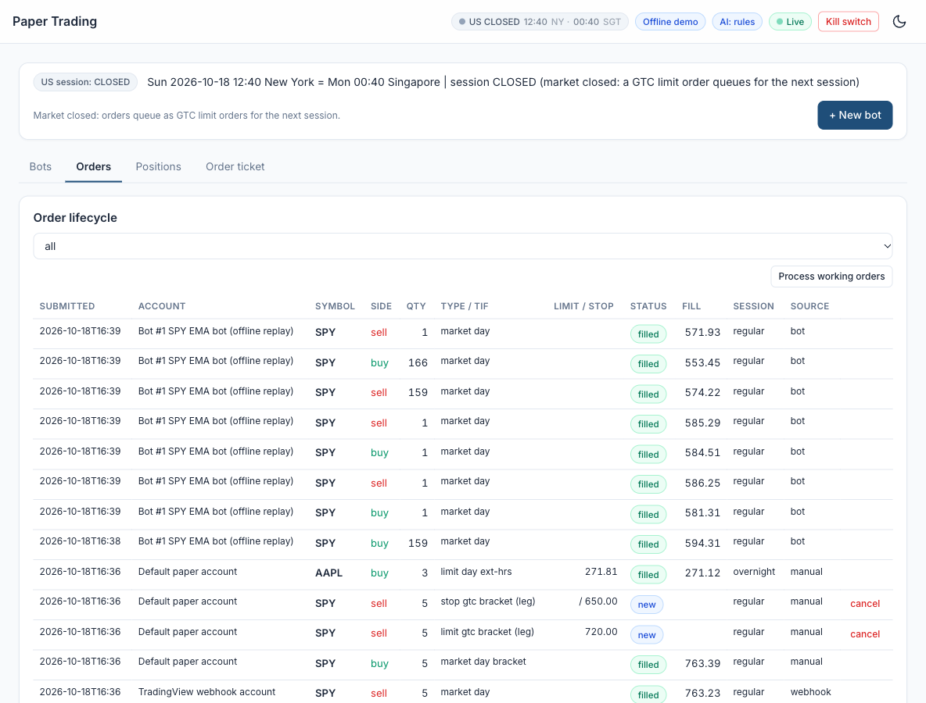
Figure: Lab 08 in the Trading Simulator.

Optional: Let AI Write the Code
This lab needs no coding. To see, run or customise the code behind it, click a link: the AI opens with the prompt filled in and writes the code for you. All prompts are also in labs_lowcode/Prompt_Library.html and .pdf.
Place paper orders on Alpaca - run it in Google Colab
I am a beginner and do not write code. Write ONE complete Python script that runs as-is in a Google Colab notebook. Start with a !pip install line for any library Colab lacks, use pandas, numpy, matplotlib, scipy, scikit-learn, statsmodels and yfinance only, get daily prices from yfinance (auto_adjust=True unless I say otherwise), put a one-line comment above each section, print results as clear tables and charts, and after the code explain in 5 short bullet points how to read the output. Paper trading and education only. Task: using alpaca-py with a PAPER account (TradingClient(..., paper=True)), read my keys from Google Colab Secrets named APCA_API_KEY_ID and APCA_API_SECRET_KEY (never put keys in the code), then place: a market order to buy 1 SPY; a limit order to buy 1 SPY 2% below the last price with extended_hours=True and time in force DAY; and a bracket order with a 3% take-profit and a 2% stop-loss. Print each order's id and status, list the open orders, then cancel the limit order.
Open in Claude | Open in ChatGPT | Open Google Colab

Debrief
Order types are tools for price, timing and risk, and the trading session decides which ones the broker accepts (K5). An order manager that reads the clock, prices limits off the quote, makes every order idempotent and prints its lifecycle is how an automated program knows exactly what happened at the broker (A3) - in New York's regular session or in its overnight session during a Singapore workday.

2.10 Lab 9: Evaluation Stage: Performance and Risk Metrics with a Benchmark Table
Maps to: A3, K3 | Duration: 25 min | Slide 138

Scenario
The investment committee wants to know which of the pipeline's signals deserves capital. Return alone cannot answer that, so the evaluation stage runs every signal through the same backtester, over the same window, with the same costs, and compares it with simply holding SPY.

Objective
Read the full metrics table and compare a strategy with buy-and-hold.

Lab Steps - In the Trading Simulator
No coding is needed. Make sure the Trading Simulator is running (installed once - see the guide 'Download, Install and Start the Trading Simulator Software') and open http://localhost:8000. In the sidebar open Course Labs > Lab 09: the app shows the same steps with a Go button that opens each page pre-filled. Every step works offline on the bundled demo data and the built-in paper broker.
Step 1. Open the analytics
Analytics: choose the EMA 10/30 seeded backtest. Hover every metric for its formula.
Open: http://localhost:8000/#/analytics (Analytics)
Check: You can define Sharpe, Sortino, Calmar, max drawdown, profit factor, expectancy, exposure and turnover.
Step 2. Compare with buy-and-hold
Tick the EMA backtest and 'Buy and hold SPY' and press Compare.
Open: http://localhost:8000/#/analytics
Check: Buy-and-hold has higher CAGR but a deeper drawdown; the strategy has lower exposure.
Step 3. Glossary
Open Help & Glossary > Metric glossary.
Open: http://localhost:8000/#/help?tab=glossary
Check: Each formula matches the course slides.
Expected in the app: A metrics table you can explain line by line.
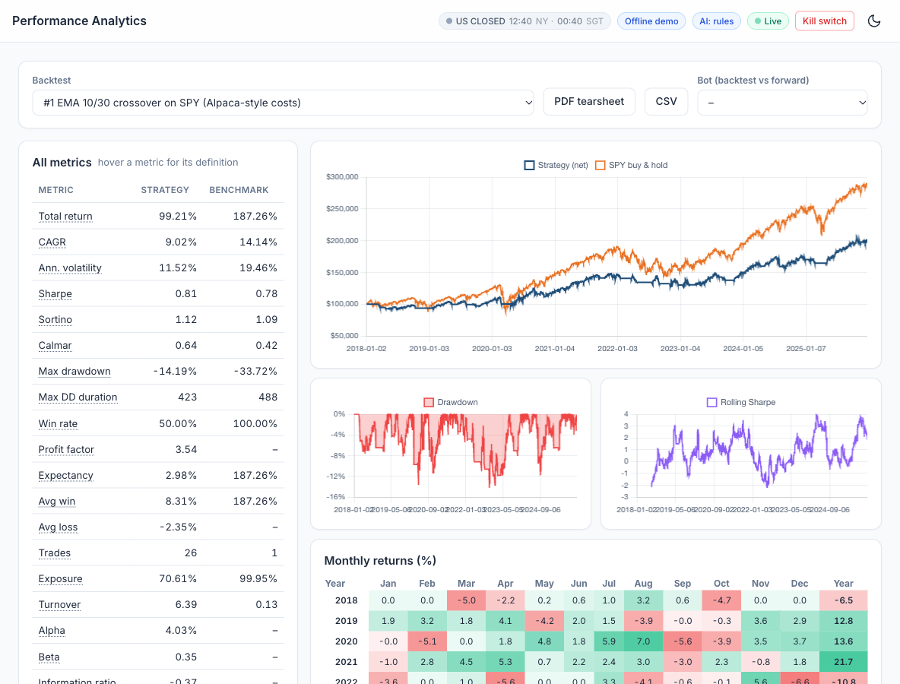
Figure: Lab 09 in the Trading Simulator.

Optional: Let AI Write the Code
This lab needs no coding. To see, run or customise the code behind it, click a link: the AI opens with the prompt filled in and writes the code for you. All prompts are also in labs_lowcode/Prompt_Library.html and .pdf.
Performance and risk metrics against buy-and-hold - run it in Google Colab
I am a beginner and do not write code. Write ONE complete Python script that runs as-is in a Google Colab notebook. Start with a !pip install line for any library Colab lacks, use pandas, numpy, matplotlib, scipy, scikit-learn, statsmodels and yfinance only, get daily prices from yfinance (auto_adjust=True unless I say otherwise), put a one-line comment above each section, print results as clear tables and charts, and after the code explain in 5 short bullet points how to read the output. Paper trading and education only. Task: for an EMA 10/30 crossover on SPY 2018-2025 (trade at the next day's open with a 0.05% cost per trade) compute and explain total return, CAGR, annual volatility, Sharpe, Sortino and Calmar ratios, maximum drawdown, win rate, profit factor and exposure, side by side with buy-and-hold SPY, and plot both equity curves.
Open in Claude | Open in ChatGPT | Open Google Colab

Debrief
Performance metrics (K3) answer different questions: CAGR measures growth, Sharpe and Sortino reward per unit of risk, drawdown and Calmar the pain an investor must survive, beta how much is just the market. Running every strategy through one evaluation stage (A3) is what makes the comparison fair.

2.11 Topic Summary
- A2 - Identify appropriate statistical algorithms and data models to test hypotheses and/or theories
- A3 - Use appropriate analytics platforms, analytical tools, statistical methods and analytical approaches given specific analytics and reporting requirements
- K3 - Range and application of various statistical methods and algorithms
- K5 - Usage of analytics platforms and tools
- K7 - Coding languages for programming of algorithms and signals
Assessed by: Practical Performance Task 2 | Written Assessment Q3, Q5, Q7

Topic 3: Machine Learning Models, Statistical Modelling and A/B Testing for Trading Signals
Day | Abilities | Knowledge | Labs | Slides
Day 2 | A4, A5 | K2, K4, K6 | 10 - 14 | 143 - 171

Learning Outcome
Conduct statistical modelling of market data with machine learning models to derive patterns and solutions, and perform A/B testing of trading strategies based on different hypotheses.

3.1 Types of Statistical Analyses, Data Models, Algorithms and Computational Methods
Maps to: K2, A2 | Slides 144-145
- Descriptive analysis summarises what happened (mean return, volatility, skew, correlation); inferential analysis tests whether an effect is real (t-test, bootstrap); predictive analysis forecasts (regression, classification); prescriptive analysis decides (optimisation).
- Supervised learning learns a mapping from features to a known target - regression for a continuous target (tomorrow's return), classification for a category (up or down).
- Unsupervised learning finds structure without a target - clustering (market regimes) and dimensionality reduction (PCA of a yield curve or a sector basket).
- Reinforcement learning learns a policy from rewards by interacting with an environment - used in research for execution and portfolio allocation, but data-hungry and fragile.
- Advanced computational methods: grid and random search over strategy parameters, Monte Carlo simulation and bootstrapping, walk-forward optimisation, and gradient-boosted ensembles.
- Strategy search is itself an algorithm: testing many parameter combinations on in-sample data and then confirming only the best few out of sample - always counting how many combinations were tried.

3.2 Supervised Learning Models for Trading Signals
Maps to: K4, A4 | Slides 146, 150-152, 157
- Target and features: the target is what you predict (next-day direction); the features are what you know at prediction time (lagged returns, RSI, MACD, volatility, volume change). Any feature using future data is leakage.
- Linear regression predicts a continuous return as a weighted sum of features; logistic regression outputs the probability of an up day and is a strong, interpretable baseline.
- Naive Bayes applies Bayes' theorem with an independence assumption; fast and surprisingly useful for text such as news headlines.
- Decision trees split the data on feature thresholds; random forests average many decorrelated trees; XGBoost builds trees sequentially, each correcting the last - typically the strongest tabular models.
- Neural networks (multi-layer perceptrons, LSTMs, Transformers) can model non-linear and sequential patterns, but need far more data and are easy to overfit on daily prices.
- Evaluation: accuracy, precision, recall, F1 and ROC AUC for classifiers; RMSE and R-squared for regressors. In trading, a model is judged finally by its net-of-cost strategy performance, not by accuracy alone.
- Turning probabilities into positions: go long when P(up) exceeds a threshold such as 0.55, stay flat otherwise, and re-train on a rolling window.

3.3 Unsupervised Learning: Clustering and PCA for Market Regimes
Maps to: K4, A4 | Slides 147, 153-154
- K-means clustering partitions observations into k groups by minimising within-cluster variance. Applied to rolling return and volatility features it separates calm-bull, choppy and stressed market regimes.
- Hierarchical clustering builds a tree (dendrogram) of similarity - used to group correlated assets and to build more diversified portfolios.
- Principal Component Analysis (PCA) finds orthogonal combinations that explain the most variance. For equities the first component is usually 'the market'; for yield curves the first three are level, slope and curvature.
- Always standardise features before clustering or PCA, and choose k with the elbow method or silhouette score - then name the clusters by inspecting their average characteristics.
- Regime-aware trading: run trend following in trending regimes and mean reversion in range-bound ones, or cut position size in the high-volatility regime.
- Clusters found on the whole history use future information; for trading, fit the clustering on past data only and assign new observations as they arrive.

3.4 Statistical Modelling Techniques for Financial Time Series
Maps to: K6, A4 | Slides 148, 155
- Returns, not prices: model log or simple returns, which are closer to stationary. Prices trend and wander; regressions on raw prices produce spurious results.
- Stylised facts of returns: fat tails, volatility clustering, weak autocorrelation of returns but strong autocorrelation of absolute returns. Normal-distribution assumptions understate tail risk.
- Time-ordered validation: never shuffle a time series. Use a chronological train / validation / test split, scikit-learn's TimeSeriesSplit, or walk-forward analysis that re-fits as time advances.
- Feature engineering: lagged returns, rolling statistics, indicator values, calendar effects and cross-asset features - each computed only from data available at the decision time.
- Regularisation (L1/L2 penalties, tree depth limits, early stopping) controls overfitting; fewer, well-motivated features usually beat many.
- Classical time-series models - autoregression (AR), ARIMA and GARCH for volatility - remain useful baselines against which a machine learning model must prove its value.

3.5 A/B Testing Trading Strategies
Maps to: A5, K2 | Slides 149, 156
- An A/B test compares variant A (for example a 20/50 crossover) with variant B (a 10/30 crossover, or the same rule with an RSI filter) on the same data and period, to decide whether B is genuinely better.
- State the hypotheses first: H0 - the mean daily returns (or Sharpe ratios) are equal; H1 - variant B's is higher. Choose the significance level (commonly 5%) before running the test.
- Tests: Welch's t-test on daily returns; a paired test on the daily return difference; and a bootstrap confidence interval for the Sharpe difference, which does not assume normality.
- Interpretation: a p-value below 0.05 rejects H0; a confidence interval for the difference that excludes zero tells the same story with a size attached. Statistical significance is not economic significance - check the effect after costs.
- Multiple testing: trying 100 variants will produce about 5 'significant' results by chance. Apply a Bonferroni correction or hold out a final test period.
- Live A/B testing: run both variants side by side in separate paper accounts during forward testing to compare them on unseen data.

3.6 Pairs Trading: Statistical Arbitrage as a Hedging Algorithm
Maps to: K6, A4 | Slides 158-160
- Pairs trading holds one stock long and an economically linked stock short, in hedge-ratio proportion. Market moves that hit both legs largely cancel, so the position is a hedge: its profit or loss comes from the spread between the two, not from the direction of the market.
- Origins: pioneered by Gerry Bamberger and developed by Nunzio Tartaglia's quantitative group at Morgan Stanley in the 1980s; still used by statistical-arbitrage funds.
- Cointegration, not correlation: two prices are cointegrated when a weighted combination of them is stationary. Highly correlated stocks can still drift apart for ever; only a cointegrated spread is expected to revert.
- Engle-Granger method: (1) regress log price A on log price B - the slope is the hedge ratio and the residual is the spread; (2) run an ADF unit-root test on the residual. A test statistic below the Engle-Granger critical value (about -3.34 at 5%) indicates cointegration.
- Trading rule: standardise the spread as a z-score over a rolling window; go short the spread (short A, long B) when z > +2, long the spread when z < -2, and exit as z returns towards 0 (for example |z| < 0.5). Trade both legs on the next bar and charge costs on both.
- Evidence: Gatev, Goetzmann and Rouwenhorst (2006) found a simple pairs rule on US stocks earned average annualised excess returns of up to 11% from 1962 to 2002; later studies find smaller and less consistent profits.
- Risks: the relationship can break (re-test cointegration on a rolling basis), the hedge ratio drifts, costs are paid twice, short positions incur borrow costs, and screening many pairs creates false discoveries.

Reference: Pairs Trading Step by Step
1. Select an economically linked pair
2. Estimate the hedge ratio (OLS)
3. Test cointegration (ADF on residual)
4. Compute the spread z-score
5. Enter / exit both legs
6. Monitor and re-test
Concept | Explanation
Why it is a hedge | Long the cheap stock, short the rich one in hedge-ratio proportion: market moves largely cancel
Choose the pair | Economically linked stocks (e.g. KO and PEP) that are cointegrated, not merely correlated
Hedge ratio and spread | Regress log price A on log price B: slope = hedge ratio, residual = the spread (Engle-Granger)
Test the spread | ADF test on the residual: a stationary spread tends to revert to its mean
Trade the z-score | Enter when |z| > 2, exit as z returns towards 0; trade both legs on the next bar
Risks | Cointegration breaks, hedge ratio drifts, double costs, short-borrow, multiple testing
Gatev, Goetzmann and Rouwenhorst (2006): a simple pairs rule on US stocks earned average annualised excess returns of up to 11% (1962-2002); later studies find smaller and less consistent profits.

How It Works: Logistic Regression for Direction
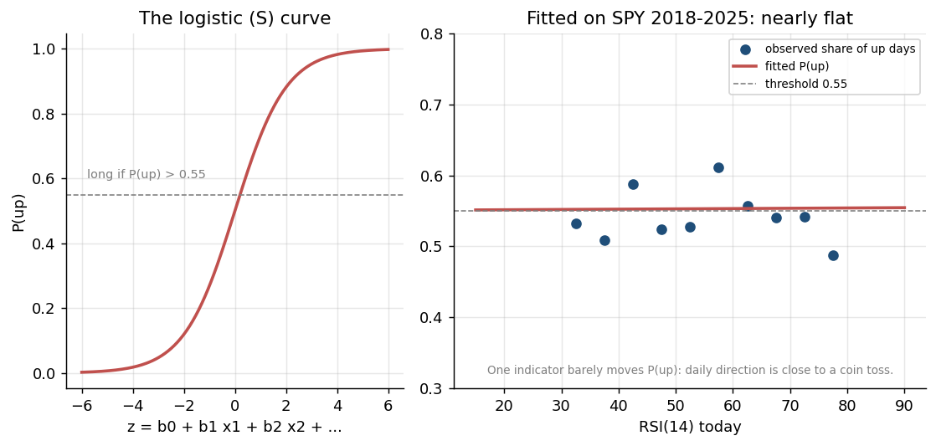
Figure: Algorithm: Logistic Regression for Direction - illustrated on real market data.
How it works | Fits P(up tomorrow) = 1 / (1 + e^-(b0 + b1 x1 + ...)) from features known today.
Rule | Go long when P(up) exceeds a threshold such as 0.55; otherwise stay flat.
Works best when | A transparent baseline: each coefficient shows how a feature moves the probability.
Watch out for | Only linear effects unless you engineer features; daily direction is close to a coin toss.

How It Works: Decision Tree and Random Forest
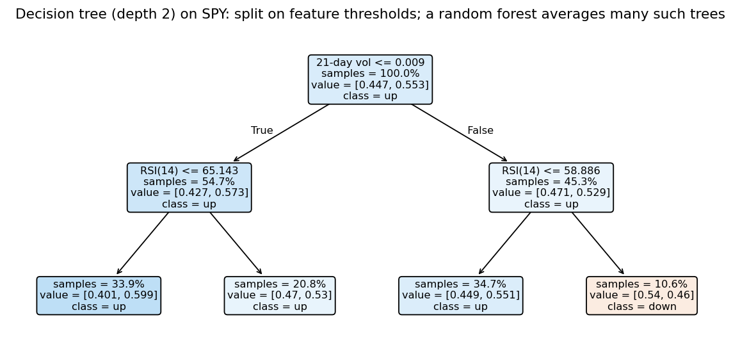
Figure: Algorithm: Decision Tree and Random Forest - illustrated on real market data.
How it works | A tree splits the data on feature thresholds (e.g. RSI < 30) into leaves with an up/down share.
Rule | A random forest averages hundreds of trees, each grown on a random sample of rows and features.
Works best when | Non-linear, interacting signals - e.g. oversold AND low volatility.
Watch out for | Deep trees memorise noise; limit depth and leaf size and validate walk-forward.

How It Works: Gradient Boosting (XGBoost)
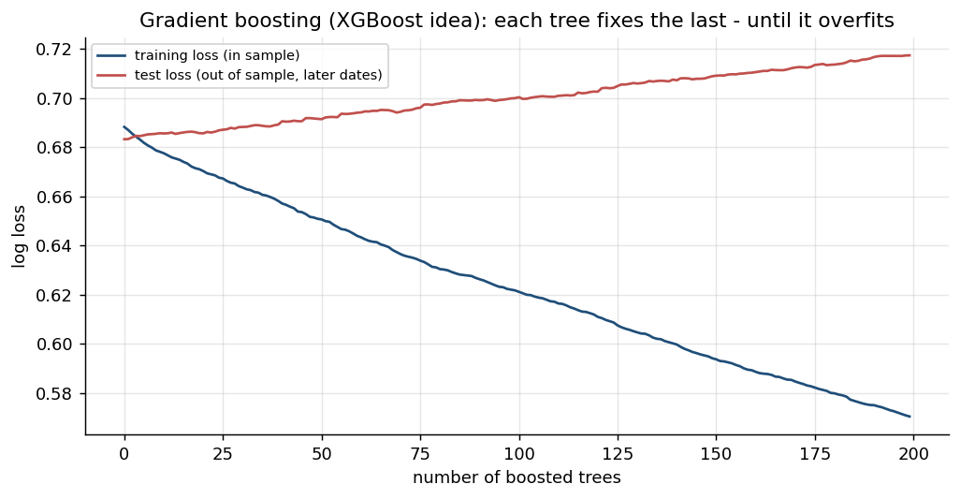
Figure: Algorithm: Gradient Boosting (XGBoost) - illustrated on real market data.
How it works | Builds trees one after another; each new tree corrects the errors of the ensemble so far.
Rule | Prediction = sum of many small trees x learning rate; stop early when test loss stops falling.
Works best when | Tabular features such as returns, indicators and volatility - usually the strongest model.
Watch out for | Training loss keeps falling while test loss rises: classic overfitting (see the chart).

How It Works: K-Means Clustering for Market Regimes
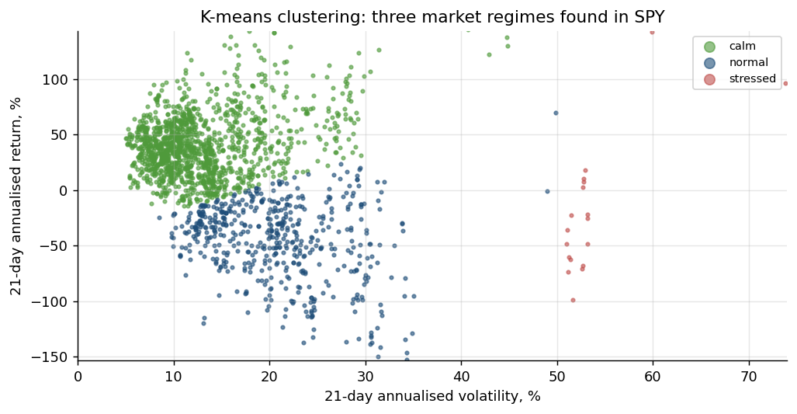
Figure: Algorithm: K-Means Clustering for Market Regimes - illustrated on real market data.
How it works | Groups days into k clusters by minimising the distance of each day to its cluster centre.
Rule | Features: rolling return and volatility (standardised). Name clusters by their averages.
Works best when | Switching or sizing strategies by regime: trend in calm markets, cut risk when stressed.
Watch out for | Fit on past data only; choose k with the elbow or silhouette method; regimes shift.

How It Works: Principal Component Analysis (PCA)
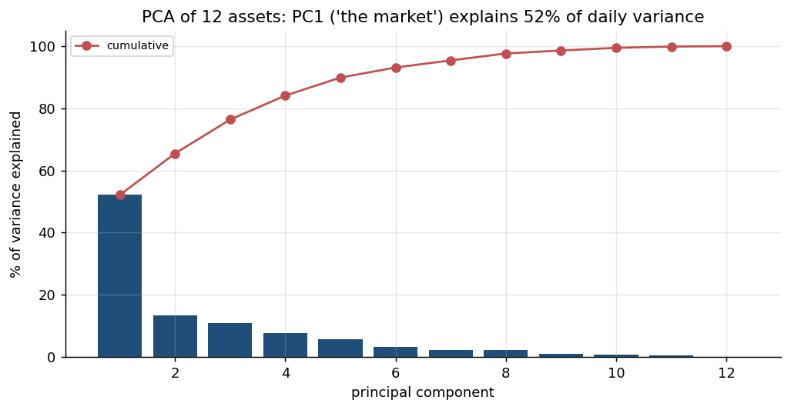
Figure: Algorithm: Principal Component Analysis (PCA) - illustrated on real market data.
How it works | Finds uncorrelated combinations of assets that explain the most variance of returns.
Rule | PC1 of a stock universe is 'the market'; later PCs are sector or style factors.
Works best when | Reducing many correlated features; building factor-neutral and pairs portfolios.
Watch out for | Standardise first; components change over time; PCs are statistical, not economic, factors.

How It Works: Walk-Forward Validation
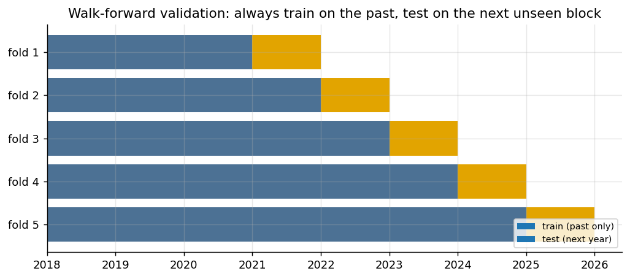
Figure: Method: Walk-Forward Validation - illustrated on real market data.
How it works | Train on a past window, test on the next unseen block, then roll forward and repeat.
Rule | Never shuffle time series; each test block is genuinely out of sample.
Works best when | Estimating how a model or parameter set would really have performed live.
Watch out for | Overlapping targets leak information - leave a gap between train and test.

How It Works: A/B Testing Two Strategy Variants
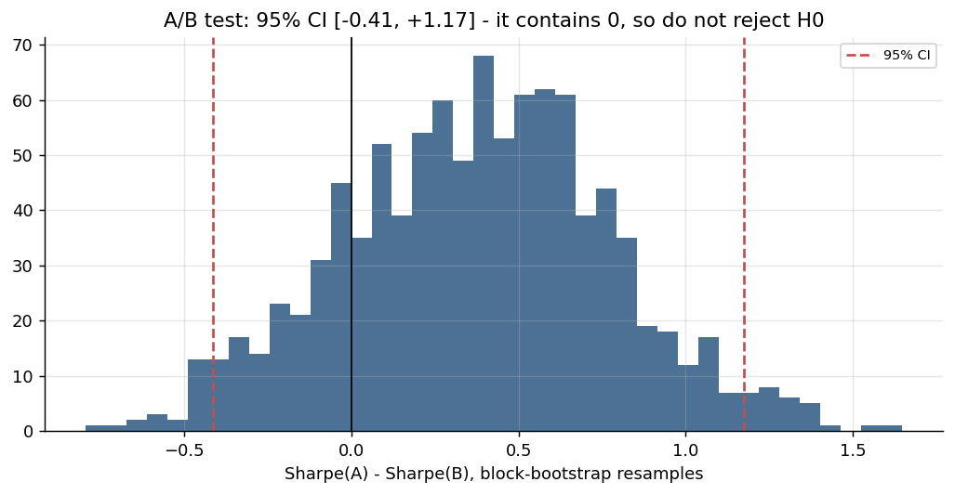
Figure: Method: A/B Testing Two Strategy Variants - illustrated on real market data.
How it works | Compare variant A and B on the same days: H0 'no difference' vs H1 'B is better'.
Rule | Welch / paired t-test on daily returns; bootstrap a 95% CI of the Sharpe difference.
Works best when | Deciding which parameter set or filter to promote to paper trading.
Watch out for | If the CI contains 0, do not reject H0; testing 100 variants gives ~5 false winners.

How It Works: Pairs Trading (Hedged Statistical Arbitrage)
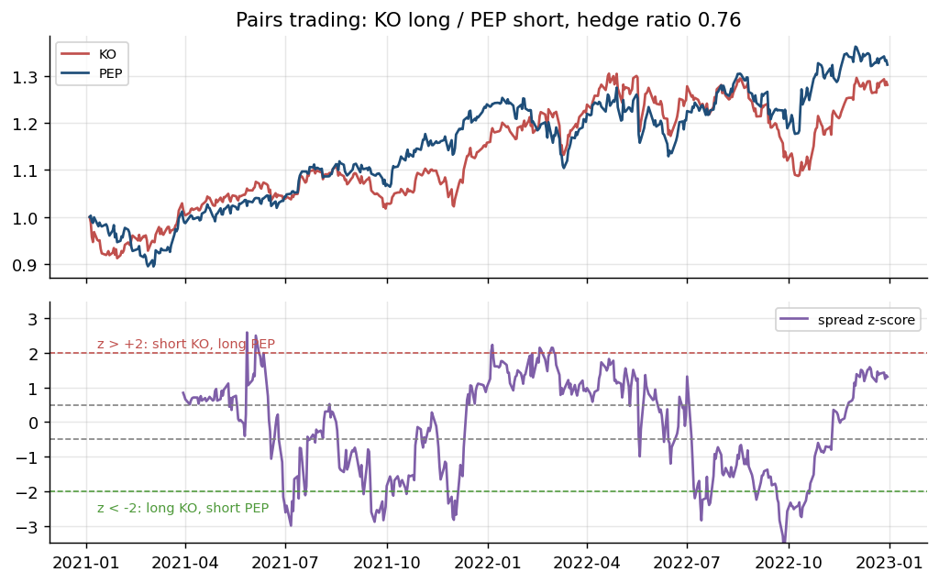
Figure: Algorithm: Pairs Trading (Hedged Statistical Arbitrage) - illustrated on real market data.
How it works | Long one stock, short a cointegrated partner in hedge-ratio proportion: market moves cancel.
Rule | Spread z > +2: short A / long B. z < -2: long A / short B. Exit as z returns to 0.
Works best when | Economically linked stocks (KO/PEP) whose spread has a stable mean.
Watch out for | Cointegration can break; costs on both legs; short-borrow; screening many pairs.

3.7 Lab 10: Strategy-Search Stage: Grid Search, Out-of-Sample Ranking and Decay
Maps to: A2, A4, K2 | Duration: 20 min | Slide 161

Scenario
A junior analyst wants the pipeline to 'find the best parameters'. The head of research agrees on one condition: parameters are ranked on 2018-2021 only and judged on the untouched 2022-2025 period (including the 2022 bear market), and the stage must report how much of the in-sample result decays.

Objective
Grid-search SMA crossover parameters in-sample and measure how the ranking decays out of sample.

Lab Steps - In the Trading Simulator
No coding is needed. Make sure the Trading Simulator is running (installed once - see the guide 'Download, Install and Start the Trading Simulator Software') and open http://localhost:8000. In the sidebar open Course Labs > Lab 10: the app shows the same steps with a Go button that opens each page pre-filled. Every step works offline on the bundled demo data and the built-in paper broker.
Step 1. Run the grid
Research > Strategy search: SMA crossover on SPY, in-sample to 2021-12-31, Alpaca costs. Press Search.
Open: http://localhost:8000/#/research/grid?strategy=sma_cross&symbol=SPY (Research > Grid SPY SMA cross)
Check: About 24 parameter sets; two heatmaps appear.
Step 2. Read the decay
Compare the in-sample and out-of-sample heatmaps and the IS->OOS rank correlation.
Open: http://localhost:8000/#/research/grid
Check: You can explain why the single best in-sample cell is usually not the best out of sample, and why a robust region is preferred.
Step 3. Walk-forward
Research > Walk-forward: SMA crossover on SPY (3-year train, 1-year test).
Open: http://localhost:8000/#/research/walkforward?strategy=sma_cross (Research > Walk-forward SPY)
Check: The stitched out-of-sample equity curve and the parameters chosen in each window.
Expected in the app: IS and OOS Sharpe heatmaps, a rank correlation and a robust parameter region.
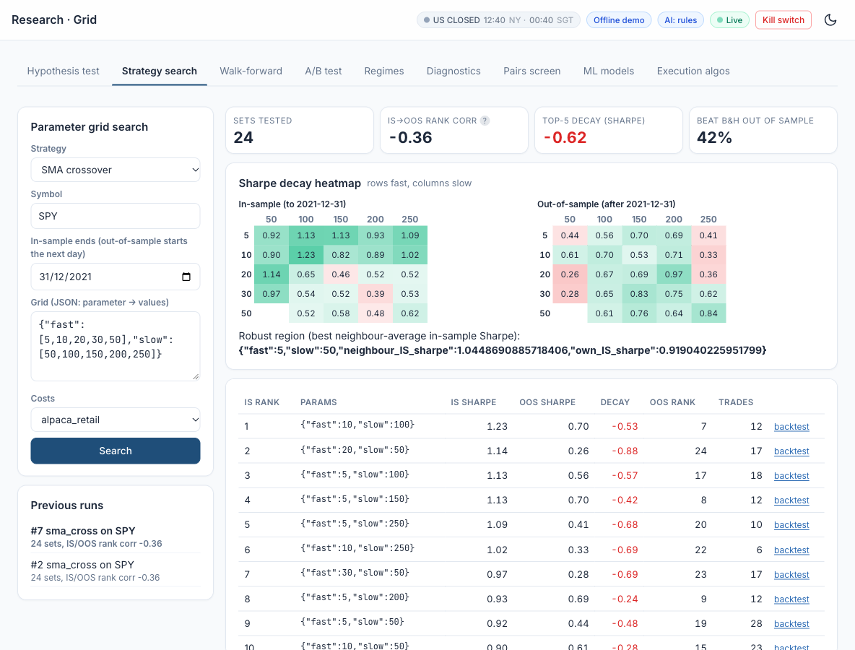
Figure: Lab 10 in the Trading Simulator.

Optional: Let AI Write the Code
This lab needs no coding. To see, run or customise the code behind it, click a link: the AI opens with the prompt filled in and writes the code for you. All prompts are also in labs_lowcode/Prompt_Library.html and .pdf.
Grid search, out-of-sample ranking and decay - run it in Google Colab
I am a beginner and do not write code. Write ONE complete Python script that runs as-is in a Google Colab notebook. Start with a !pip install line for any library Colab lacks, use pandas, numpy, matplotlib, scipy, scikit-learn, statsmodels and yfinance only, get daily prices from yfinance (auto_adjust=True unless I say otherwise), put a one-line comment above each section, print results as clear tables and charts, and after the code explain in 5 short bullet points how to read the output. Paper trading and education only. Task: grid-search an SMA crossover on SPY (trade at the next day's open with a 0.05% cost per trade): fast 5 to 50 in steps of 5, slow 50 to 250 in steps of 25, fast below slow. Show the Sharpe ratio in-sample (2018-2021) and out-of-sample (2022-2025) as two heatmaps, print the Spearman rank correlation between them, and explain what it says about overfitting.
Open in Claude | Open in ChatGPT | Open Google Colab

Debrief
Grid search is a statistical search over model structures (A2, A4); comparing in-sample with out-of-sample results (K2) exposes how much of the 'best' result was luck. A hold-out period, a count of trials and a preference for robust regions are the pipeline's defences against fooling itself.

3.8 Lab 11: ML-Signal Stage: a Walk-Forward Classifier from Probability to Position
Maps to: A4, K4, K6 | Duration: 20 min | Slide 163

Scenario
The desk's data scientist claims a machine-learning model reading technical features can predict whether SPY closes up tomorrow. The pipeline will only accept an ML signal that is validated walk-forward, turned into positions with an explicit probability threshold and traded next bar with the same costs as every other signal - and that still beats buy and hold.

Objective
Train logistic regression, random forest and XGBoost walk-forward and trade P(up) > threshold.

Lab Steps - In the Trading Simulator
No coding is needed. Make sure the Trading Simulator is running (installed once - see the guide 'Download, Install and Start the Trading Simulator Software') and open http://localhost:8000. In the sidebar open Course Labs > Lab 11: the app shows the same steps with a Go button that opens each page pre-filled. Every step works offline on the bundled demo data and the built-in paper broker.
Step 1. Train the classifiers
Research > ML models on SPY, threshold 0.55.
Open: http://localhost:8000/#/research/ml (Research > ML SPY)
Check: AUC close to 0.5 - daily direction is close to a coin toss; read the verdict.
Step 2. Backtest an ML strategy
Backtest 'ML: XGBoost (walk-forward)' on SPY.
Open: http://localhost:8000/#/backtest?strategy=ml_xgboost&symbols=SPY (Backtest SPY XGBoost)
Check: Judge the model by the net-of-cost strategy, not by accuracy.
Step 3. Check for leakage
Research > Diagnostics on 'ML: logistic regression'.
Open: http://localhost:8000/#/research/diagnostics?strategy=ml_logistic
Check: Look-ahead check PASS: refits use only past bars.
Expected in the app: Accuracy / AUC table, feature importance and a net-of-cost backtest of the ML signal.
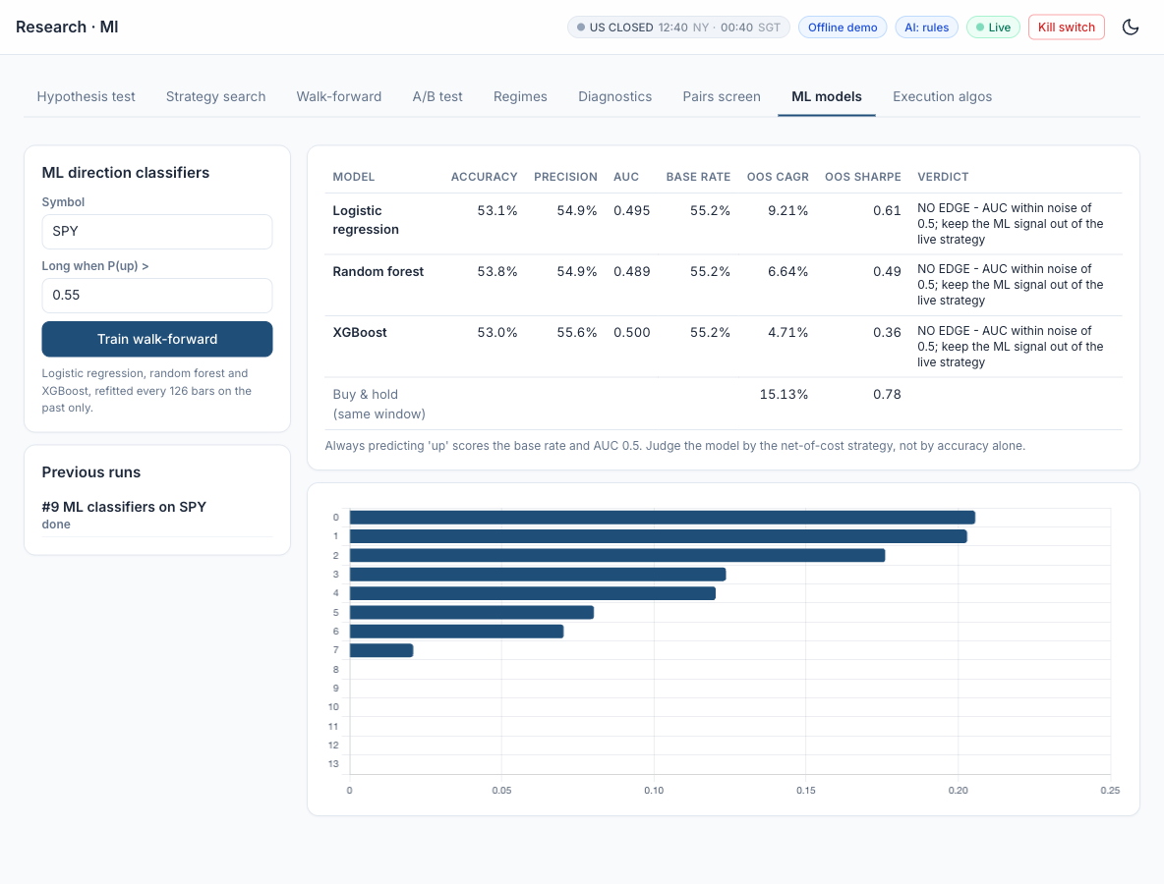
Figure: Lab 11 in the Trading Simulator.

Optional: Let AI Write the Code
This lab needs no coding. To see, run or customise the code behind it, click a link: the AI opens with the prompt filled in and writes the code for you. All prompts are also in labs_lowcode/Prompt_Library.html and .pdf.
A walk-forward machine-learning signal - run it in Google Colab
I am a beginner and do not write code. Write ONE complete Python script that runs as-is in a Google Colab notebook. Start with a !pip install line for any library Colab lacks, use pandas, numpy, matplotlib, scipy, scikit-learn, statsmodels and yfinance only, get daily prices from yfinance (auto_adjust=True unless I say otherwise), put a one-line comment above each section, print results as clear tables and charts, and after the code explain in 5 short bullet points how to read the output. Paper trading and education only. Task: predict whether SPY closes higher tomorrow with walk-forward logistic regression and random forest classifiers (expanding window, first 504 days to train, retrain every 126 days), using features computed with data up to today only: RSI(14), 5- and 21-day returns, 21-day volatility and the distance from SMA(50). Report accuracy and AUC per model and the feature importance, and backtest 'long when P(up) > 0.55' (trade at the next day's open with a 0.05% cost per trade) against buy-and-hold.
Open in Claude | Open in ChatGPT | Open Google Colab

Debrief
Supervised models (K4) can be trained and validated correctly (K6) and still find no edge - an honest negative result is valuable evidence (A4). Walk-forward validation stops the model learning from the future, a leakage test proves the check works, and the cost-aware backtest shows what an AUC of 0.5 is worth in money.

3.9 Lab 12: Regime-Filter Stage: PCA and K-Means as a Gate on the Signals
Maps to: A4, K4, K6 | Duration: 15 min | Slide 165

Scenario
The risk team suspects the desk's signals behave differently in calm and stressed markets. It asks for an unsupervised regime model that can switch signals off in stress - fitted walk-forward so that the gate never uses information from the future.

Objective
Find market regimes with walk-forward K-means and gate a signal in the high-volatility regime.

Lab Steps - In the Trading Simulator
No coding is needed. Make sure the Trading Simulator is running (installed once - see the guide 'Download, Install and Start the Trading Simulator Software') and open http://localhost:8000. In the sidebar open Course Labs > Lab 12: the app shows the same steps with a Go button that opens each page pre-filled. Every step works offline on the bundled demo data and the built-in paper broker.
Step 1. Analyse regimes
Research > Regimes: SPY, 3 clusters, gate the EMA crossover.
Open: http://localhost:8000/#/research/regime (Research > Regimes SPY)
Check: PC1 explains the largest share of variance (the market factor); the 2020 crash is in the stress regime.
Step 2. Backtest the regime-filtered strategy
Backtest 'Regime-filtered strategy (K-means gate)'.
Open: http://localhost:8000/#/backtest?strategy=regime_filtered&symbols=SPY (Backtest SPY regime filter)
Check: Compare max drawdown with the ungated EMA crossover.
Expected in the app: PCA explained variance, a regime timeline and gated vs ungated performance.
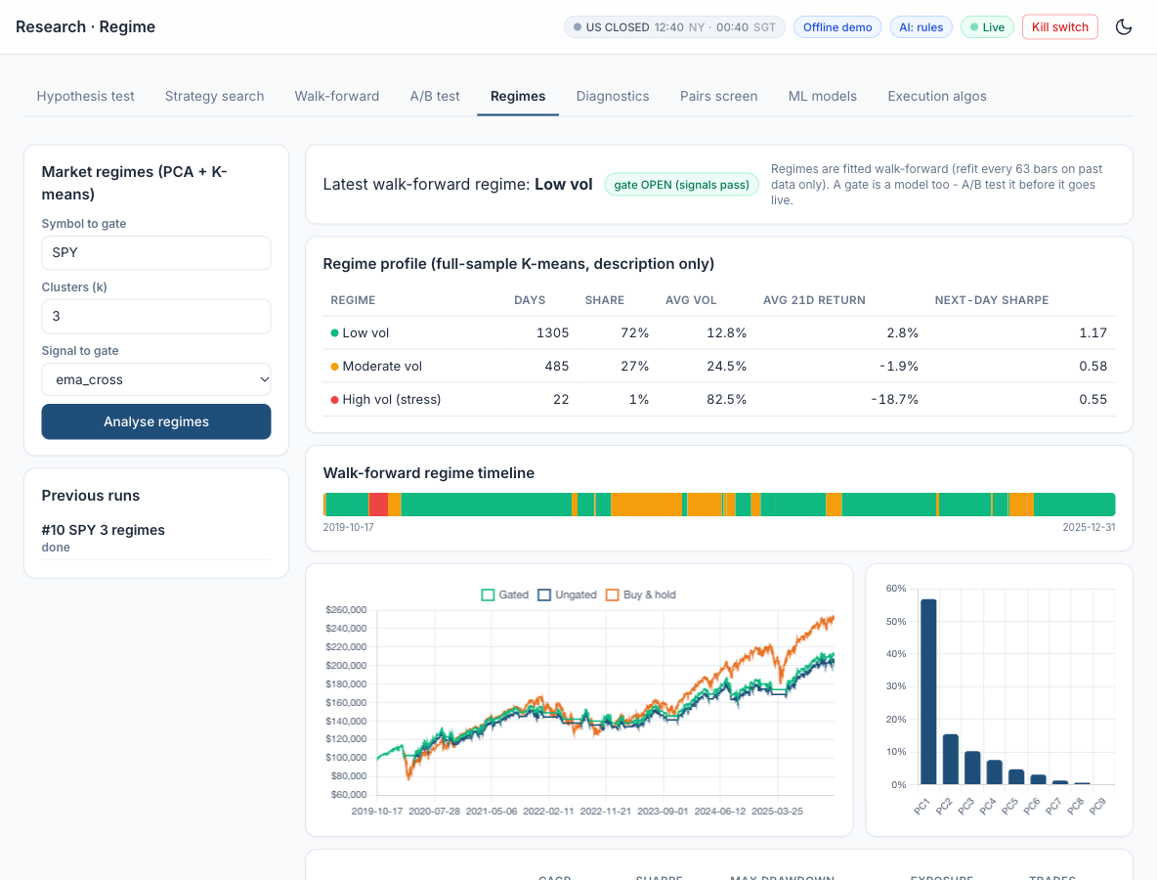
Figure: Lab 12 in the Trading Simulator.

Optional: Let AI Write the Code
This lab needs no coding. To see, run or customise the code behind it, click a link: the AI opens with the prompt filled in and writes the code for you. All prompts are also in labs_lowcode/Prompt_Library.html and .pdf.
Market regimes with PCA and K-means - run it in Google Colab
I am a beginner and do not write code. Write ONE complete Python script that runs as-is in a Google Colab notebook. Start with a !pip install line for any library Colab lacks, use pandas, numpy, matplotlib, scipy, scikit-learn, statsmodels and yfinance only, get daily prices from yfinance (auto_adjust=True unless I say otherwise), put a one-line comment above each section, print results as clear tables and charts, and after the code explain in 5 short bullet points how to read the output. Paper trading and education only. Task: label SPY market regimes for 2018-2025 with PCA and K-means (3 clusters) on the 21-day return, 21-day volatility and 63-day return, fitting on past data only (refit once a year). Plot the regimes on the price chart, then backtest an EMA 20/50 crossover with and without a gate that stays flat in the high-volatility regime (trade at the next day's open with a 0.05% cost per trade) and compare CAGR, Sharpe and maximum drawdown.
Open in Claude | Open in ChatGPT | Open Google Colab

Debrief
Unsupervised learning (K4) finds structure without labels: PCA compresses correlated assets into a few drivers and K-means groups days into regimes. Fitting the regimes walk-forward is part of validating the model (K6), and testing the gate signal by signal after costs (A4) shows that a filter can help one strategy and hurt another.

3.10 Lab 13: A/B-Test Stage: a Statistical Decision before Capital Moves
Maps to: A5, K2 | Duration: 15 min | Slide 167

Scenario
Two portfolio managers each champion a variant for the SPY sleeve: the 200-day trend filter and the 3-day dip buy. The pipeline's rule is that capital only moves between variants when an A/B test on the same days, with the same costs, says the difference is reliable - and the decision is recorded.

Objective
Decide statistically between two variants before moving capital.

Lab Steps - In the Trading Simulator
No coding is needed. Make sure the Trading Simulator is running (installed once - see the guide 'Download, Install and Start the Trading Simulator Software') and open http://localhost:8000. In the sidebar open Course Labs > Lab 13: the app shows the same steps with a Go button that opens each page pre-filled. Every step works offline on the bundled demo data and the built-in paper broker.
Step 1. Run the A/B test
Research > A/B test: A = Trend filter, B = Dip buy, SPY, alpha 0.05, 20 variants tried.
Open: http://localhost:8000/#/research/abtest?a=trend_filter&b=dip_buy (Research > A/B trend_filter vs dip_buy)
Check: Read the decision; if the CI contains 0, do not reject H0.
Step 2. Your own variants
A = EMA crossover {"fast": 10, "slow": 30}, B = EMA crossover {"fast": 20, "slow": 50}.
Open: http://localhost:8000/#/research/abtest?a=ema_cross&b=ema_cross
Check: You can explain the Bonferroni-adjusted alpha.
Expected in the app: Welch and paired t-tests, a bootstrap Sharpe CI and a decision with a multiple-testing caution.
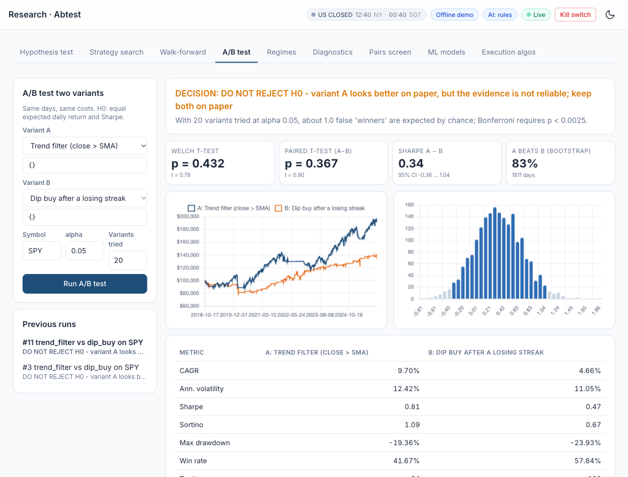
Figure: Lab 13 in the Trading Simulator.

Optional: Let AI Write the Code
This lab needs no coding. To see, run or customise the code behind it, click a link: the AI opens with the prompt filled in and writes the code for you. All prompts are also in labs_lowcode/Prompt_Library.html and .pdf.
A/B test two strategy variants - run it in Google Colab
I am a beginner and do not write code. Write ONE complete Python script that runs as-is in a Google Colab notebook. Start with a !pip install line for any library Colab lacks, use pandas, numpy, matplotlib, scipy, scikit-learn, statsmodels and yfinance only, get daily prices from yfinance (auto_adjust=True unless I say otherwise), put a one-line comment above each section, print results as clear tables and charts, and after the code explain in 5 short bullet points how to read the output. Paper trading and education only. Task: A/B test two strategies on SPY 2018-2025 (trade at the next day's open with a 0.05% cost per trade): A = EMA 10/30 crossover, B = EMA 20/50 crossover. Compare their daily returns with a Welch t-test, a paired t-test and a block-bootstrap 95% confidence interval of the Sharpe difference, apply a Bonferroni correction for 20 variants tried, and state the decision on H0 in one sentence.
Open in Claude | Open in ChatGPT | Open Google Colab

Debrief
A/B testing (A5) applies statistical inference to a business choice: the trend filter looks better, but the evidence cannot reject 'no difference'. Statistical tests (K2) - paired where the data are paired, bootstrapped where returns are not normal, corrected for the number of variants tried - protect capital from being moved on noise.

3.11 Lab 14: Pairs Stage: a Hedged, Market-Neutral Statistical-Arbitrage Sleeve
Maps to: A4, K6 | Duration: 20 min | Slide 169

Scenario
Lion City Capital's equity desk wants a sleeve whose returns do not depend on the direction of the market. The head of trading asks for the classic statistical-arbitrage hedge as a pipeline stage: hold one stock long and an economically linked stock short in hedge-ratio proportion, trade the spread when it stretches, and output per-leg target weights. Candidates: KO/PEP, JPM/BAC and XLF/JPM.

Objective
Screen pairs for cointegration and backtest a market-neutral KO/PEP spread.

Lab Steps - In the Trading Simulator
No coding is needed. Make sure the Trading Simulator is running (installed once - see the guide 'Download, Install and Start the Trading Simulator Software') and open http://localhost:8000. In the sidebar open Course Labs > Lab 14: the app shows the same steps with a Go button that opens each page pre-filled. Every step works offline on the bundled demo data and the built-in paper broker.
Step 1. Screen the pairs
Research > Pairs screen (formation to 2022-12-31).
Open: http://localhost:8000/#/research/pairs (Research > Pairs screen)
Check: High correlation does not imply cointegration - compare the corr and ADF columns.
Step 2. Backtest KO/PEP
Backtest the pairs strategy on KO, PEP (both legs, short leg allowed, borrow cost charged).
Open: http://localhost:8000/#/backtest?strategy=pairs_cointegration&symbols=KO,PEP (Backtest KO/PEP pairs)
Check: Beta to SPY near 0 in 'All metrics'; the trade list has long and short legs.
Expected in the app: An Engle-Granger screen and a pairs backtest with beta near zero.
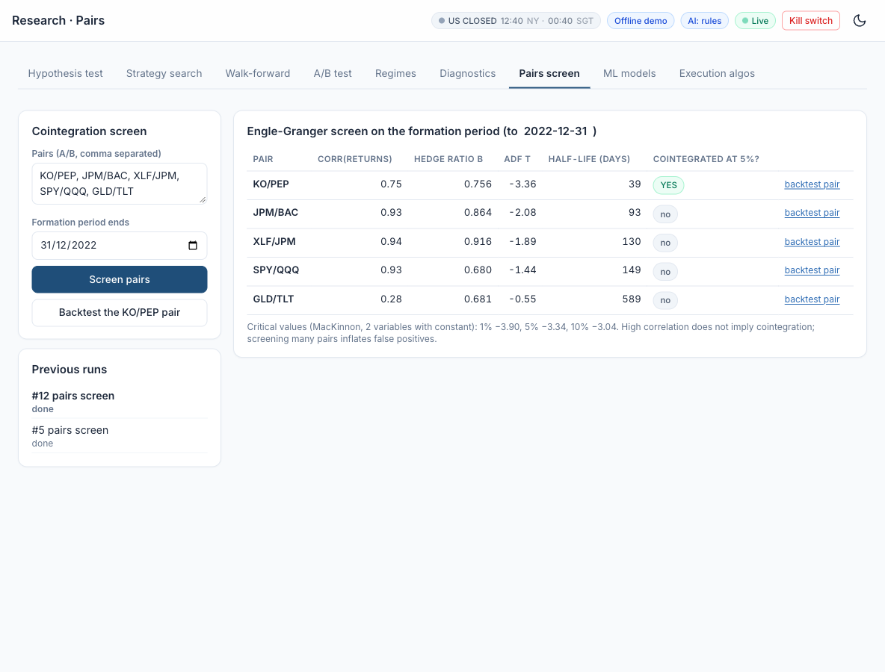
Figure: Lab 14 in the Trading Simulator.

Optional: Let AI Write the Code
This lab needs no coding. To see, run or customise the code behind it, click a link: the AI opens with the prompt filled in and writes the code for you. All prompts are also in labs_lowcode/Prompt_Library.html and .pdf.
A hedged pairs trade - run it in Google Colab
I am a beginner and do not write code. Write ONE complete Python script that runs as-is in a Google Colab notebook. Start with a !pip install line for any library Colab lacks, use pandas, numpy, matplotlib, scipy, scikit-learn, statsmodels and yfinance only, get daily prices from yfinance (auto_adjust=True unless I say otherwise), put a one-line comment above each section, print results as clear tables and charts, and after the code explain in 5 short bullet points how to read the output. Paper trading and education only. Task: screen KO/PEP, XOM/CVX, V/MA and HD/LOW for cointegration (Engle-Granger) on 2018-2022 and estimate each hedge ratio by OLS. Then backtest a market-neutral KO/PEP spread strategy on 2023-2025: 60-day z-score of the spread, enter when |z| > 2, exit when |z| < 0.5, long one leg and short the other, 0.05% cost per leg. Print the screen table, the trades, CAGR, Sharpe, maximum drawdown and the strategy's beta to SPY.
Open in Claude | Open in ChatGPT | Open Google Colab

Debrief
Pairs trading is a hedging algorithm: the short leg cancels most of the market exposure of the long leg, which is why the beta to SPY is near zero (A4). The statistical model is cointegration, not correlation (K6). A pair that is cointegrated in one period can stop reverting in the next, so professional desks re-test cointegration on a rolling basis and size each pair small.

3.12 Topic Summary
- A4 - Conduct statistical modelling of data to derive patterns and solutions
- A5 - Perform A/B testing based on different hypotheses
- K2 - Types of statistical analyses, data models, algorithms and advanced computational methods
- K4 - Range and application of various types of data models
- K6 - Statistical modelling techniques
Assessed by: Practical Performance Task 3 | Written Assessment Q2, Q4, Q6

Topic 4: Building an End-to-End Algorithmic Trading Pipeline: Backtest, Forward Test and Performance Analysis
Day | Abilities | Knowledge | Labs | Slides
Day 2 | A7, A8, A9, A10 | K7, K8 | 15 - 20 | 172 - 196

Learning Outcome
Perform coding and configuration of an automated trading program based on selected models or algorithms, conduct tests on its actions and outcomes, diagnose unintended outcomes, and draw insights from the results to support decisions and report accordingly.

4.1 Architecture of an End-to-End Algorithmic Trading Pipeline
Maps to: A7, K7 | Slides 173, 179
- The pipeline: (1) strategy search and research, (2) data ingestion, (3) signal generation, (4) backtest with costs, (5) risk checks, (6) order execution, (7) forward test on paper, (8) monitoring, logging and performance reporting.
- Configuration lives outside the code: symbols, parameters, position limits and API keys sit in a config file or environment variables, so a change is a reviewed configuration change rather than an edit to the logic.
- Pre-trade risk controls: maximum position size, maximum order value, maximum daily loss, market-hours check, duplicate-order check and a kill switch that halts all trading - the controls regulators require of algorithmic traders.
- Event sources: a scheduled job (every bar), a streaming feed (every quote), or an external alert - such as a TradingView alert sent by webhook to your own server, which then places the order through Alpaca.
- Agentic extension: analyst agents produce a view, a trader agent proposes an order, and a risk-manager agent with hard limits approves or rejects it - the LLM never bypasses the coded risk checks.
- Every decision is logged: timestamp, inputs, signal, order request, broker response and fill - the audit trail for diagnosing problems and for compliance review.

4.2 Backtesting with Realistic Trading Costs
Maps to: A8, K7 | Slides 174-176
- A backtest replays a strategy on historical data. Vectorised backtests are fast (whole-array operations); event-driven backtests replay bar by bar and model orders more realistically.
- Execute on the NEXT bar: a signal computed on today's close can only be traded at tomorrow's open (or later). Same-bar execution is the commonest source of look-ahead bias.
- Trading costs: commission (Alpaca charges none on US equities, but most brokers do), the bid-ask spread, slippage and market impact, and regulatory fees on sells (the US SEC Section 31 fee and FINRA Trading Activity Fee). Short positions also incur borrow costs.
- Model costs explicitly: cost per trade = commission + (half-spread + slippage) x shares x price + regulatory fees. Express them in basis points of traded value so they scale with turnover.
- Report gross and net results side by side, the cost breakdown, and the break-even cost - the cost per trade at which the strategy stops making money.
- A strategy whose edge disappears at 5 to 10 basis points per trade is not tradeable for most desks, however good its gross Sharpe ratio looks.

4.3 Forward Testing with Automated Paper Trading
Maps to: A7, A8 | Slides 180-181
- Forward testing (paper trading) runs the strategy in real time on data it has never seen, placing simulated orders - the bridge between a backtest and live capital.
- The automated bot loop: wait for the bar to close; fetch the latest bars; compute the signal; run the risk checks; compare the target position with the actual position; submit the buy or sell order; read the order status; log everything; sleep until the next bar.
- Alpaca's market clock (is the market open?) and calendar prevent orders outside trading hours; the pattern-day-trader rule applies to paper accounts under USD 25,000 as it does to live ones.
- Run the forward test long enough to see a meaningful number of trades - weeks for a daily strategy - and compare its fills, slippage and returns with what the backtest predicted for the same period.
- Run variants side by side in separate paper accounts as a live A/B test, and only promote a strategy to live trading through a documented review.

4.4 Potential Reasons for Unintended Outcomes and How to Diagnose Them
Maps to: A9, K8 | Slides 177, 182
- Overfitting: parameters tuned to noise. Signs - a spectacular in-sample Sharpe that collapses out of sample, and performance that is very sensitive to small parameter changes.
- Look-ahead bias: using information not available at the decision time - same-bar execution, centred rolling windows, or features normalised with full-sample statistics.
- Survivorship bias: testing only on today's index members, which excludes the companies that failed. Data-snooping bias: reporting the best of many tests without adjustment.
- Cost and execution drag: under-estimated spread and slippage, partial fills and rejected orders. Signs - paper or live returns persistently below the backtest by roughly the turnover x cost.
- Regime change and concept drift: the market behaves differently from the training period (2020 COVID volatility, the 2022 rate-hiking cycle). Monitor rolling performance and feature distributions.
- Data and software errors: unadjusted splits, time-zone mismatches, missing bars, duplicated orders, and stale positions after a restart. Knight Capital's 2012 loss came from obsolete code activated by a deployment error.
- Diagnosis method: reproduce the result, isolate the first step where it diverges from expectation (data, signal, order, fill), compare against a benchmark or a known-good run, fix, then re-test.

4.5 Performance Analysis, Insights and Reporting
Maps to: A10 | Slides 178
- A tearsheet presents the equity curve against the benchmark, the drawdown chart, monthly returns, rolling Sharpe ratio, the metrics table and the cost breakdown on one page.
- Compare backtest and forward test for the same period: did the live fills, number of trades and returns behave as the backtest predicted? Explain every material gap.
- Draw insights, not just numbers: in which regimes did the strategy earn its returns, what drove its drawdowns, how sensitive is it to costs and parameters, and how correlated is it with the desk's existing book?
- Report for the decision-maker: lead with the recommendation (promote, extend the forward test, modify or retire), support it with three or four key figures, and state the risks and limitations plainly.
- Keep a model record: hypothesis, data, parameters, test results, version and approval - the documentation an investment committee and model-risk reviewer expect.

Historical Data: Backtest, Tune, Then Forward Test
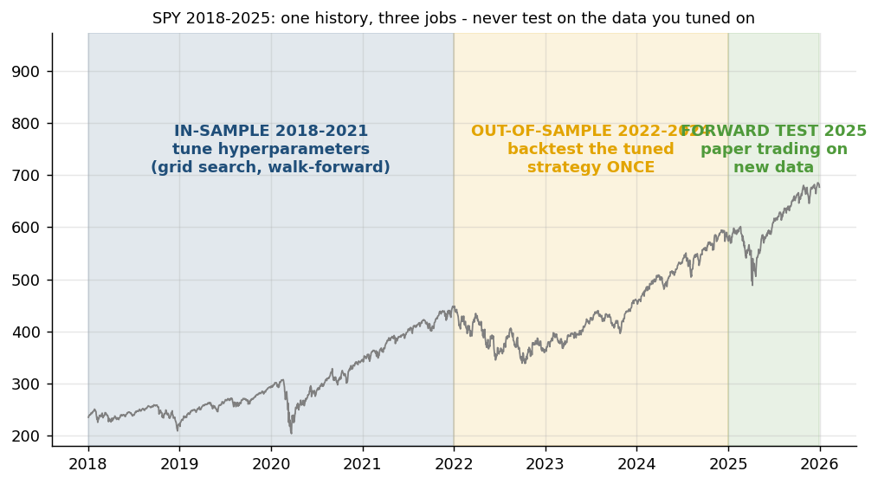
Figure: one history, three jobs - SPY 2018-2025.
Backtest on history | Replay the strategy's rules over past prices - next-bar fills, trading costs - to see how it would have performed.
Tune hyperparameters (in-sample) | Search the settings (MA lengths, RSI levels, model parameters) on the OLDER history only, by grid search or walk-forward.
Confirm out-of-sample | Backtest the tuned settings ONCE on later history the search never saw. A big drop from in-sample = overfitting.
Forward test (paper) | Run the tuned strategy on NEW data as it arrives - paper orders, real fills and risk checks - before any capital.
The same rule moves through four tests; each uses data the previous step never touched.
1. Historical data (2018-2025)
2. Tune in-sample (2018-2021)
3. Backtest once out-of-sample (2022-2024)
4. Forward test on paper (2025 onward)
5. Go-live decision
Tuning on the test period, or re-tuning after seeing out-of-sample results, turns the test into more tuning - the result will look better than reality (Labs 10, 15, 16).

4.6 Lab 15: Backtest-Engine Stage: Cost Models, Execution Timing and Break-Even
Maps to: A7, A8, K7 | Duration: 25 min | Slide 184

Scenario
Alpaca advertises commission-free trading and a trader concludes that costs do not matter. Before the pipeline is automated, the head of execution wants the backtest engine to show gross versus net results under four cost scenarios, where the money goes, the break-even cost of a fast and a slow strategy, and how sensitive results are to the assumed fill time.

Objective
Run the same strategy under four cost models and find its break-even cost.

Lab Steps - In the Trading Simulator
No coding is needed. Make sure the Trading Simulator is running (installed once - see the guide 'Download, Install and Start the Trading Simulator Software') and open http://localhost:8000. In the sidebar open Course Labs > Lab 15: the app shows the same steps with a Go button that opens each page pre-filled. Every step works offline on the bundled demo data and the built-in paper broker.
Step 1. Zero vs Alpaca vs high-cost
Backtest Dip buy on SPY three times with cost model zero, alpaca_retail and high_cost.
Open: http://localhost:8000/#/backtest?strategy=dip_buy&symbols=SPY&costs=high_cost (Backtest SPY dip-buy, high-cost route)
Check: The 'Costs: gross vs net' tab shows the drag; dip-buy trades often, so costs bite.
Step 2. Break-even and execution timing
Read the break-even one-way cost; then switch Execution to 'next bar close' and compare.
Open: http://localhost:8000/#/backtest?strategy=dip_buy&symbols=SPY&execution=next_close
Check: A strategy whose break-even is only a few bps is fragile.
Step 3. Stops and sizing
Open 'position sizing, stop-loss, take-profit' and run EMA 20/50 with a 5% stop and volatility-target sizing.
Open: http://localhost:8000/#/backtest?strategy=ema_cross&symbols=SPY&fast=20&slow=50&stop_loss_pct=5&sizing=vol_target
Check: The trade list shows stop_loss exits.
Expected in the app: Gross vs net CAGR, a cost breakdown and the break-even bps.
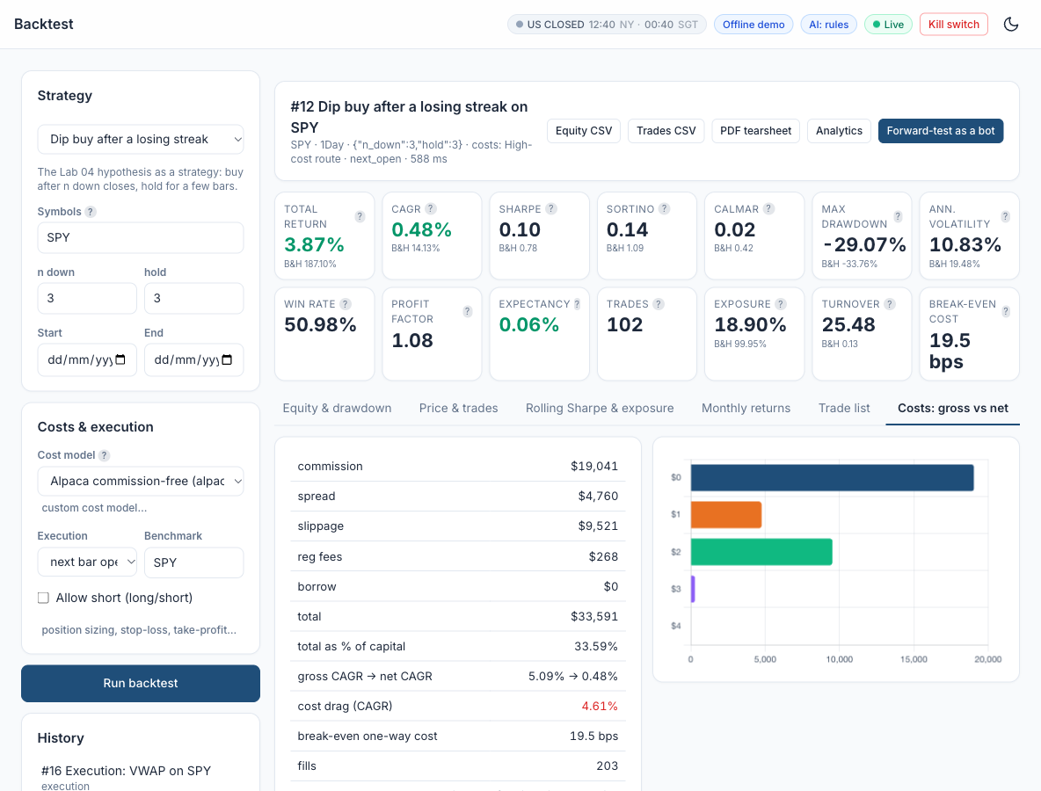
Figure: Lab 15 in the Trading Simulator.

Optional: Let AI Write the Code
This lab needs no coding. To see, run or customise the code behind it, click a link: the AI opens with the prompt filled in and writes the code for you. All prompts are also in labs_lowcode/Prompt_Library.html and .pdf.
Trading costs and the break-even cost - run it in Google Colab
I am a beginner and do not write code. Write ONE complete Python script that runs as-is in a Google Colab notebook. Start with a !pip install line for any library Colab lacks, use pandas, numpy, matplotlib, scipy, scikit-learn, statsmodels and yfinance only, get daily prices from yfinance (auto_adjust=True unless I say otherwise), put a one-line comment above each section, print results as clear tables and charts, and after the code explain in 5 short bullet points how to read the output. Paper trading and education only. Task: backtest 'buy when RSI(2) < 10, sell when RSI(2) > 70' on SPY 2018-2025 at the next day's open under three cost models - zero, retail (0.02% spread + 0.01% slippage) and high (0.10% + 0.05%). Print gross and net CAGR and Sharpe for each, find the break-even one-way cost in basis points by bisection, and compare next-day-open with next-day-close execution.
Open in Claude | Open in ChatGPT | Open Google Colab

Debrief
Commission is only one trading cost (K7): spread and slippage scale with turnover, and the assumed fill time can matter as much as the fee schedule. Coding the cost model into the engine (A7) and testing outcomes under several scenarios (A8) shows whether an edge survives real-world execution - the break-even cost is the single number that says how much room the strategy has.

4.7 Lab 16: Automation Stage: a Scheduled, Risk-Checked Forward Test and Live Paper Trading
Maps to: A7, A8, K7 | Duration: 25 min | Slide 186

Scenario
The desk is ready to automate the configured EMA 10/30 strategy on SPY. Before any capital is considered, the pipeline must run unattended as a forward test: one decision cycle at a fixed time, completed bars only, pre-trade risk checks, a kill switch, idempotent paper orders and an audit row for every decision - first as a 2025 replay, then live on the Alpaca paper account during class.

Objective
Create a bot, run it on a schedule, watch orders, positions and P&L live, and halt it with the kill switch.

Lab Steps - In the Trading Simulator
No coding is needed. Make sure the Trading Simulator is running (installed once - see the guide 'Download, Install and Start the Trading Simulator Software') and open http://localhost:8000. In the sidebar open Course Labs > Lab 16: the app shows the same steps with a Go button that opens each page pre-filled. Every step works offline on the bundled demo data and the built-in paper broker.
Step 1. Create the bot
Paper Trading > + New bot: EMA crossover 10/30 on SPY, schedule 'every 10s', simulator broker, replay from 2025-01-02.
Open: http://localhost:8000/#/trading?new=1&strategy=ema_cross (Paper Trading > New bot (EMA cross))
Check: The bot appears with status stopped.
Step 2. Start it and watch
Press Start. Every cycle replays one trading day: it sees bars to yesterday's close and its orders fill at today's open. Or press 'Run one cycle now' repeatedly. (If the bot does not cycle, the simulator was started without its scheduler - ask your trainer.)
Open: http://localhost:8000/#/trading
Check: Equity curve grows cycle by cycle; the Pipeline Map path lights up during each cycle.
Step 3. Kill switch
Press the bot's Kill switch, then try 'Run one cycle now'. Release it. Try the global kill switch in the top bar too.
Open: http://localhost:8000/#/trading
Check: Cycles report 'kill switch ON - no orders sent'; the Risk stage turns red on the Pipeline Map.
Step 4. Backtest vs forward
Press Compare in 'Backtest vs forward test'.
Open: http://localhost:8000/#/trading
Check: The curves track closely; you can explain the remaining gap (whole shares, fills, timing).
Expected in the app: A bot equity curve, a blotter of its orders, a backtest-vs-forward comparison and a tested kill switch.
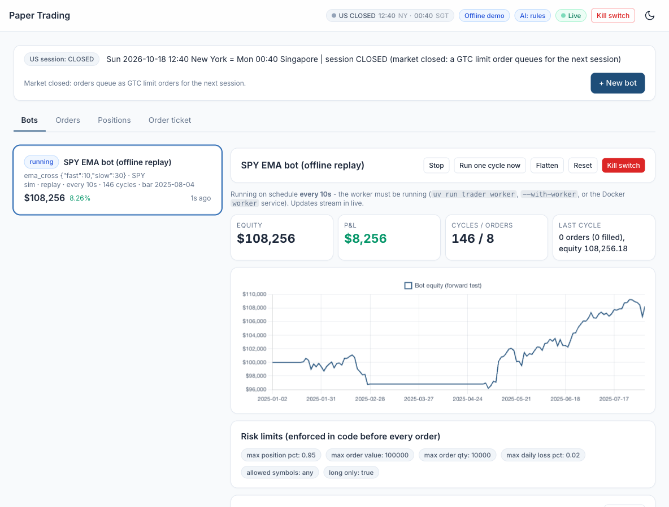
Figure: Lab 16 in the Trading Simulator.

Optional: Let AI Write the Code
This lab needs no coding. To see, run or customise the code behind it, click a link: the AI opens with the prompt filled in and writes the code for you. All prompts are also in labs_lowcode/Prompt_Library.html and .pdf.
A risk-checked paper-trading bot - run it in Google Colab
I am a beginner and do not write code. Write ONE complete Python script that runs as-is in a Google Colab notebook. Start with a !pip install line for any library Colab lacks, use pandas, numpy, matplotlib, scipy, scikit-learn, statsmodels and yfinance only, get daily prices from yfinance (auto_adjust=True unless I say otherwise), put a one-line comment above each section, print results as clear tables and charts, and after the code explain in 5 short bullet points how to read the output. Paper trading and education only. Task: write a simple paper-trading bot for SPY: each run it takes daily bars up to yesterday, computes an EMA 10/30 crossover, checks risk limits (maximum position 50% of equity, no new buys after a 2% daily loss, a KILL_SWITCH flag) and changes the position only when the target changes, logging every decision to a CSV. Include a replay mode that simulates 2025 day by day with a $100,000 paper account (no broker needed) and compares the forward result with a backtest of the same rule.
Open in Claude | Open in ChatGPT | Open Google Colab

Debrief
The runner is a software agent coded from a selected model (A7): signal on completed bars, deterministic risk limits, idempotent execution, a kill switch and an audit log. The forward test and the live paper loop check the actions it takes and their outcomes on unseen data (A8), including the real effect of whole shares, fills and session rules (K7).

4.8 Lab 17: Event-Driven Automation: TradingView Webhook to Signal, Risk and Execution
Maps to: A7, K5, K7 | Duration: 20 min | Slide 188

Scenario
Some Lion City Capital traders design signals in TradingView. The desk wants their alerts to place paper orders automatically - but only through the pipeline: a gateway that checks a shared secret, the allow-list, a maximum size and duplicate alerts, asks the pipeline's own signal, runs the risk checks and then hands the order to the order manager, logging every request.

Objective
Send TradingView alerts to the app's webhook and see them pass validation, signal confirmation and risk into paper orders.

Lab Steps - In the Trading Simulator
No coding is needed. Make sure the Trading Simulator is running (installed once - see the guide 'Download, Install and Start the Trading Simulator Software') and open http://localhost:8000. In the sidebar open Course Labs > Lab 17: the app shows the same steps with a Go button that opens each page pre-filled. Every step works offline on the bundled demo data and the built-in paper broker.
Step 1. Copy the alert template
Integrations > TradingView webhook: copy the URL and the JSON alert message (reveal the secret only on your own machine).
Open: http://localhost:8000/#/integrations (Integrations > TradingView webhook)
Check: You know which placeholders TradingView fills in.
Step 2. Run the self-test
Press 'Run self-test (7 simulated alerts)'.
Open: http://localhost:8000/#/integrations
Check: 7/7: valid buy and sell (200), wrong secret (401), symbol not allowed and qty too large (422), malformed (400), retry ignored (200 duplicate).
Step 3. Real alerts (paid TradingView plan)
Optional - trainer demonstration: with a paid TradingView plan, an alert on the exported Pine strategy can post to the simulator's webhook URL once the trainer has made the simulator reachable from the internet (a public tunnel URL). Watch the trainer's alert pass validation, signal confirmation and risk into a paper order.
Open: http://localhost:8000/#/integrations
Check: The alert appears in the audit log and its order in Paper Trading > Orders (source webhook).
Expected in the app: 7 simulated alerts handled as expected and the audit log.
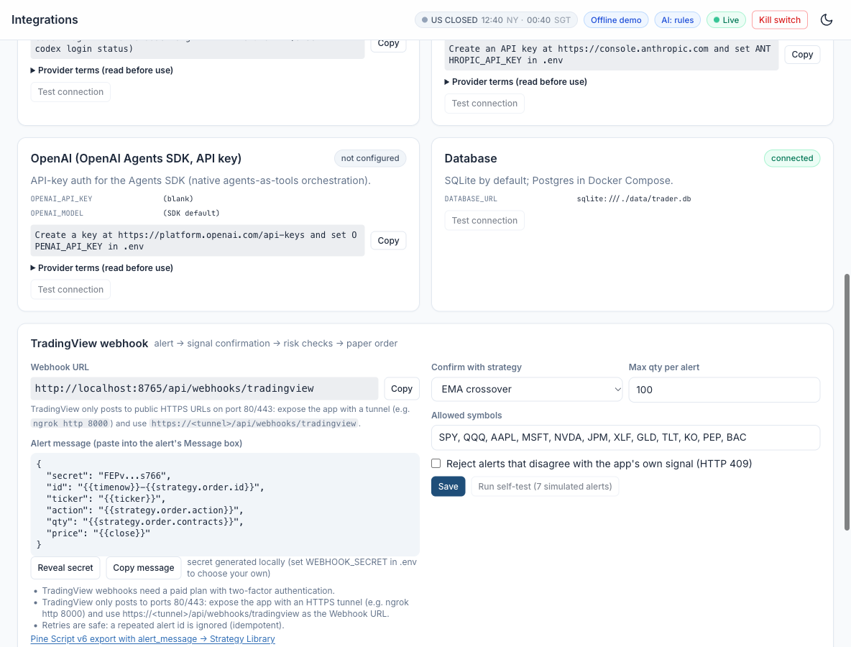
Figure: Lab 17 in the Trading Simulator.

Optional: Let AI Write the Code
This lab needs no coding. To see, run or customise the code behind it, click a link: the AI opens with the prompt filled in and writes the code for you. All prompts are also in labs_lowcode/Prompt_Library.html and .pdf.
A webhook that turns TradingView alerts into paper orders - run it in Google Colab
I am a beginner and do not write code. Write ONE complete Python script that runs as-is in a Google Colab notebook. Start with a !pip install line for any library Colab lacks, use pandas, numpy, matplotlib, scipy, scikit-learn, statsmodels and yfinance only, get daily prices from yfinance (auto_adjust=True unless I say otherwise), put a one-line comment above each section, print results as clear tables and charts, and after the code explain in 5 short bullet points how to read the output. Paper trading and education only. Task: write a small FastAPI app with a /webhook endpoint that receives a TradingView alert JSON {secret, ticker, action, price}, rejects a wrong secret, validates the fields, confirms the signal with a 20-day SMA check, caps the position size, and logs the paper order it would send. Test it inside Colab with FastAPI's TestClient by posting 7 sample alerts (valid buy, valid sell, wrong secret, missing field, unknown ticker, duplicate, oversized) and print each result.
Open in Claude | Open in ChatGPT | Open Google Colab

Debrief
A webhook lets a charting platform trigger execution on a trading platform (K5), but the gateway code (A7) is where the controls live: authentication, allow-lists, size limits, duplicate protection, the pipeline's own signal, the risk layer and an audit log. Each automated order still pays spread and slippage (K7), so alert frequency matters.

4.9 Lab 18: Diagnostics Stage: Automated Bias Checks before Go-Live
Maps to: A9, K8 | Duration: 20 min | Slide 190

Scenario
A junior quant sends the investment committee a 'smoothed momentum' backtest on SPY with a Sharpe ratio above 4 and asks to go live. The desk responds by adding a diagnostics stage to the pipeline: every strategy - including its own ema_cross - must pass automated checks for look-ahead, cost drag, overfitting and survivorship before it may trade, even on paper.

Objective
Run the automated diagnostics on a deliberately biased strategy, fix it, and re-run.

Lab Steps - In the Trading Simulator
No coding is needed. Make sure the Trading Simulator is running (installed once - see the guide 'Download, Install and Start the Trading Simulator Software') and open http://localhost:8000. In the sidebar open Course Labs > Lab 18: the app shows the same steps with a Go button that opens each page pre-filled. Every step works offline on the bundled demo data and the built-in paper broker.
Step 1. Diagnose the biased exhibit
Research > Diagnostics on 'Lab 18 exhibit: biased smoothed momentum' (seeded custom strategy).
Open: http://localhost:8000/#/research/diagnostics?strategy=custom_lab18_biased_smoothed_momentum (Research > Diagnostics (Lab 18 exhibit))
Check: Look-ahead (features) FAIL: rolling(center=True) uses future bars. Verdict BLOCK.
Step 2. Fix it in the Strategy Builder
Open the exhibit in the Strategy Builder and change the single setting center=True to center=False (or let AI fix it: use the Lab 18 Strategy Builder prompt in the Prompt Library). Validate, Save.
Open: http://localhost:8000/#/builder?key=custom_lab18_biased_smoothed_momentum (Strategy Builder (exhibit))
Check: The validation's look-ahead check now passes.
Step 3. Re-run diagnostics
Diagnose the fixed strategy; compare the same-bar vs next-bar Sharpe and the cost-drag row.
Open: http://localhost:8000/#/research/diagnostics?strategy=custom_lab18_biased_smoothed_momentum
Check: No FAIL on look-ahead; cost drag and overfitting WARN explained.
Expected in the app: A FAIL on the biased exhibit, a PASS / WARN table for the fixed version and a verdict.
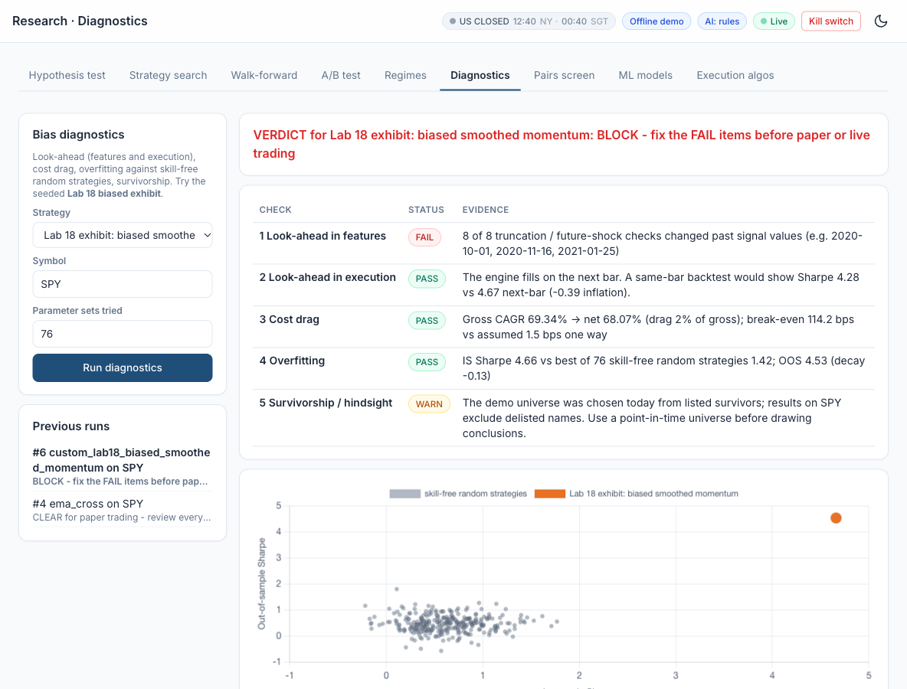
Figure: Lab 18 in the Trading Simulator.

Optional: Let AI Write the Code
This lab needs no coding. To see, run or customise the code behind it, click a link: the AI opens with the prompt filled in and writes the code for you. All prompts are also in labs_lowcode/Prompt_Library.html and .pdf.
Diagnose a too-good-to-be-true backtest - run it in Google Colab
I am a beginner and do not write code. Write ONE complete Python script that runs as-is in a Google Colab notebook. Start with a !pip install line for any library Colab lacks, use pandas, numpy, matplotlib, scipy, scikit-learn, statsmodels and yfinance only, get daily prices from yfinance (auto_adjust=True unless I say otherwise), put a one-line comment above each section, print results as clear tables and charts, and after the code explain in 5 short bullet points how to read the output. Paper trading and education only. Task: recreate this biased SPY strategy on 2018-2025: signal = 1 when the 5-day rolling mean computed with center=True is rising; strategy return = signal x the same day's return; no costs. Print its CAGR and Sharpe, then fix it one problem at a time - a trailing window, next-day execution, a 0.05% cost - printing CAGR and Sharpe after each fix next to buy-and-hold, and explain each bias in plain English.
Open in Claude | Open in ChatGPT | Open Google Colab
Fix the Lab 18 exhibit in the Strategy Builder - paste it into the Strategy Builder
Here is a strategy from my Trading Simulator's Strategy Builder that looks too good to be true. Find the look-ahead bias, explain it in plain English for a beginner, and give me the corrected code with the same class name and params, changing as little as possible. Use only data up to each bar: the engine trades on the next bar. Here is the code: [paste the exhibit's code from the Strategy Builder here]
Open in Claude | Open in ChatGPT

Debrief
Most 'too good to be true' results come from a short list of causes (K8): look-ahead in features or execution, overfitting, survivorship and ignored costs. Automating the checks and using the verdict as a gate (A9) is what stops an unintended outcome from reaching even a paper account - and the same checks run on the desk's own strategy, not only on other people's.

4.10 Lab 19: Monitoring and Reporting Stage: Automated Tearsheet and Backtest-vs-Forward Report
Maps to: A8, A10 | Duration: 25 min | Slide 192

Scenario
After a year of paper trading, the investment committee wants a one-page tearsheet and a short report on the automated EMA 10/30 strategy: how the research backtest compares with the forward test, what it cost, whether any monitoring limit is breached, and whether the desk should allocate capital - produced automatically by the pipeline, every time.

Objective
Produce a one-page tearsheet and explain the gap between backtest and forward test.

Lab Steps - In the Trading Simulator
No coding is needed. Make sure the Trading Simulator is running (installed once - see the guide 'Download, Install and Start the Trading Simulator Software') and open http://localhost:8000. In the sidebar open Course Labs > Lab 19: the app shows the same steps with a Go button that opens each page pre-filled. Every step works offline on the bundled demo data and the built-in paper broker.
Step 1. Export the tearsheet
Backtest page (or Analytics) > PDF tearsheet for your best backtest; also export the equity and trades CSV.
Open: http://localhost:8000/#/analytics (Analytics > PDF tearsheet)
Check: The PDF has equity vs benchmark, drawdown, monthly heatmap, metrics and the cost table.
Step 2. Backtest vs forward
Analytics: select your Lab 16 bot under 'Bot (backtest vs forward)'.
Open: http://localhost:8000/#/analytics
Check: Explain every material gap (fills, sizing, costs, timing).
Step 3. Draw insights
Monthly heatmap: in which regimes did the strategy earn its returns, what drove its drawdowns?
Open: http://localhost:8000/#/analytics
Check: Two or three insights, not just numbers.
Expected in the app: A PDF tearsheet and a written explanation of the backtest-vs-forward differences.
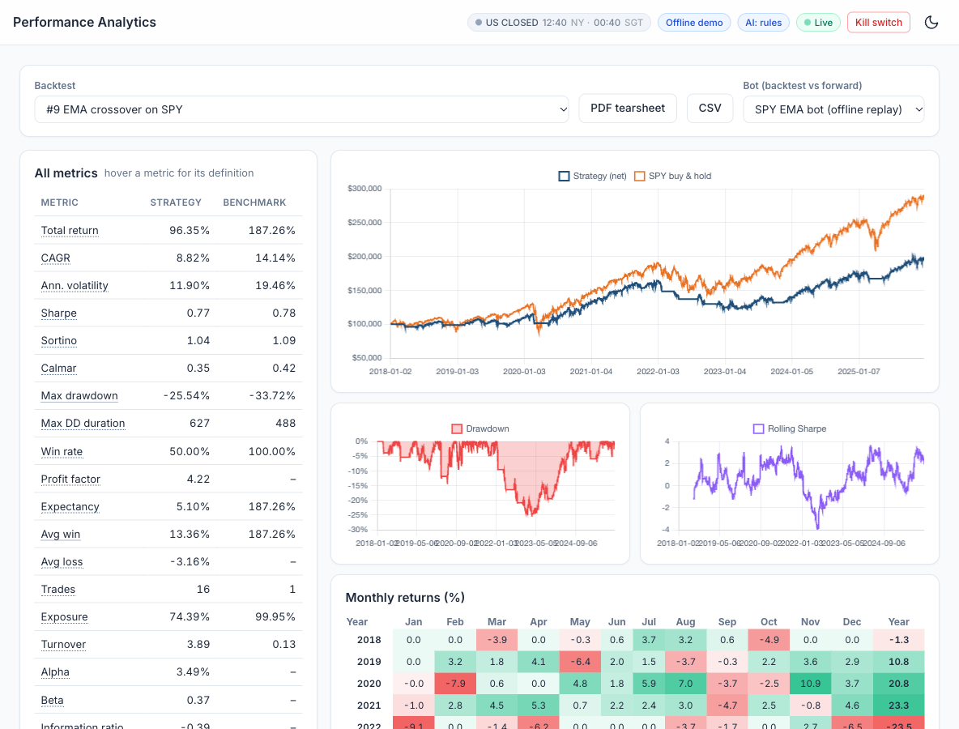
Figure: Lab 19 in the Trading Simulator.

Optional: Let AI Write the Code
This lab needs no coding. To see, run or customise the code behind it, click a link: the AI opens with the prompt filled in and writes the code for you. All prompts are also in labs_lowcode/Prompt_Library.html and .pdf.
A one-page performance tearsheet - run it in Google Colab
I am a beginner and do not write code. Write ONE complete Python script that runs as-is in a Google Colab notebook. Start with a !pip install line for any library Colab lacks, use pandas, numpy, matplotlib, scipy, scikit-learn, statsmodels and yfinance only, get daily prices from yfinance (auto_adjust=True unless I say otherwise), put a one-line comment above each section, print results as clear tables and charts, and after the code explain in 5 short bullet points how to read the output. Paper trading and education only. Task: produce a one-page PDF tearsheet for an EMA 10/30 crossover on SPY 2018-2025 (trade at the next day's open with a 0.05% cost per trade): equity curve against buy-and-hold, a drawdown chart, a monthly returns heatmap and a metrics table (CAGR, Sharpe, Sortino, maximum drawdown, win rate). Then replay 2025 day by day with the same rule and explain any difference from the 2025 backtest.
Open in Claude | Open in ChatGPT | Open Google Colab

Debrief
Comparing the backtest with the forward test is the final test of whether actions and outcomes match the model (A8). Automated monitoring with explicit thresholds turns that comparison into an alarm, and a good report turns numbers into trends, insights and a clear, conditional recommendation (A10) - including the honest message that the strategy reduces risk but has not beaten buy and hold.

4.11 Lab 20: Capstone: One Command Runs the Pipeline End to End, with an Agentic Layer and Human Approval
Maps to: A7, A10, K1 | Duration: 20 min | Slide 194

Scenario
Lion City Capital's head of trading wants the whole pipeline - data, research, signals, execution, automation, diagnostics and reporting - to run with one command, stop sending orders whenever a gate fails, and finish with an optional multi-agent layer (inspired by the TradingAgents framework, arXiv 2412.20138) whose proposals pass hard risk limits and a human's approval before any paper order.

Objective
Run the whole pipeline end to end, get a human-approved proposal from the multi-agent desk, switch on the always-on agent, and create, backtest and forward-test your own strategy (from a template or written for you by AI).

Lab Steps - In the Trading Simulator
No coding is needed. Make sure the Trading Simulator is running (installed once - see the guide 'Download, Install and Start the Trading Simulator Software') and open http://localhost:8000. In the sidebar open Course Labs > Lab 20: the app shows the same steps with a Go button that opens each page pre-filled. Every step works offline on the bundled demo data and the built-in paper broker.
Step 1. Run the multi-agent desk
AI Agents > Run multi-agent analysis on NVDA, AAPL, SPY. Read each agent's card: three analysts, the two-round bull/bear debate, the trader, the risk manager, the hard-limit gate (code) and the portfolio manager.
Open: http://localhost:8000/#/agents (AI Agents > desk)
Check: Eight agent entries per symbol plus the code gate; the brain badge shows which provider or rules answered.
Step 2. Human approval
Approve (or reject) the proposals. Approved buys become paper bracket orders in the regular session or extended-hours limit orders overnight.
Open: http://localhost:8000/#/agents
Check: Run status 'executed' and the orders visible in Paper Trading (source agent).
Step 3. Always-on agent
AI Agents > Always-on agent: enable it with a 60-minute wake-up (the worker must run), or press 'Wake it now'. Check Memory.
Open: http://localhost:8000/#/agents
Check: A new always_on run and memory notes appear.
Step 4. Create your own strategy
Strategy Builder: start from a template and change only its parameters - or describe your idea in the Lab 20 prompt of the Prompt Library and paste the code the AI writes. Validate (look-ahead check), Save.
Open: http://localhost:8000/#/builder?template=ema_rsi (Strategy Builder (EMA + RSI template))
Check: Your strategy appears in the Strategy Library with an auto-generated parameter form.
Step 5. Backtest, diagnose and forward-test it
Backtest it, run Diagnostics, then create a paper bot for it and start it.
Open: http://localhost:8000/#/trading?new=1
Check: Pipeline Map > Strategy lifecycle for your strategy shows the gates it passed.
Step 6. End-to-end on the Pipeline Map
Open the Pipeline Map and press 'Run a bot cycle'. Then switch to 'Strategy lifecycle'.
Open: http://localhost:8000/#/pipeline (Pipeline Map)
Check: All 14 stages have run; you can walk a colleague through each stage.
Expected in the app: A Pipeline Map with every stage green, an approved agent proposal with its decision trace, and your custom strategy trading on paper.
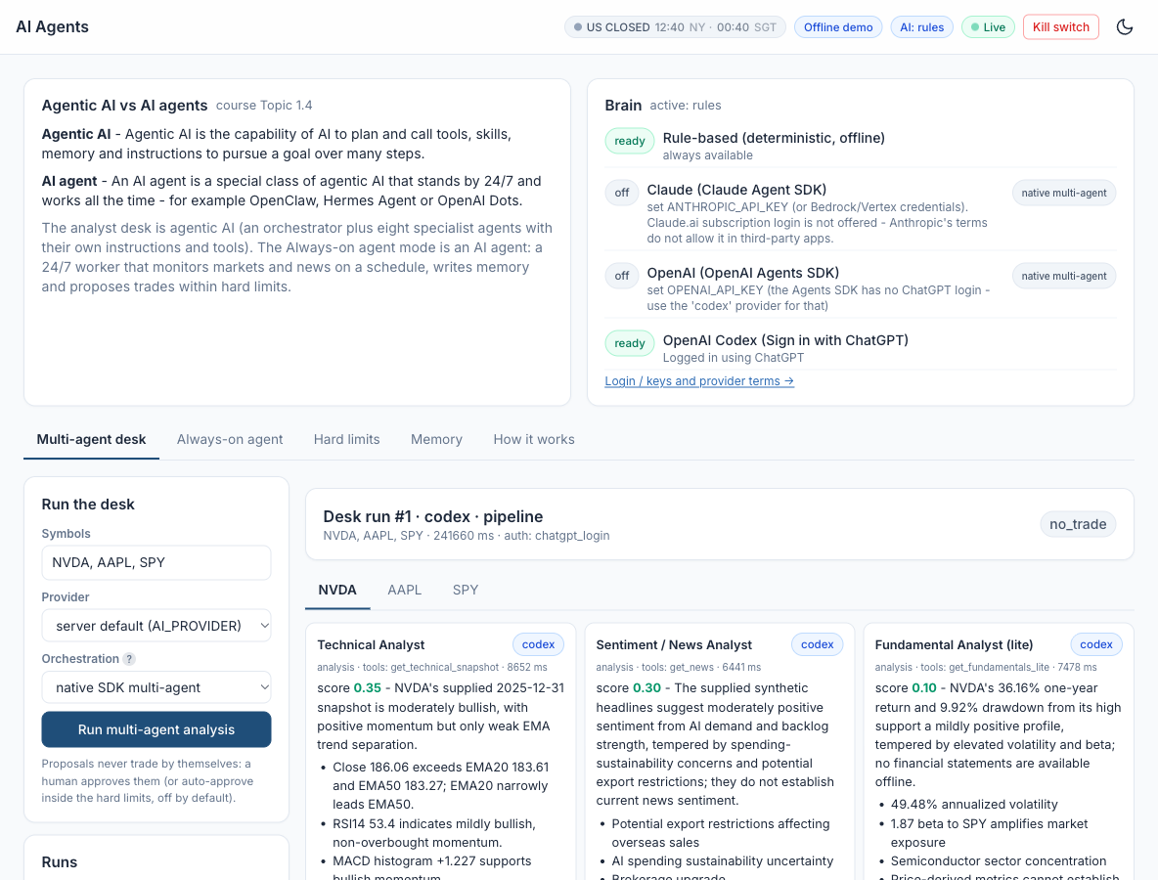
Figure: Lab 20 in the Trading Simulator.

Optional: Let AI Write the Code
This lab needs no coding. To see, run or customise the code behind it, click a link: the AI opens with the prompt filled in and writes the code for you. All prompts are also in labs_lowcode/Prompt_Library.html and .pdf.
Your own strategy for the Strategy Builder - paste it into the Strategy Builder
Write a strategy for my Trading Simulator's Strategy Builder. Rules: one Python class that subclasses Strategy (from trader.strategies.base import Strategy, enter_exit, flat_until_ready); import indicators with `from trader.core import indicators as ta` (ta.sma(series, window), ta.ema(series, span), ta.rsi(close, window), ta.macd(close, fast, slow, signal) returns columns macd/signal/hist, ta.bollinger(close, window, k) returns columns lower/middle/upper/pct_b, ta.atr(df, window), ta.donchian(df, window), ta.realized_vol(close, window)); give it a name and a params dict such as {"window": {"default": 20, "min": 2, "max": 200, "help": "Lookback in bars"}}; implement generate_signals(self, data) where data is an OHLCV DataFrame, and return a Series of 1 (long), 0 (flat) or -1 (short) aligned to data.index. Use only data up to each bar - no center=True and no shift(-1) - because the engine trades on the next bar. Reply with the code only, then 3 bullet points explaining the rule. My idea: buy SPY when RSI(14) falls below 30 while the close is above its 200-day SMA, and sell when RSI(14) rises above 55. (Replace this idea with your own.)
Open in Claude | Open in ChatGPT

Debrief
Agentic AI (K1) chains specialised agents that reason, debate and act, which makes it powerful and risky. Wiring it into an end-to-end pipeline whose gates, deterministic risk limits, kill switch and human approval it cannot override (A7), and evaluating every stage's evidence critically (A10), is how a desk adopts AI and automation responsibly.

4.12 Topic Summary
- A7 - Perform coding and configuration of software agents or programs based on selected models or algorithms
- A8 - Conduct tests on the actions taken and outcomes to assess effectiveness of the models
- A9 - Diagnose unintended outcomes produced by statistical models
- A10 - Draw relevant trends and insights from data analysis to support decisions and report accordingly
- K7 - Coding languages for programming of algorithms and signals
- K8 - Potential reasons for unintended outcomes
Assessed by: Practical Performance Task 4 | Written Assessment Q7, Q8

Assessment Preparation
The assessment mirrors what you have practised. The Written Assessment asks you to explain what you did and why; the Practical Performance asks you to do it again on a new trading scenario. Each lab folder also contains a LabNN_Instructions.pdf with the same steps, AI prompts and checks as this guide.
Question | TSC Ref | Knowledge Statement | Topic | Marks
Q1 | K1 | Data analytics and modelling business use cases | Topic 1 | 11
Q2 | K2 | Types of statistical analyses, data models, algorithms and advanced computational methods | Topic 3 | 11
Q3 | K3 | Range and application of various statistical methods and algorithms | Topic 2 | 11
Q4 | K4 | Range and application of various types of data models | Topic 3 | 11
Q5 | K5 | Usage of analytics platforms and tools | Topic 2 | 11
Q6 | K6 | Statistical modelling techniques | Topic 3 | 11
Q7 | K7 | Coding languages for programming of algorithms and signals | Topic 2 | 11
Q8 | K8 | Potential reasons for unintended outcomes | Topic 4 | 12
Q9 | K9 | Forms of data within financial services | Topic 1 | 11

Task | TSC Ref | Task Title | Related Labs
Task 1 | A1, A6 | Develop and test the trading hypothesis, and identify big data applications | Labs 3 and 4
Task 2 | A2, A3 | Justify the statistical algorithms and data model, and apply the provided program and TradingView | Labs 5 to 9
Task 3 | A4, A5 | Model the data with walk-forward logistic regression and A/B test two variants | Labs 10 to 14
Task 4 | A7, A8, A9, A10 | Configure and forward-test the trading program, diagnose the unintended outcome and report to the investment committee | Labs 15 to 20

Formula Sheet
Measure | Formula / definition
Simple return | r_t = P_t / P_(t-1) - 1
CAGR | (ending value / starting value)^(1 / years) - 1
Annualised volatility | standard deviation of daily returns x sqrt(252)
Sharpe ratio | (mean daily return - daily risk-free rate) / std of daily returns x sqrt(252)
Sortino ratio | as Sharpe, but dividing by the standard deviation of negative returns only
Maximum drawdown | min over t of (equity_t / running peak_t - 1)
Calmar ratio | CAGR / |maximum drawdown|
Win rate | profitable trades / total trades
Profit factor | gross profit / |gross loss|
Expectancy | win rate x average win - (1 - win rate) x |average loss|
Exposure | share of bars with a non-zero position
Turnover | total traded value / average capital
Beta / alpha | regression of strategy returns on benchmark returns: slope = beta, intercept = alpha
EMA | EMA_t = a x P_t + (1 - a) x EMA_(t-1), a = 2 / (n + 1)
RSI | 100 - 100 / (1 + average gain / average loss), Wilder smoothing over 14 bars
Bollinger Bands | SMA_20 +/- 2 x rolling standard deviation_20
Cost per trade | commission + (half-spread + slippage) x shares x price + regulatory fee on sells
Welch's t statistic | (mean_B - mean_A) / sqrt(s_A^2 / n_A + s_B^2 / n_B)

Troubleshooting Cheat-Sheet
Sign | Most likely cause | First diagnostic step
401 / 403 from Alpaca | Wrong or live keys used against the paper endpoint | Regenerate paper keys; paste them again in Integrations > Alpaca and press Save & test
Simulator shows 'Offline demo' | No Alpaca keys saved in Integrations | Expected if you have no account - the bundled data is used
Empty DataFrame of bars | Weekend / holiday range, or symbol not on the IEX feed | Widen the date range; try SPY; check the feed setting
Order rejected | Market closed, insufficient buying power, PDT rule, bad quantity | Read the order's status and reject reason; check the market clock
Backtest looks too good | Look-ahead (same-bar execution) or no costs | Check the signal is shifted one bar; re-run with costs
Great in-sample, poor out-of-sample | Overfitting from parameter search | Compare the heatmap's neighbours; test on the hold-out period
Price chart shows a sudden 50% drop | Unadjusted stock split | Use adjusted data (adjustment='all' on Alpaca)
Times are off by hours | UTC versus New York versus Singapore time | Read the session badge in the simulator's top bar (New York and Singapore time)
Pine script will not compile | Missing //@version=6 or v5 syntax | Read the Pine Editor console line number; check function names
Webhook not received | No public URL, wrong secret, or free TradingView plan | Run the self-test on Integrations > TradingView webhook first

Glossary
Term | Meaning
Algorithmic trading | Using computer programs that follow predefined rules on price, timing, volume or models to generate and execute orders automatically, with limited or no human intervention.
AI agent | A special class of agentic AI that stands by 24/7 and works all the time: always on, woken by schedules, events and messages, with its own long-term memory.
Agentic AI | The capability of AI to plan and act: it calls tools, uses skills and memory, and follows instructions to complete multi-step work when it is asked.
Alpaca | API-first US broker with commission-free US equities and ETFs and a free paper-trading environment; used for market data, orders and forward testing.
TradingView | Browser-based charting platform with Pine Script, a Strategy Tester and alerts.
Pine Script | TradingView's programming language for indicators and strategies; version 6 is current.
Paper trading | Simulated trading with virtual money against real market prices.
Backtest | Replay of a strategy on historical data to estimate how it would have performed.
Forward test | Running a strategy in real time on unseen data, usually on paper, before committing capital.
Look-ahead bias | Using information in a test that was not available at the time of the decision.
Overfitting | Fitting a model or parameters to noise, so that it fails on new data.
Survivorship bias | Testing only on assets that still exist, ignoring those that failed or were delisted.
Slippage | The difference between the expected price of a trade and the price at which it is filled.
Bracket order | An entry order with an attached take-profit and stop-loss order.
Walk-forward analysis | Repeatedly training on a past window and testing on the next unseen window.
A/B test | A statistical comparison of two variants to decide whether one is genuinely better.
Regime | A market state (for example calm-trending or high-volatility) with distinct statistical behaviour.
Kill switch | A control that immediately stops an algorithm from sending orders.
Tearsheet | A one-page summary of a strategy's performance, risk and costs.
MAS FEAT | The Monetary Authority of Singapore's principles of Fairness, Ethics, Accountability and Transparency for AI and data analytics in finance.

References
- OpenClaw - https://en.wikipedia.org/wiki/OpenClaw
- Turing Post - What is Hermes Agent (Nous Research) - https://www.turingpost.com/p/hermes
- TechCrunch - OpenAI launches Dots (29 Sep 2026) - https://techcrunch.com/2026/09/29/openai-launches-dots-its-bubbly-agentic-avatar/
- D. E. Shaw & Co. - https://en.wikipedia.org/wiki/D._E._Shaw_%26_Co.
- Two Sigma - https://en.wikipedia.org/wiki/Two_Sigma
- Man AHL - who we are - https://www.man.com/ahl
- IFR - Jane Street thrives amid record trading - https://www.ifre.com/bonds/2246615/jane-street-thrives-amid-record-trading-bonanza
- IFR - Flow market maker: Citadel Securities - https://www.ifre.com/ifr-awards/2327839/flow-marketmaker-citadel-securities
- TradingView - Paper Trading main functionality - https://www.tradingview.com/support/solutions/43000516466-paper-trading-main-functionality/
- Alpaca - Trade with Alpaca on TradingView - https://alpaca.markets/learn/trade-with-alpaca-on-tradingview
- Alpaca - 24/5 trading - https://docs.alpaca.markets/us/docs/245-trading
- Alpaca - crypto spot trading (24/7) - https://docs.alpaca.markets/us/docs/crypto-trading
- Vaswani et al. (2017) Attention Is All You Need - https://arxiv.org/abs/1706.03762
- Xiao et al. (2024) TradingAgents - https://arxiv.org/abs/2412.20138
- TradingAgents GitHub - https://github.com/TauricResearch/TradingAgents
- Open Finance Lab: AgenticTrading - https://github.com/Open-Finance-Lab/AgenticTrading
- Treleaven, Galas & Lalchand (2013) Algorithmic Trading Review - https://cacm.acm.org/research/algorithmic-trading-review/
- MathWorks: algorithmic trading - https://www.mathworks.com/discovery/algorithmic-trading.html
- ScienceDirect Topics: algorithmic trading - https://www.sciencedirect.com/topics/economics-econometrics-and-finance/algorithmic-trading
- Pepperstone: algorithmic trading - https://pepperstone.com/en-gb/learn-to-trade/glossary/algorithmic-trading
- IG: algorithmic trading - https://www.ig.com/en/trading-platforms/algorithmic-trading
- Equiti: guide to algorithmic trading - https://www.equiti.com/sc-en/news/trading-ideas/guide-to-algorithmic-trading/
- DBS: what is algorithmic trading (2026) - https://www.dbs.bank.in/in/treasures/articles/learning-centre/algorithmic-trading
- SEC & CFTC: Findings on the 6 May 2010 market events - https://www.sec.gov/news/studies/2010/marketevents-report.pdf
- SEC: Knight Capital market access charges (2013) - https://www.sec.gov/news/press-release/2013-222
- Nasdaq: Regulation NMS FAQ - https://nasdaqtrader.com/content/marketregulation/regnms/regnms_faqs.pdf
- SEC: decimalisation completed 9 Apr 2001 - https://www.sec.gov/news/speech/spch509.htm
- Overdahl & McMillan (1998) NYSE Rule 80A - https://ideas.repec.org/a/ucp/jnlbus/v71y1998i1p27-53.html
- Commission Delegated Regulation (EU) 2017/589 (MiFID II RTS 6) - https://eur-lex.europa.eu/eli/reg_del/2017/589/oj
- Regulation Asia: SGX RegCo algorithmic trading guide (2020) - https://www.regulationasia.com/sgx-regco-publishes-regulatory-guide-on-algorithmic-trading/
- Alpaca: commission-free API brokerage (2018) - https://alpaca.markets/blog/commission-free-api-stock-algorithmic-trading/
- Wu et al. (2023) BloombergGPT - https://arxiv.org/abs/2303.17564
- TradingView: Pine Script v6 has landed (Dec 2024) - https://www.tradingview.com/blog/en/pine-script-v6-has-landed-48830/
- MAS: FEAT Principles (Nov 2018) - https://www.mas.gov.sg/news/media-releases/2018/mas-introduces-new-feat-principles-to-promote-responsible-use-of-ai-and-data-analytics
- MAS: Guidelines on AI Risk Management (Oct 2026) - https://www.mas.gov.sg/regulation/guidelines/guidelines-on-artificial-intelligence-risk-management-for-financial-institutions
- Markowitz (1952) Portfolio Selection, Journal of Finance - https://www.math.hkust.edu.hk/~maykwok/courses/ma362/07F/markowitz_JF.pdf
- Cboe - The creation of listed options (1973) - https://www.cboe.com/insights/posts/the-creation-of-listed-options-at-cboe
- Black-Scholes model history - https://www.macroption.com/black-scholes-history/
- Princeton Newport Partners (Thorp) - https://en.wikipedia.org/wiki/Princeton_Newport_Partners
- UCI Libraries - Edward O. Thorp career exhibit - https://exhibits.lib.uci.edu/thorp/career
- MSCI - Factor indexing through the decades (Barra) - https://www.msci.com/downloads/web/msci-com/research-and-insights/paper/factor-indexing-through-the-decades/factor-indexing-through-the-decades.pdf
- Renaissance Technologies - https://en.wikipedia.org/wiki/Renaissance_Technologies
- Pairs trade (Bamberger, Tartaglia, Morgan Stanley) - https://en.wikipedia.org/wiki/Pairs_trade
- Gatev, Goetzmann & Rouwenhorst - Pairs Trading (NBER w7032) - https://nber.org/papers/w7032
- Long-Term Capital Management - https://en.wikipedia.org/wiki/Long-Term_Capital_Management
- Khandani & Lo - What Happened to the Quants in August 2007? - https://www.nber.org/system/files/working_papers/w14465/w14465.pdf
- Island ECN - https://en.wikipedia.org/wiki/Island_ECN
- UNSW BusinessThink - speed bumps and HFT (Spread Networks, microwave) - https://www.businessthink.unsw.edu.au/articles/how-speed-bumps-are-curbing-high-frequency-traders
- IEX (350-microsecond speed bump; SEC approval 2016) - https://en.wikipedia.org/wiki/IEX
- SEC (2010) Concept Release on Equity Market Structure, Release 34-61358 - https://www.sec.gov/files/rules/concept/2010/34-61358.pdf
- Lopez-Lira & Tang - Can ChatGPT Forecast Stock Price Movements? - https://arxiv.org/abs/2304.07619
- Glasserman & Lin - Look-ahead bias in GPT sentiment - https://arxiv.org/abs/2309.17322
- Alpha-GPT - human-AI interactive alpha mining - https://arxiv.org/abs/2308.00016
- FinMem - LLM trading agent with layered memory - https://arxiv.org/abs/2311.13743
- FinAgent - multimodal foundation agent for trading - https://arxiv.org/abs/2402.18485
- StockAgent - LLM stock trading in simulated markets - https://arxiv.org/abs/2407.18957
- QuantAgent - multi-agent LLMs for high-frequency trading - https://arxiv.org/abs/2509.09995
- AI Hedge Fund (open source) - https://github.com/virattt/ai-hedge-fund
- Chain-of-Alpha (2025) - LLM alpha mining, reviews Alpha-GPT and AlphaAgent - https://arxiv.org/abs/2508.06312

